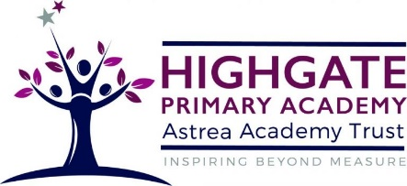

Music at Highgate Primary Academy
Music at Highgate aims to ensure that all pupils:
• Perform, listen to, review and evaluate music
• Be taught to sing, create and compose music
• Understand and explore how music is created, produced and communicated.

At Highgate Primary, the intention is that children gain a firm understanding of what music is through listening, singing, playing, evaluating, analysing, and composing across a wide variety of historical periods, styles, traditions, and musical genres. We aim to develop a curiosity for the subject and an unbiased respect for the role that music may be expressed in any person’s life. We are committed to ensuring children understand the value and importance of music in the wider community, and are able to use their musical skills, knowledge, and experiences to involve themselves in music, in a variety of different contexts.
We offer our pupils experiences in playing and performing from instrument lessons within school to performing with thousands of children in an arena performance.
Understanding and exploring how music is created, considering inter-related dimensions, is something that can be achievable and is adaptable to all learners, regardless of individual needs giving a fully inclusive experience to all Highgate pupils.

