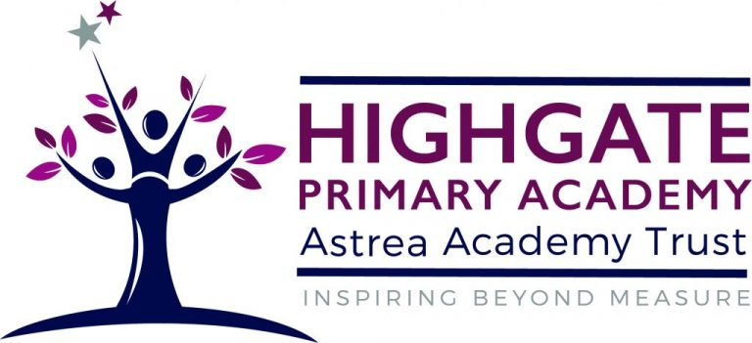
Music Overview at Highgate
 | Autumn 1 | Autumn 2 | Spring 1 | Spring 2 | Summer 1 | Summer 2
EYFS | Songs & nursery rhymes daily | Songs & nursery rhymes daily | Songs & nursery rhymes daily | Songs & nursery rhymes daily | Songs & nursery rhymes daily | Songs & nursery rhymes daily
Y1/2  CYCLE A | Musicianship  Outside agency | Musicianship  Outside agency | Musicianship  Outside agency | Musicianship  Outside agency | Musicianship  Outside agency | Musicianship  Outside agency
Y1/2  YCLE B | Musicianship  Outside agency | Musicianship  Outside agency | Musicianship  Outside agency | Musicianship  Outside agency | Musicianship  Outside agency | Musicianship  Outside agency
Y3/4  CYCLE A | Percussion  Outside agency | Percussion  Outside agency | Percussion  Outside agency | Percussion  Outside agency | Percussion  Outside agency | Percussion  Outside agency
Y3/4  CYCLE B | Percussion  Outside agency | Percussion  Outside agency | Percussion  Outside agency | Percussion  Outside agency | Percussion  Outside agency | Percussion  Outside agency
Y5/6  CYCLE A | Film music | Musical theatre | Advanced rhythms | Songs of World War 2 | South and West Africa | Composing and performing a leavers’ song
Y5/6  CYCLE B | Blues | Dynamics pitch and texture: Coast – Fingal’s Cave by Mendelssohn | Looping and remixing: Dance music | Composition to represent the festival of colour: Holi | Transposition: Pop Art | Composing notation: Egyptians

