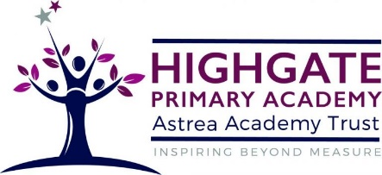
Computing at Highgate

At Highgate we aim to provide a high-quality computing education which ensures that pupils are able to express themselves and develop their ideas through information and communication technology, at a level suitable for the future workplace and as active participants in a digital world.
The National Curriculum Programme of Study aims to ensure that all pupils can access these 3 key areas of computing:

Computer Science: Ensures that all pupils can understand and apply the fundamental principles and concepts of computer science, including abstraction, logic, algorithms and data representation. Pupils can analyse problems in computational terms, and have repeated practical experience of writing computer programs in order to solve such problems.

Information Technology: Where pupils can evaluate and apply information technology, including new or unfamiliar technologies, analytically to solve problems are responsible, competent, confident and creative users of information and communication technology.

Digital Literacy: Where pupils are responsible, competent, confident and creative users of information and communication technology.

Our Inclusive Approach

We believe that computing is a skill accessible for all children and a key tool in developing progression and skills across all other areas of the curriculum. In order to include all levels of learners, we incorporate learning materials that are accessible to all abilities. For learners with special educational needs and difficulties, specific resources or approaches are implemented where appropriate to enable to access the curriculum.

