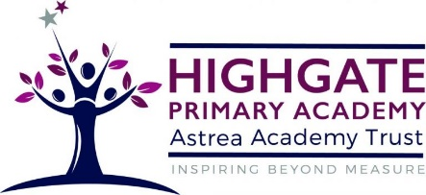

Design Technology at Highgate Primary Academy

At Highgate Primary Academy, we aim to provide children with the opportunities to use their creativity and imagination to design and make products that solve real and relevant problems from a variety of contexts. Pupils progress by drawing on their broad range of subject knowledge within other areas such as mathematics, science, engineering, computing and art. Through taking risks, evaluating and thinking critically, pupils develop a deep understanding of the use of Design and Technology in their lives, and the world around them. Through our DT curriculum, our children are inspired by engineers, designers, chefs and architects; enabling them to create a range of structures, mechanisms, textiles, electrical systems and food products with a real-life purpose.
The range pedagogical approaches that design can offer, is useful for many learners to overcome some of the barriers that may present themselves in other curriculum areas. Indeed, some of the learners may thrive enjoying the prospect to express their ideas in a way that is unique to them.

