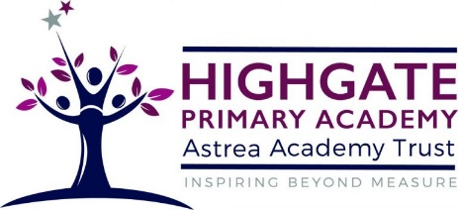
PSHE Curriculum at Highgate

The PSHE curriculum that we deliver follows the national curriculum, which explores relationships, health and wellbeing, for year 6 RSE. In addition to those areas, we also explore living in the wider world. Our intention by delivering this informative curriculum is to develop our children into a well-rounded citizen, who has the knowledge and understanding of themselves and others and is able to live confidently with in society.
PSHE is delivered so it is accessible to all children. Our intention is that they develop into confident, independent, responsible and healthy individuals, with solid skills, knowledge and understanding of PSHE. The opportunities our children have in PSHE allow them to learn, enquire, explore, understand, explain, problem solve, reason and evaluate. From this, they are able to tackle SMSC issues as they are growing up. Through exploration and embedding these skills, they are developing transferable skills to all other aspects of our curriculum, school life and living in the wider world.
Though PSHE is delivered as a stand-alone subject, it is also discreetly visible is all aspect of school life. Our children are given opportunities to learn how to keep themselves and other safe, physically and mentally. This can be seen in our PSHE lessons, the wider curriculum, assemblies and day-to-day school life. Our intentions at Highgate through PSHE, is that our children can understand and manage their mental and emotional needs; and how to manage these as they are growing up with support from those around them.

