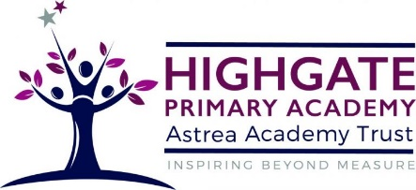

Art and Design at Highgate Primary Academy
At Highgate, we believe that art is a vital part of children’s education, with a significant and valuable role in the taught curriculum and the enrichment opportunities that we offer our pupils. Children will develop their understanding of the visual language of art with effective teaching and considered sequences of lessons and experiences. Understanding of the visual elements of art and design (line, tone, texture, colour, pattern, shape, 3D form) will be developed by providing a curriculum that will enable children to reach their full potential.
The skills and knowledge that children will develop throughout each art topic are mapped across each year group and are progressive throughout the school. We aim to ensure that children understand the context of the artwork, as well as the artists that they are learning about and being inspired by.
The Art curriculum at Highgate Primary Academy is fully inclusive and contributes to children’s personal development in creativity, independence, judgement and self-reflection. The range of approaches that art and design can offer, is useful for many learners to overcome some of the barriers that may present themselves in other curriculum areas. Some learners indeed thrive, enjoying the prospect to express their ideas in a way that is unique.

