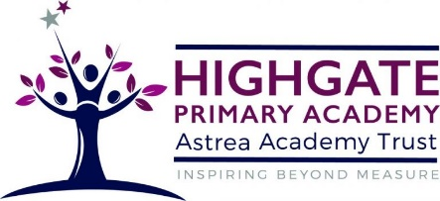

Geography at Highgate Primary Academy

Our teaching of Geography at Highgate will excite children about the world we live in, and the people within it. We are committed to providing an ambitious, knowledge-rich curriculum that strives to provide all of our pupils with a strong cultural capital that will remain with them for the rest of their lives. We want children to be fascinated by geographers out there in the world and see this as a future career for themselves. We will equip pupils with knowledge about diverse places, people, resources and natural and human environments together with a deep understanding of the Earth’s key physical and human processes. Our curriculum is progressive and interconnected which ensures that skills and knowledge are built on year by year and sequenced appropriately to maximise learning for all children.

Our Inclusive Approach

We make our whole class teaching accessible to all by encouraging learners to ask questions about their learning. We build in opportunities for small group and whole class discussions. Sessions are oracy led with visuals and practical opportunities where appropriate to support all learners.

