Year 6- Cycle A

Half Term | Autumn A |  | Autumn B
PKC Links | Literature Shakespeare | Literature: Narrative | Science-Environmental | Literature: Mythical Narrative
Planning Sequence | 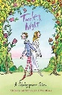  Twelfth Night  William Shakespeare | 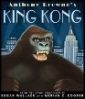  Kong  (Anthony Brown Version) | 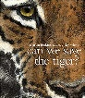  Can we save the tiger?  Martin Jenkins | 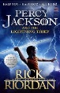  Percy Jackson and The Lightening Thief  Rick Riordan
Final Written Outcomes | Play Script | News Report | Persuasive | Extended Mythical Narrative
Half Term | Spring A |  | Spring B
PKC Links | Science: Forces | Value: Tenacity (Autumn B) | Literature: Grimm Tales (building on Autumn B) |  | Geography: North America (Spring A)
Planning Sequence | 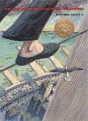  The Man Who Walked  Between The Towers  Mordicai, Gerstein | 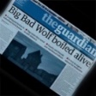  The Three Little Pigs Project  The Guardian | 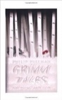  Grimm Tales for Young and Old  Phillip Pullman | 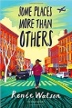  Some Places More Than Others  Renee Watson
Final Written Outcomes | Biography | Discussion/Balanced argument | Own version traditional tale | Poetry
Half Term | Summer A |  | Summer B
PKC Links | Literature | Geography: British Geographical Issues | History: The History of Human Rights (Summer B) |  | Literature: RE/SMSC
Planning Sequence | 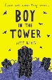  The Boy In The tower  Polly Ho-Yen | 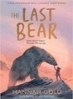  The Last Bear  Hannah Gold | 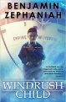  Windrush Child  Benjamin Zephaniah | 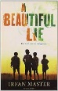  A Beautiful Lie  Ifran Master
Final Written Outcomes | Extended narrative | Newspaper | Persuasive | Recount
Objectives

