Year 5
Half Term | Autumn A |  | Autumn B
PKC Links | Literature: Shakespeare | Literature: Legends and folklore | Science: The Human Body (Autumn A) | Art: Style in Art (Autumn A)
Planning Sequence | The Tempest  William Shakespeare | 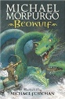  Beowulf  Michael Morpurgo |   Robot Girl  Malorie Blackman | 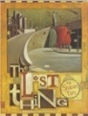  The Lost Thing  Shaun Tan
Final Written Outcomes | Playscript | Narrative: Own legend or missing chapter | Discussion (NB. Outcome from first half of plan) | Fantasy Narrative
Half Term | Spring A |  | Spring B
PKC Links | Literature: Legends and folklore | School Value: Tenacity | Art: Art from Western Africa (Spring A) |  | Science: Living Things (Spring A)
Planning Sequence | 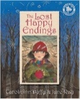  The Lost Happy Endings  Carol Ann Duffy | 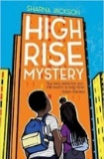  High Rise Mystery  Sharna Jackson | 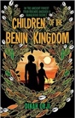  Children of the Benin Kingdom  Dina Orji | 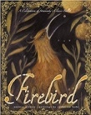  Firebird  Saviour Pirotta and Catherine Hyde
Final Written Outcomes | Newspaper report (NB. Outcome from first half of plan) | Extended narrative | Non-chronological report | Prequel from an alternative perspective
Half Term | Summer A |  | Summer B
PKC Links | History: Transatlantic Slave Trade (Spring B) | Science: Forces (Spring B) | Science: Astronomy (Summer A) |  | Science: Meteorology (Summer B)
Planning Sequence | 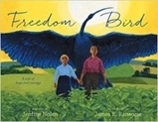  Freedom Bird  Jerdine Nolen | 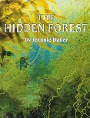Hidden Forest  Jeannie Baker | Hidden Figures  Margot Lee Shetterly  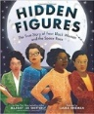 | 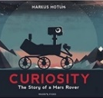  Curiosity  Markus Motum
Final Written Outcomes | Biography | Speech (Debate) | Memoir | Explanation

Year 6

Half Term | Autumn A |  | Autumn B
PKC Links | PSHE: Hope | Literature: Shakespeare | Literature: Gothic narratives | History: The Suffragettes (Autumn B)
Planning Sequence | 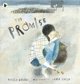  The Promise  Nicola Davies | 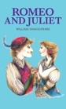  Romeo and Juliet  William Shakespeare | 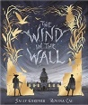  The Wind in the Wall  Sally Gardner | 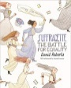  Suffragette: The Battle for Equality  David Roberts
Final Written Outcomes | Sequel to continue the cyclical story | Playscript | Extended Gothic Narrative | Persuasive campaign
Half Term | Spring A |  | Spring B
PKC Links | Science: Classification of Living Things (Autumn B) | Geography: British Geographical Issues (Autumn B) | Literature: Grimm Tales (building on Autumn B) |  | Literature: Classic Poetry
Planning Sequence | 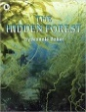  The Hidden Forest  Jeannie Baker | 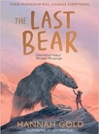  The Last Bear  Hannah Gold | 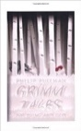  Grimm Tales for Young and Old  Phillip Pullman | 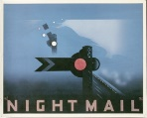  Night Mail  W H Auden
Final Written Outcomes | Balanced discussions | Newspaper | Own version traditional tale | Poetry
Half Term | Summer A |  | Summer B
PKC Links | History: World War II (Spring A & B) | Value: Tenacity | History: The History of Human Rights (Summer B) |  | Geography: North America (Spring A) / Transition
Planning Sequence | 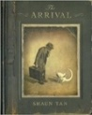  The Arrival  Shaun Tan | 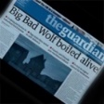  The Three Little Pigs Project  The Guardian | 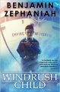  Windrush Child  Benjamin Zephaniah | 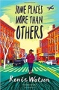  Some Places More Than Others  Renee Watson
Final Written Outcomes | Extended narrative | Discussion | Persuasive | Poetry

