Year 1
Half Term | Autumn A |  | Autumn B
Curric links |  | Art: Colour (Aut A) | Geography: Spacial sense (Aut A) |  | Value: Tenacity
Text | 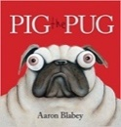  Pig the Pug  Aaron Blabey  How to be a Dog  Jo Williamson | 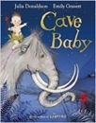  Cave Baby  Julia Donaldson and Emily Gravett | 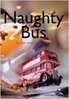  Naughty Bus  Jan Oke and Jerry Oke | 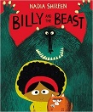  Billy and the Beast  Nadia Shireen
Final Written Outcomes | How to guide-non-fiction | Narrative retelling | Narrative retelling | Narrative- own version
Half Term | Spring A |  | Spring B
Curric Links | Science: Animals and their needs (Aut B) |  | Science: Seasons and weather (Sp A) |  | Art: Architecture (Sp A)
Planning Sequence | 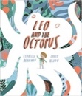  Leo and the Octopus  Isabelle Marinov | Leo and the Octopus  Isabelle Marinov | 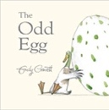  The Odd Egg  Emily Gravett | 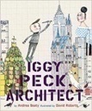  Iggy Peck, Architect  Andrea Beatty and David Roberts
Final Written Outcomes | Fact file | Poem | Egg Spoters guide | Fact file
Half Term | Summer A |  | Summer B
Curric Links | Science – Taking care of the Earth (Sp B) |  | Geographu: Seven continents (Su A) |  | PSHE: Being yourself
Planning Sequence | 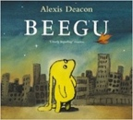  Beegu  Alexis Deacon | 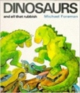  Dinosaurs and all that Rubbish  Michael Foreman | 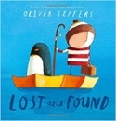  Lost and Found  Oliver Jeffers | 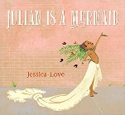  Julian is a Mermaid  Jessica Love
Final Written Outcomes | Narrative – own version | Pamphlet | Narrative | Poem

