Year 3
Half Term | Autumn A |  |  | Autumn B
Curric link | History: The Stone Age to the Iron Age (Aut A) |  | The Human Body (Aut A) | The Egyptians | Value: Curiosity
Text | 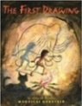  The First Drawing  by  Mordicai Gerstein |  | The Heart and the Bottle 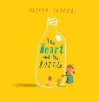  By Oliver Jeffers | 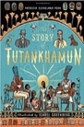  The Story of Tutankhamun  Patricia Cleveland-Peck | 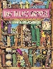  How to Live Forever  by Colin Thompson
Final Written Outcome | Narrative |  | Own version narrative | Letter of explanation | Mystery Narrative
Half Term | Spring A |  |  | Spring B
Curric link | Life in Ancient Rome | The Rise and Fall of Rome |  | Art: Art of Ancient Egypt (Sp A) |  | Plants: The Varmints
Text | 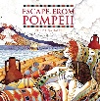  Escape from Pompeii |  | 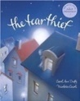  The Tear Thief  Carol Ann Duffy | 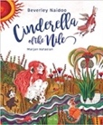  Cinderella of the Nile  Beverley Naidoo | 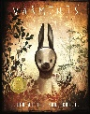  The Varmints by Helen Ward  & Marc Craste
Final Written Outcome | Non-chronological report |  | Letter of explanation | Traditional Tale | Explanation
Half Term | Summer A |  |  | Summer B
Curric link | UK: London and South East |  | Rocks | Asia – Japan | Electricity
Text | 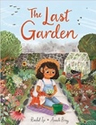  The Last Garden  Rachel Ip |  | 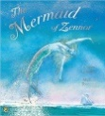  The Mermaid of Zennor  Charles Causley | 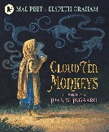  The Cloud Tea Monkeys  by Mal Peet | 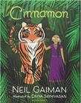  Cinnamon  Neil Gaiman  Or Sparky by Jennie Offil
Final Written Outcome | Narrative |  | Narrative (legend) | Explanation and Non-chronological | Letter

