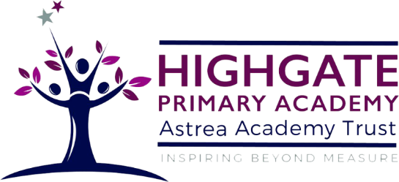

English Curriculum Statement

Intent
Our curriculum leads to the necessary development of language, communication, reading and writing that children require to succeed in life. Through our curriculum children will become more confident, resilient and independent therefore able to explore and enjoy Literature and cope with the demands of the modern world once they leave school.

At Highgate Primary Academy, we will:
- Deliver a wide and robust English Curriculum utilising the Literacy Tree and The Primary knowledge Curriculum.
- Keep reading at the heart of our curriculum and ensure that we have a reading rich environment.
- Provide children with a strong start in the Early Years and Key Stage 1 with a robust Phonics programme following Read Write Inc.
- Ensure that vocabulary acquisition is high profile throughout the school to close the language deficit developed through Covid.
- To meet the needs of every learner through the school.

Implementation
At Highgate Primary Academy, we use various schemes as well as unified whole-school sequences of learning to ensure that there is a rich coverage of the national curriculum statements and outcomes such as Read, Write Inc, The Literacy Tree and Fresh Start. Skills are taught progressively and knowledge is built up over time. We provide opportunities for speaking and listening skills to develop at every opportunity as well as vocabulary and language acquisition, which is a high priority within our English Curriculum.

-Our Inclusive Approach
Phonics
We have an inclusive phonics environment which is reading rich. There will be opportunities for learners to apply their decoding skills at a sentence level, phrase level, word level and initial sound level.

Reading
Within the classroom and library, there are a range of texts which meet the needs of all learners. These are also well organised to support learners with browsing and making choices. We learners, especially those who find it more challenging and feel less confident, how to navigate book areas/corners and where to find the texts they will be able to and will want to read.
Reading is taught through Read Write Inc in the Early Years and Key Stage 1, progressing to a Whole Class Reading model (when pupils have completed the Read Write inc programme) that focuses on the development of fluency and language acquisition aswell as comprehension skills. The Whole Class Reading model aims to expose children to a wide range of text types, to enthuse children as readers and to develop children as competent and confident readers in the future.

Writing
In writing, pupils read a specifically chosen text to engage pupils and give a strong and engaging context for writing. After exploring this text, pupils develop knowledge of a range of core year group writing skills, linked to the national curriculum, and practise using them in the context they will be writing in. Pupils then read model texts of the text type/genre they will be writing, explore and practise the use of key features, layout features and cohesive devices for that subject. Following this, pupils will plan their ideas for writing, write jointly with teachers and then independently, and then finally edit and re-draft writing before publishing and/or presenting their writing to others.

We strive to create a vocabulary-rich classroom to close the gaps and enable future attainment. Key questions and vocabulary linked to what children are currently learning are displayed on learning walls. Vocabulary on working walls is then referred to when teachers and practitioners are speaking and modelling writing. This encourage learners to use the vocabulary displayed to support their independent work. Visuals are also added to key vocabulary to ensure all learners can access it.

