Year 4
Half Term | Autumn A |  | Autumn B
PKC Links | PSHE: Relationships | History: The Stone Age to the Iron Age | Rememberance day | History: Ancient Egypt
Planning Sequence | 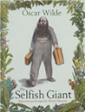  Selfish Giant  Oscar Wilde | 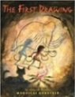  The First Drawing  by  Mordicai Gerstein | 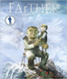  FArTHER  Grahame Baker Smith | 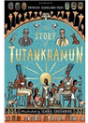  The Story of Tutankhamun  Patricia Cleveland-Peck
Final Written Outcomes | Narrative: Own version | Narrative | Sequel story | Non-chronological report
Half Term | Spring A |  | Spring B
PKC Links | History: Ancient Rome | Value: Curiosity | Art: Art of Ancient Egypt |  | Science: Plants
Planning Sequence | 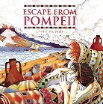  Escape from Pompeii  Christina Balit | 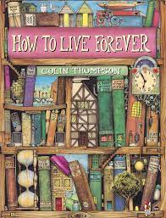  How to live forever  By Colin Thompson | 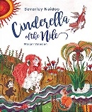  Cinderella of the Nile  By Beverley Naidoo | 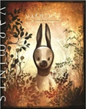  Varmints  Helen Ward B
Final Written Outcomes | Non-chronological report | Mystery Narrative | Traditional Tale | Explanation
Half Term | Summer A |  | Summer B
PKC Links | Geography: London | Rocks | Asia – Japan |  | Literature: Poems
Planning Sequence | 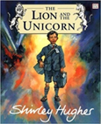  Shirley Hughes  The Lion and the unicorn | 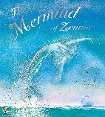  The Mermaid of Zennor  By Charles Causley | 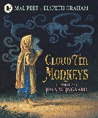  The Cloud Tea Monkeys  by Mal Peet | 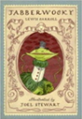  Lewis Carroll  Jabberwocky
Final Written Outcomes | Own version historical narrative | Narrative (legend) | Explanation and Non-chronological | Nonsense poem

