Half Term | Autumn A |  | Autumn B
Curric links | PSHE: Change & Relationships | Geography: Spatial Sense (Autumn A)  Science – The Human Body | Design Technology: Mechanisms
Planning Sequence | 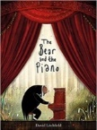  The Bear and the Piano  David Litchfield | 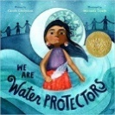  We Are Water Protectors  Carole Lindstrom | 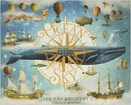  Ocean Meets Sky  Eric Fan and Terry Fan | 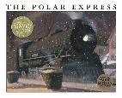  The Polar Express
Final Written Outcomes | Own version narrative about bravery | Environmental campaign | Fantasy world narrative | Own version diary
Half Term | Spring A |  | Spring B
Curric Links | Science: Living things and the environment (Autumn B) | School value: Tenacity/Curiosity | Literature: A Twist in the Tale
Planning Sequence | 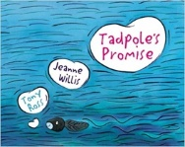  Tadpole’s Promise  Jeanne Willis | 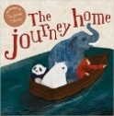  The Journey Home  Frann Preston-Gannon | 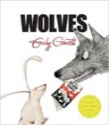  Wolves  Emily Gravett | Goldilocks & the Three Bears  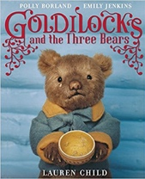  Lauren Child  Unit also includes: You & Me and Goldilocks & Just the One Bear
Final Written Outcomes | Own version narratives | Persuasive letters | Non-chronological leaflet | Sequel Story
Half Term | Summer A |  | Summer B
Curric Links | Science: Plants (Spring B) | Science: Materials and Matter (Summer A) | Exposure to Classics: Poetry |  | Science: Astronomy (Summer B)
Planning Sequence | 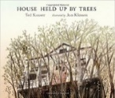  House Held Up By Trees  Ted Kooser | 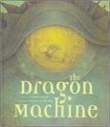  The Dragon Machine  Helen Ward | 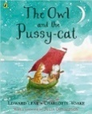  The Owl and the Pussy-cat  Edward Lear | 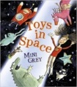  Toys in Space  Mini Grey
Final Written Outcomes | Newspaper | Narrative | Rhyming poems | Fantasy world narrative
Year 2

