Hexthorpe Primary PSHE Intent, Implementation and Impact Statements

Intent

At Hexthorpe, our PSHE curriculum encourages children to be curious about the world around them, whilst developing the skills set to aspire and thrive within their community. We want them to be able to recognise their well-being to regulate their own feelings and find ways to overcome these and move forward confidently. We also want our children to aspire to achieve above and beyond their skills set and learn those life skills to understand and confidently live in their community. We aim to provide all learners with the understanding of how to make and keep themselves healthy, including mental health. Our PSHE curriculum will have some cross-curriculum links, however, will be a holistic approach that will come through each day.

Implementation

In order to successfully implement a well-rounded, diverse PSHE curriculum that meets the needs of all learners, we use 1decision to ensure that all learners are exposed to a carefully planned, sequential PSHE curriculum which builds year-on-year, developing the vocabulary of our PSHE learners and their ability to develop a set of life skills that will support them with their time at Hexthorpe, also to stay with them as they go through life.

Impact

The impact of our well-rounded, diverse and carefully sequenced PSHE curriculum will be: all children being able to regulate their feelings much more effectively and confidently, children to have aspirational views of their lives, learners to have a bank of life skills that supports them throughout their lives and for children to recognise how to make and keep themselves healthy including their mental health. Hexthorpe aims to develop well-rounded individuals that aspire, thrive and are healthy within their community throughout their lives.

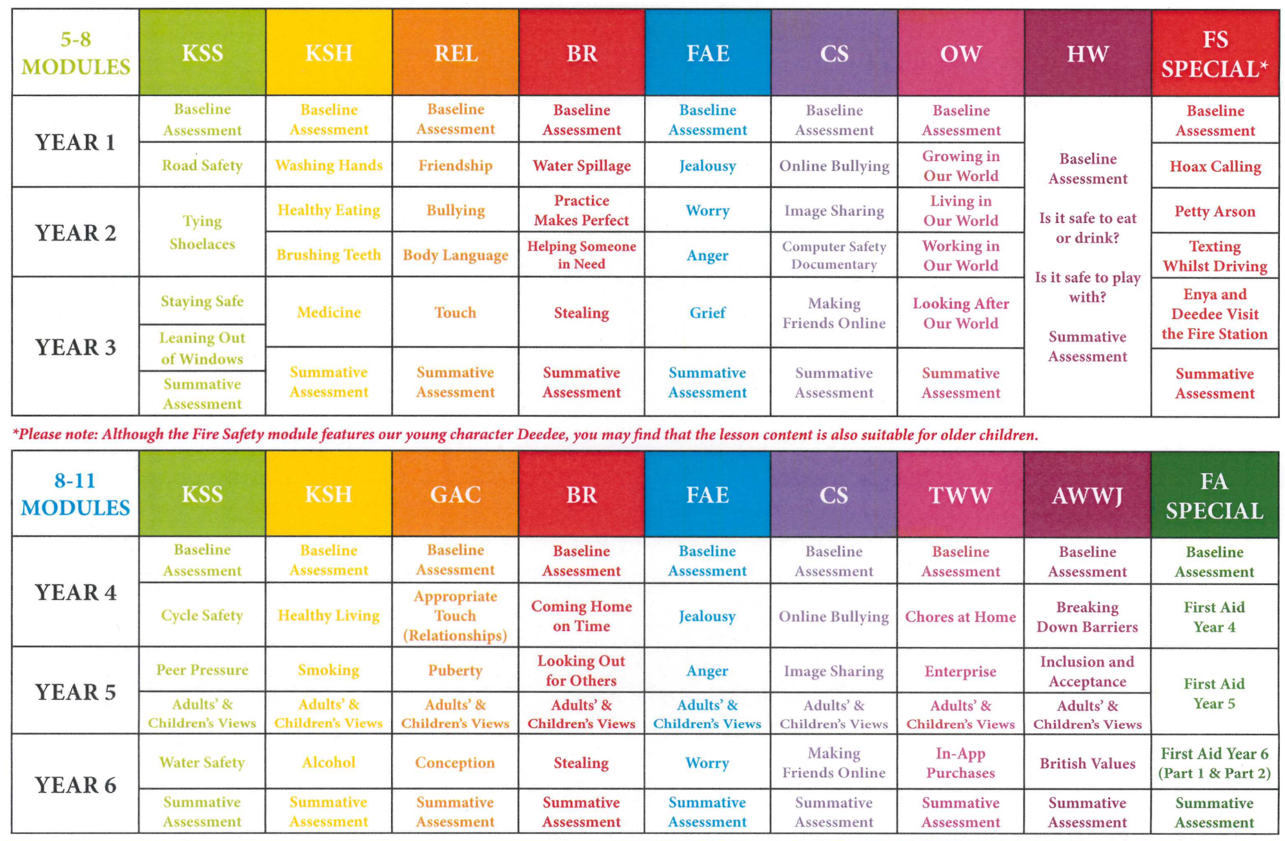
 | EYFS | Year 1 | Year 2 | Year 3 | Year 4 | Year 5 | Year 6
Autumn 1 | Staying Safe:  - Identifying risks to keep ourselves and others safe  - Understand that rules help to keep ourselves and others safe  Staying Safe:  - Identifying risks to keep ourselves and others safe  - Understand that rules help to keep ourselves and others safe | Road Safety:  - Understanding what we need to keep ourselves and others safe.  - Being able to recognise safe places to cross on a road.  - Understand difference between safe and risky choices.  Washing Hands:  - Understand what we can do to keep us healthy.  - To know how germs spread and practise good hand washing.  - To know the differences between healthy and unhealthy choices. | Tying shoelaces:  - To understand why it is important your shoelaces are tied.  - Learn to tie shoelaces.  Healthy eating:  - know that food is needed for our bodies to be healthy and to grow understand that some foods are better for good health than others  - be able to list different types of healthy food understand how to keep yourself and others healthy  - know the differences between healthy and unhealthy choices  Brushing teeth:  - understand why we need to brush our teeth  - be able to practise brushing your teeth  - know the differences between healthy and unhealthy choices  - be able to develop strategies to help you remember to brush your teeth when you forget, are tired, or busy | Staying safe and leaning out of windows:  - know ways to keep yourself and others safe  - be able to recognise risky situations  - be able to identify trusted adults around you  - understand the differences between safe and risky choices be able to recognise a range of warning signs be able to spot the dangers we may find at home  - know the importance of listening to our trusted adults  - be able to understand ways we can keep ourselves and others safe at home  - know the differences between safe and risky choices  Medicine:  - know, understand, and be able to practise simple safety rules about medicine understand when it is safe to take medicine know who we can accept medicine from understand the differences between healthy and unhealthy choices | Cycle safety:  - identify strategies we can use to keep ourselves and others safe  - recognise the impact and possible consequences of an accident or incident identify what is a risky choice  - create a set of rules for and identify ways of keeping safe  Healthy Living:  - explain what is meant by a balanced diet and plan a balanced meal recognise how too much sugar, salt, and saturated fat in our food and drink can affect us now and when we are older understand nutritional information on packaged food and explain what it means describe different ways to maintain a healthy lifestyle | Peer pressure (adults and children’s views):  - identify strategies we can use to keep ourselves and others safe  - recognise ways to manage peer pressure  - explain the potential outcomes that may happen when we take risks recognise the impact and possible consequences of an accident or incident  Smoking (adults and children’s views):  - explain some of the risks associated with smoking (physical, social, and legal) and name the addictive ingredient found in cigarettes, e-cigs, etc. describe how smoking can affect your immediate and future health and wellbeing give reasons why someone might start and continue to smoke identify and use skills and strategies to resist any pressure to smoke | Water safety:  - identify a range of danger signs  - develop and name strategies that can help keep ourselves and others safe recognise the impact and possible consequences of an accident or incident  Alcohol:  - identify what is a risky choice  - identify the risks associated with alcohol (+ drugs - extension)  - describe how alcohol can affect your immediate and future health  - develop and recognise skills and strategies to keep safe
Autumn 2 | Keeping/Staying Healthy:  - Develop an understanding of the importance of making healthy choices  - Relationships Managing friendships and social interaction  - Being aware of our own needs and having empathy for our understanding of others  Keeping/Staying Healthy:  - Develop an understanding of the importance of making healthy choices  - Relationships Managing friendships and social interaction  - Being aware of our own needs and having empathy for our understanding of others | Friendship:  - To understand different types of relationships and how to be a good friend.  - To recognise kind and thoughtful behaviours, as well as the importance of caring for others.  - To be able to see a situation from another person’s point of view. | Bullying:  - be able to name a range of feelings  - understand why we should care about other people’s feelings  - be able to see and understand bullying behaviours  - know how to cope with these bullying behaviours  Body Language:  - be able to recognise and name a range of feelings understand that feelings can be shown without words  - be able to see a situation from another person’s point of view  - understand why it is important to care about other people’s feelings | Touch:  - understand the difference between appropriate and inappropriate touch  - know why it is important to care about other people’s feelings  - understand personal boundaries  - know who and how to ask for help  - be able to name human body parts | Appropriate touch (relationships):  - identify the different types of relationships we can have and describe how these can change as we grow explain how our families support us and how we can support our families  - identify how relationships can be healthy or unhealthy  - explain how to ask for help and identify who can help us if a relationship makes us feel uncomfortable | Puberty (adults and children’s views):  - explain what puberty means  - describe the changes that boys and girls may go through during puberty  - identify why our bodies go through puberty  - develop coping strategies to help with the different stages of puberty  - identify who and what can help us during puberty | Conception:  - explain the terms ‘conception’ and ‘reproduction’  - describe the function of the female and male reproductive systems  - identify the various ways adults can have a child  - explain various different stages of pregnancy  - identify the laws around consent
Spring 1 | Being Responsible:  - Understand that sometimes we have to do things that we don’t like doing  - Developing a sense of responsibility  Computer and Online Safety:  - Understand the risk and how to stay safe when using technology  Being Responsible:  - Understand that sometimes we have to do things that we don’t like doing  - Developing a sense of responsibility  Computer and Online Safety:  - Understand the risk and how to stay safe when using technology | Water spillage:  - To understand responsibilities and how these can change as you grow up.  - To understand why we must be responsible and the importance of preventing accidents.  - To recognise the differences between being responsible and irresponsible.  Online Bullying:  - To understand computers, the internet and rules to keep us safe.  - To understand how your online activity can affect others.  - To identify the positives and negatives of using technology.  - To recognise kind and unkind comments and who and how we can be helped. | Image Sharing Online:  Computer Safety Documentary:  - understand how your online actions can affect others  - be able to name the positive and negative ways you can use technology  - know the risks of sharing images without permission  - understand the types of images that you should and should not post online  - understand how your online activity can affect others  - be able to identify the positives and negatives of using technology know who and how to ask for help be able to list rules for keeping and staying safe  Practice makes perfect:  - be able to name ways you can improve in an activity or sport understand the importance of trying hard and not giving up  - be able to see the benefits of practising an activity or sport  - be able to learn ways to set goals and work to reach them | Stealing:  - understand the differences between borrowing and stealing be able to describe how you might feel if something of yours is borrowed and not returned  - know why it is wrong to steal  - be able to understand the differences between being responsible and irresponsible  Making friends online:  - be able to identify possible dangers and consequences of talking to strangers online  - know how to keep safe in online chatrooms  - be able to name the positives and negatives of using technology understand the difference between safe and risky choices online. | Coming home on time:  - recognise the importance of behaving in a responsible manner in a range of situations describe a range of situations where being on time is important explain the importance of having rules in the home  - describe ways that behaviour can be seen to be sensible and responsible  Online bullying:  - recognise the key values that are important in positive online relationships  - identify the feelings and emotions that may arise from online bullying develop coping strategies to use if we or someone we know is being bullied online identify how and who to ask for help | Looking out for others (adults and children’s views):  - recognise why we should take action when someone is being unkind  - describe caring and considerate behaviour, including the importance of looking out for others demonstrate why it is important to behave in an appropriate and responsible way identify how making some choices can impact others’ lives in a negative way  Image sharing Online  Adults and Children’s views (online safety):  - list reasons for sharing images online  - identify rules to follow when sharing images online  - describe the positive and negative consequences of sharing images online  - recognise possible influences and pressures to share images online | Stealing:  - explain what consent means  - recognise the importance of being honest and not stealing  - explain why it is important to have a trusting relationship between friends and family  - identify how making some choices can impact others’ lives in a negative way  Making friends online:  - list the key applications that we may use now and in the future  - know and understand why some applications have age restrictions  - identify ways to keep yourself and others safe in a range of situations online and offline  - recognise that people may not always be who they say they are online
Spring 2 | Feelings and Emotions:  - Understanding emotions  - Develop strategies for managing feelings  - Understand that it is ok to ask for help  Feelings and Emotions:  - Understanding emotions  - Develop strategies for managing feelings  Understand that it is ok to ask for help | Jealousy:  - To understand and recognise a range of emotions that we feel physically and mentally.  - To recognise and name emotions and their physical effects.  - To learn a range of skills to cope with unpleasant/uncomfortable emotions.  - To understand that feelings can be communicated with or without words. | Helping someone in need:  - know how you can help other people  - be able to recognise kind and thoughtful behaviours and actions understand the risks of talking to people you don’t know very well in the community  - be able to identify the differences between being responsible and being irresponsible  Worry and Anger:  - be able to recognise and name emotions and their physical effects  - know the difference between pleasant and unpleasant emotions  - learn a range of skills for coping with unpleasant/uncomfortable emotions  - understand that feelings can be communicated with and without words be able to recognise and name emotions and their physical effects  - know the difference between pleasant and unpleasant emotions  - learn a range of skills for coping with unpleasant/uncomfortable emotions  - understand that feelings can be communicated with and without words | Grief:  - be able to recognise and name emotions and their physical effects  - know the difference between pleasant and unpleasant emotions  - learn a range of skills for coping with unpleasant/uncomfortable emotions  - understand that feelings can be communicated with and without words | Jealousy:  - recognise our thoughts, feelings, and emotions, and identify the differences between those that feel good and those that feel not so good  - describe how we can support others who feel lonely, jealous, or upset recognise that we can choose how we act on our emotions and understand that our choices and actions can affect ourselves and other people  - demonstrate a range of strategies to help control and manage unpleasant/ uncomfortable emotions, such as loneliness and jealousy | Anger (adults and children’s views):  - recognise that everyone experiences emotions and that these can have physical effects on our body, both pleasant and unpleasant  - explain how feelings can be communicated with or without words recognise that we can choose how we act on our emotions and that our choices and actions can affect ourselves and other people demonstrate a range of strategies to help control and manage unpleasant/ uncomfortable emotions, such as anger | Worry:  - recognise our thoughts, feelings, and emotions  - identify how we can reduce our feeling of worry  - explain how we can support others who feel worried  - recognise that we can choose how we act on our emotions and that our choices and actions can affect ourselves and other people
Summer 1 | Our World:  - Understand similarities and differences  - Identify people who help us in our local community  - Respecting the local environment  Our World:  - Understand similarities and differences  - Identify people who help us in our local community  Respecting the local environment | Growing in our world:  - To understand how we care for others and the needs of a baby.  - To recognise what you can do for yourself now that you’re older.  - To be able to describe the common features of family life and recognise how our families are special and unique.  Hazard watch??? | Living in our world and working in our world:  - understand why we should look after living things  - be able to identify how we can look after living things both inside and outside of the home  - recognise why it is important to keep our communities and countryside clean  - be able to encourage others to help keep their communities and countryside clean  - understand different ways we can receive money  - know how to keep money safe  - be able to describe the skills you may need in a future job or career be able to recognise the differences between wants and needs  Hazard watch? | Looking after our world:  - be able to explain the meaning of reduce, reuse, and recycle recognise how we can help look after our planet  - be able to identify how to reduce the amount of water and electricity we use  - understand how we can reduce our carbon footprint  Hazard watch? | Chores at home:  - identify ways in which we can help those who look after us  - explain the positive impact of our actions  - describe the ways in which we can contribute to our home, school, and community identify the skills we may need in our future job roles | Inclusion and Acceptance (adults and children’s views):  - identify some of the ways in which we are different and unique  - explain some of the elements which help us to have a diverse community  - describe strategies to overcome barriers and promote diversity and inclusion | In-app purchases:  - know and understand various money-related terms recognise some of the ways in which we can spend money via technology  - describe the potential impact of spending money without permission  - identify strategies to save money
Summer 2 | Change and Transition:  - Building confidence  - Managing changes at home  Change and Transition:  - Building confidence  Managing changes at home | Hoax calling:  - To understand what a hoax call is and why it can be risky.  - To understand why our emergency services are important.  - To be able to practise simple ways of staying safe and finding help. | Petty arson and texting whilst driving:  - know what a ‘hoax call’ is and why it can be risky  - understand why our emergency services are an important part of our community  - be able to show my knowledge of fire safety to others  - be able to practise simple ways of staying safe and finding help  - be able to recognise how drivers can be distracted  - understand the importance of being responsible and how our actions/choice can affect others | Enya and Deedee visit the fire station:  - know what a ‘hoax call’ is and why it can be risky  - understand why our emergency services are an important part of our community  - be able to show my knowledge of fire safety to others  - be able to practise simple ways of staying safe and finding help  - be able to recognise how drivers can be distracted  - understand the importance of being responsible and how our actions/choice can affect others | Breaking down barriers:  - recognise positive attributes in others explain why being different is okay recognise your own strengths and goals, and understand that these may be different from those around you identify some of the ways we can overcome barriers and promote equality  First Aid:  - identify and name situations that may require first aid  - list reasons why someone may struggle to breathe  - identify the signs of an asthma attack or choking  - identify the signs of an allergic reaction and anaphylactic shock understand the correct steps for seeking immediate emergency help  - provide first aid treatment to someone who is struggling to breathe | Enterprise (adults and children’s views):  - understand and explain why people might want to save money  - identify ways in which you can help out at home  budget for items you would like to buy recognise ways to make money and the early stages of enterprise  First Aid:  - complete a primary survey for first aid demonstrate the recovery position for an unresponsive breathing casualty  - know when to deliver CPR  - demonstrate how to do CPR  - know when to call for emergency help | British Values:  - understand that there are a wide range of religions and beliefs in the UK  - explain each of the British values  - create a range of values for your educational setting explain how all religions can live in cohesion  First Aid – Part 1 & Part 2:  Part 1:  - identify a range of situations that may require first aid understand how to support someone with a minor or serious head injury  - understand how to support someone who is having a seizure  - understand how to support someone with a severe bleed know when to call for medical help  Part 2:  - identify a range of situations that may require first aid understand how to support someone with a minor burn or scald  - understand how to support someone who is having a heart attack  - understand how to support someone with a fractured bone know when to call for medical help

