Hexthorpe Primary PE Intent, Implementation and Impact Statements

Intent
At Hexthorpe, our PE curriculum has been designed alongside the PE Lead for our trust and intends to enable every child to develop a lifelong love for physical activity for life. We encourage children to be ambitious and have the knowledge and cultural capital they need to succeed in life. We want children to have a good understanding of an active and healthy lifestyle, in order to become and remain healthy. We develop links with the wider community through providing children with a broad range of opportunities to sports competitions, sports clubs and sporting events throughout the school year. We want to ignite creativity and allow children to be aspirational. We do this through developing physical literacy, emotional and thinking skills to be able to achieve in PE, sport and in wider life.

Implementation
In order to successfully implement a knowledge-rich PE curriculum, we use and adapt the Get Set 4 PE scheme to allow teachers to confidently teach PE. Lessons in PE are planned sequentially to allow children to make progress through the key stages. Every PE lesson develops the fundamental skills for life, through six key focus areas; personal, social, creative, cognitive, health and fitness and applying physical. One PE lesson per week is delivered for each year group by a sports coach who models good practice to develop the children and other staff and the second lesson is delivered by the class teacher. In all PE lessons, children are encouraged to review their learning, have high expectations to challenge themselves and be tenacious. Children are given the opportunity to attend multiple sports clubs throughout the week led by the sports coach and are taught healthy competition through inter and intra sporting events.

Impact

The impact of this bespoke, knowledge-rich and sequenced PE curriculum is that: children have a love for physical activity and sports and have the confidence to take risks and challenge their physical ability. All children will have a solid understanding of the importance of a healthy, balanced lifestyle and an active body. They can transfer vocabulary and knowledge from the PSHCE, Science and DT curriculum of healthy diet choices and be aware of mental health. They will be able to confidently articulate their PE knowledge and demonstrate reflective thinking of their own skills.

Overview

Below is a brief overview of the subjects across all year groups from Reception to Year 6. The top subject is led by the class teacher and the bottom subject is led by the sports coach to ensure staff are up to date with all areas of P.E. Some topics have been designed to feed into the sporting events throughout our calendar such as netball (netball tournament), cricket (cricket tournament), rugby (dragon ball tournament and athletics (KS1 and KS2 Olympics.

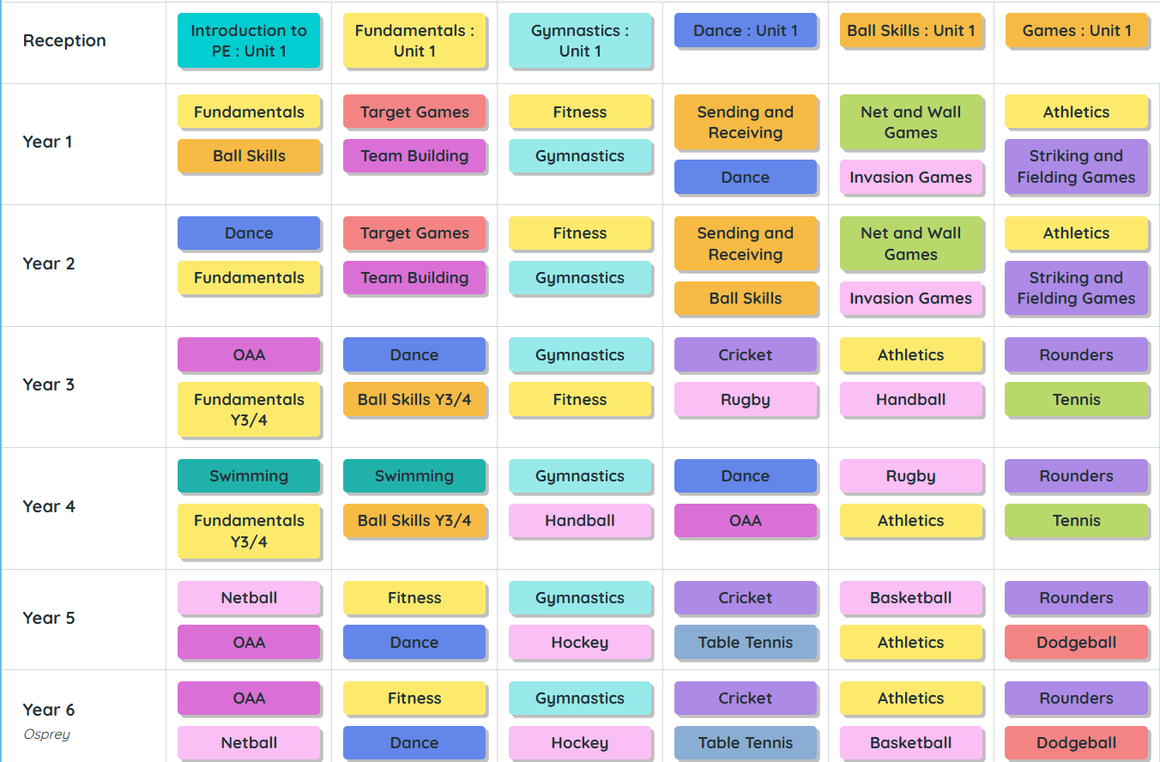
 | EYFS | Year 1 | Year 2 | Year 3 | Year 4 | Year 5 | Year 6
Autumn 1 | Introduction to PE: Unit 1  SEE GET SET 4 PE KEY SKILLS OF UNIT AS UNABLE TO ADD DUE TO COPYRIGHT.  Continuous Provision  Gross Motor  Spatial awareness and multi-step instruction games Running, jumping, using tricycles outside  Fine Motor  Small tools; cutlery, tweezers, pipettes Drawing my family, people who help me  PD – Gross motor  Spatial awareness and multi-step instruction games Running, jumping, using tricycles and scooters outside with increasing control.  PD – Fine motor  Small tools; cutlery, tweezers, pipettes, scissors. Cutting paper, card, fabric, tracing, using templates, playdough, writing, painting. | Fundamentals  Ball Skills | Dance  Fundamentals | Outdoor Adventure and Activity  Fundamentals Year 3/4 | Swimming  Fundamentals Year 3/4 | Netball  Outdoor Adventure and Activity | Outdoor Adventure and Activity  Netball
Autumn 2 | Fundamentals: Unit 1  SEE GET SET 4 PE KEY SKILLS OF UNIT AS UNABLE TO ADD DUE TO COPYRIGHT.  Continuous Provision  Gross Motor  Spatial awareness and multi-step instruction games Running, jumping, using tricycles outside  Fine Motor  Small tools; cutlery, tweezers, pipettes Drawing my family, people who help me  PD – Gross motor  Spatial awareness and multi-step instruction games Running, jumping, using tricycles and scooters outside with increasing control.  PD – Fine motor  Small tools; cutlery, tweezers, pipettes, scissors. Cutting paper, card, fabric, tracing, using templates, playdough, writing, painting. | Target Games  Team Building | Target Games  Team Building | Dance  Ball Skills Year 3/4 | Swimming  Ball Skills Year 3/4 | Fitness  Dance | Fitness  Dance
Spring 1 | Gymnastics: Unit 1  SEE GET SET 4 PE KEY SKILLS OF UNIT AS UNABLE TO ADD DUE TO COPYRIGHT.  Continuous Provision  Gross Motor  Spatial awareness and multi-step instruction games Running, jumping, using tricycles outside  Fine Motor  Small tools; cutlery, tweezers, pipettes Drawing my family, people who help me  PD – Gross motor  Spatial awareness and multi-step instruction games Running, jumping, using tricycles and scooters outside with increasing control.  PD – Fine motor  Small tools; cutlery, tweezers, pipettes, scissors. Cutting paper, card, fabric, tracing, using templates, playdough, writing, painting. | Fitness  Gymnastics | Fitness  Gymnastics | Gymnastics  Fitness | Gymnastics  Handball | Gymnastics  Hockey | Gymnastics  Hockey
Spring 2 | Dance: Unit 1  SEE GET SET 4 PE KEY SKILLS OF UNIT AS UNABLE TO ADD DUE TO COPYRIGHT.  Continuous Provision  Gross Motor  Spatial awareness and multi-step instruction games Running, jumping, using tricycles outside  Fine Motor  Small tools; cutlery, tweezers, pipettes Drawing my family, people who help me  PD – Gross motor  Spatial awareness and multi-step instruction games Running, jumping, using tricycles and scooters outside with increasing control.  PD – Fine motor  Small tools; cutlery, tweezers, pipettes, scissors. Cutting paper, card, fabric, tracing, using templates, playdough, writing, painting. | Sending and Receiving  Dance | Sending and Receiving  Ball Skills | Cricket  Rugby | Dance  Outdoor Activity and Adventure | Cricket  Table Tennis | Cricket  Table Tennis
Summer 1 | Ball Skills: Unit 1  SEE GET SET 4 PE KEY SKILLS OF UNIT AS UNABLE TO ADD DUE TO COPYRIGHT.  Continuous Provision  Gross Motor  Spatial awareness and multi-step instruction games Running, jumping, using tricycles outside  Fine Motor  Small tools; cutlery, tweezers, pipettes Drawing my family, people who help me  PD – Gross motor  Spatial awareness and multi-step instruction games Running, jumping, using tricycles and scooters outside with increasing control.  PD – Fine motor  Small tools; cutlery, tweezers, pipettes, scissors. Cutting paper, card, fabric, tracing, using templates, playdough, writing, painting. | Net and Wall Games  Invasions Games | Net and Wall Games  Invasion Games | Athletics  Handball | Rugby  Athletics | Basketball  Athletics | Athletics  Basketball
Summer 2 | Games: Unit 1  SEE GET SET 4 PE KEY SKILLS OF UNIT AS UNABLE TO ADD DUE TO COPYRIGHT.  Continuous Provision  Gross Motor  Spatial awareness and multi-step instruction games Running, jumping, using tricycles outside  Fine Motor  Small tools; cutlery, tweezers, pipettes Drawing my family, people who help me  PD – Gross motor  Spatial awareness and multi-step instruction games Running, jumping, using tricycles and scooters outside with increasing control.  PD – Fine motor  Small tools; cutlery, tweezers, pipettes, scissors. Cutting paper, card, fabric, tracing, using templates, playdough, writing, painting. | Athletics  Striking and Fielding Games | Athletics  Striking and Fielding Games | Rounders  Tennis | Rounders  Tennis | Rounders  Dodgeball | Rounders  Dodgeball

