Hexthorpe FS2 Long Term Curriculum Plan
The ‘starting points’ have been planned for the academic year; however, there is scope for adaptations to meet the interests of the children at the time and so the information below may change slightly as the year progresses.
Autumn 1  All about me | Autumn 2  Transport: Past & Present |  | Spring 1  Space |  | Spring 2  Growing and Changing |  | Summer 1  Kings and Queens |  | Summer 2  Stories from the Past
Fundamental British Values and Hexthorpe Core Values (Ongoing)
Democracy: Making decisions together (PSED: BR, MS and SR) Children to know their views count, value each other’s views and values and talks about their feelings. When appropriate demonstrate democracy in action, for example children sharing views on the theme of their role play area with a show of hands.

Rule of Law: Understanding rules matter (PSED: BR, MS and SR) Children understand their own and others’ behaviour and its consequences and learn to distinguish right from wrong. Rules and codes of behaviour, for example, to agree the rules about tidying up and rules apply to everyone.

Individual Liberty Freedom for all: (PSED: BR, MS and SR; UW: P, C and C) Develop a positive sense of themselves, develop their self-knowledge, self-esteem and increase their confidence and their own abilities. For example, talking about their experiences and learning. Explore language of feelings and responsibility, reflect on their differences, and understand we are free to have different opinions.

Mutual respect and tolerance: Treat others as you want to be treated (PSED: BR, MS and SR, UW: P, C and C) Ethos of inclusivity and intolerance where views, faiths cultures and races are valued. Children are engaged with the wider community. Acquire tolerance and appreciation of and respect from their own and other cultures. Know about similarities and differences about themselves and others and among families, faiths, communities’ cultures and traditions. Share and discuss practises, celebrations, and experiences. Importance of tolerant behaviours such as sharing and respecting other opinions, promote diverse attitudes and challenge stereotypes, for example, sharing stories that reflect and value the diversity of children’s experiences and providing resources and activities that challenge gender, cultural and racial stereotyping.

Scholarship  Developing and celebrating a positive attitude to learning.  Understanding links between learning and applying skills and knowledge taught to different areas of learning. |  | Curiosity  Developing a sense of curiosity through different areas of learning.  Allowing the children’s interests and own enquiry to lead routes of learning. |  | Tenacity  Providing children with challenges that encourage independence and exploration.  Developing resilience to persevere with challenges and gaining sense of success/achievement. |  | Aspiration  Providing the children with a wide range of experiences and opportunities to broaden their understanding of the world.  Encouraging goals to aim for and achieve – short term and longer term. |  | Unity  Providing a wide variety of opportunities for children to develop their communication and social interactions.  Developing their understanding of the world through learning about each other’s cultures and celebrating the diversity in the school.

 | Autumn 1  All about me | Autumn 2  Transport: Past & Present | Spring 1  Space | Spring 2  Growing and Changing | Summer 1  Kings and Queens | Summer 2  Stories from the Past
Literacy Tree | You Choose  Nick Sharratt  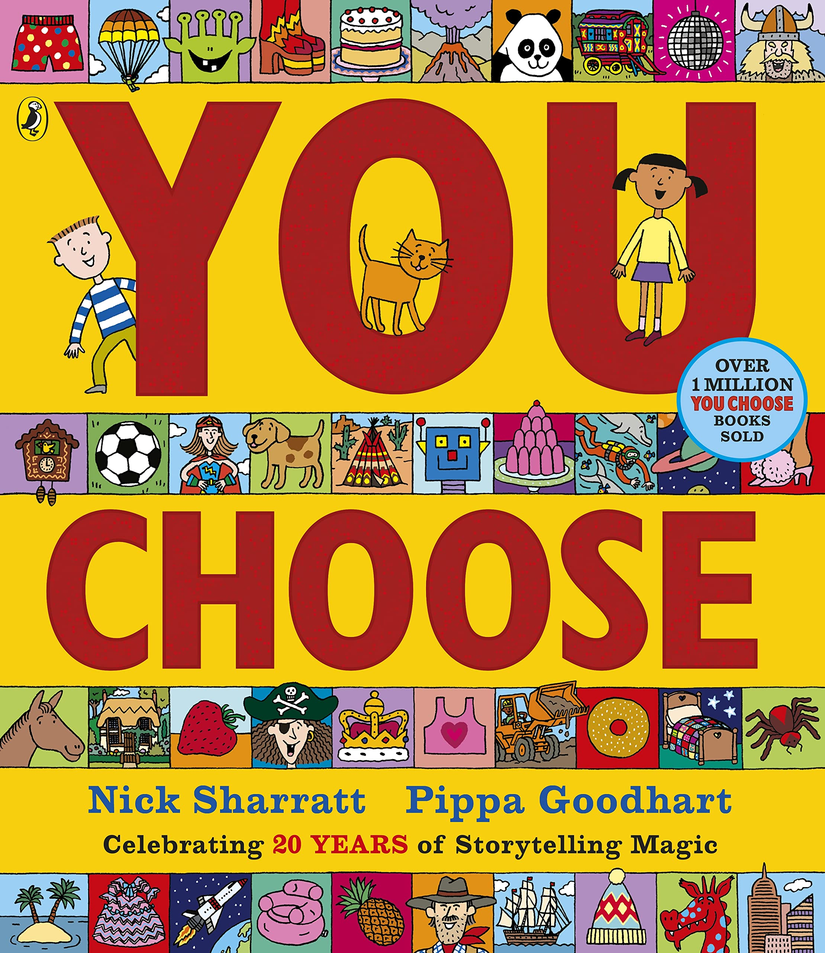  Where the Wild Things Are  Maurice Sendak  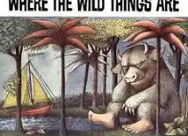  Brining the Rain to Kapiti Plain  Verma Aarma  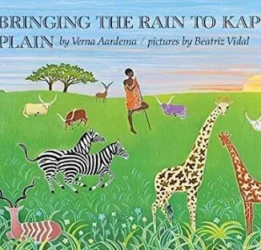 | Look Up! Nathan Bryon and Dapo Adeola  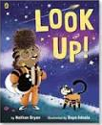  I am Henry Finch Alexis Deacon  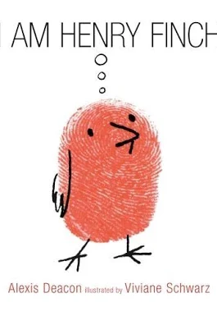 | Little Red Lynn Roberts and David Roberts  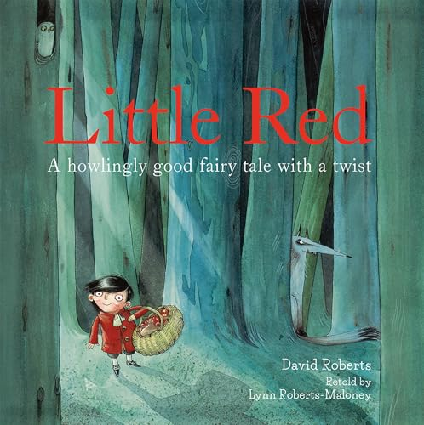  The Tiny Seed Eric Carle  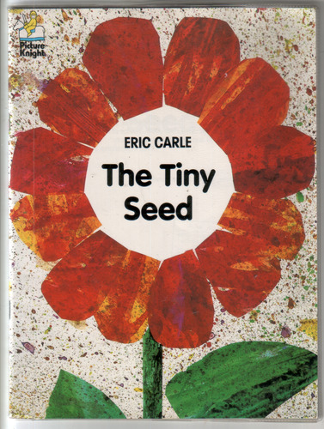 | Super Milly and the Super School Day  Stephanie Clarkeson  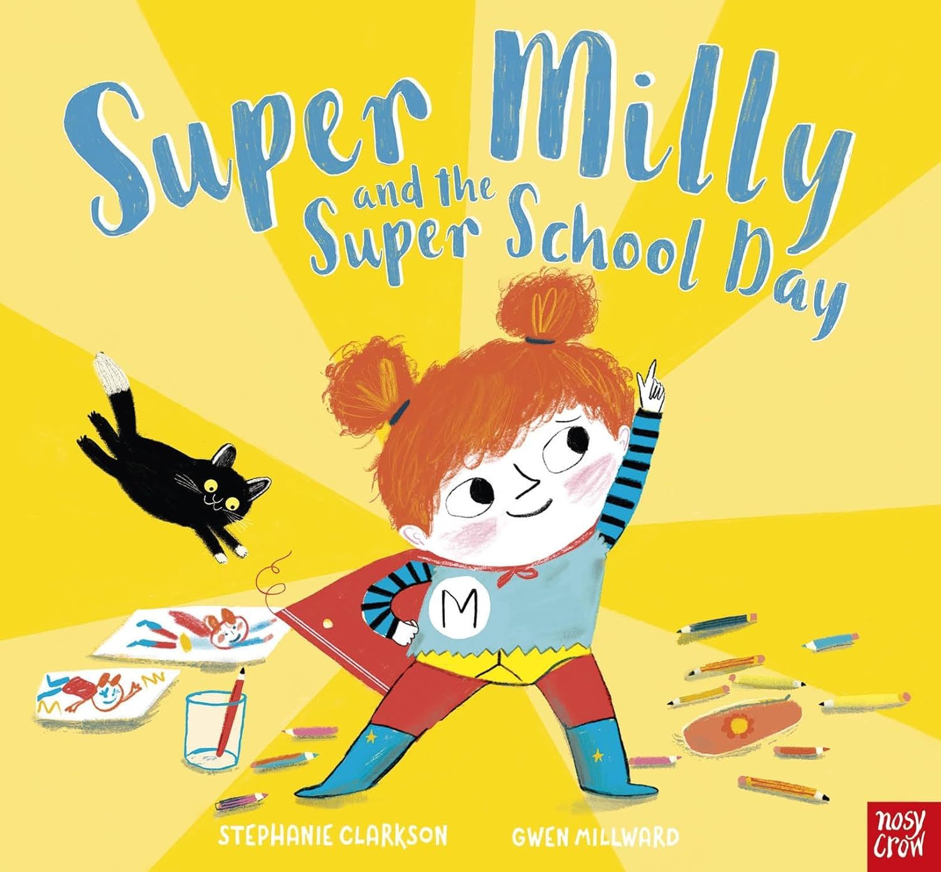  The Extraordinary Gardener  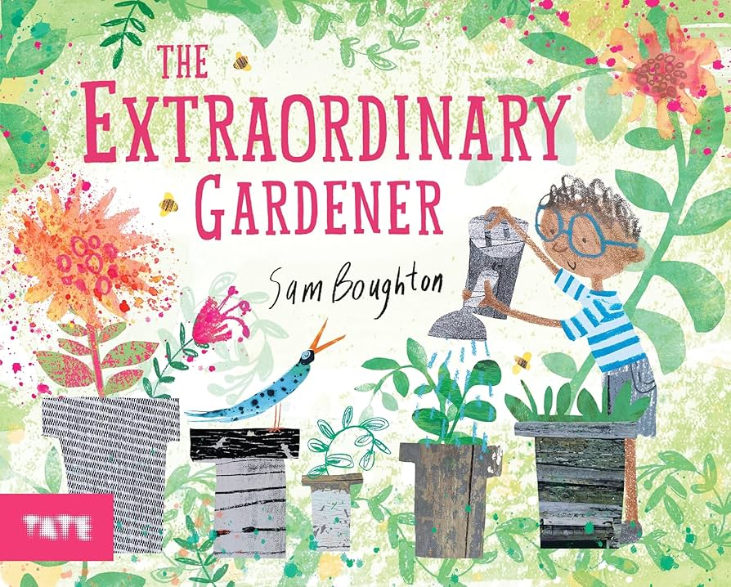 | Oi Frog Kes Gray and Jim Field  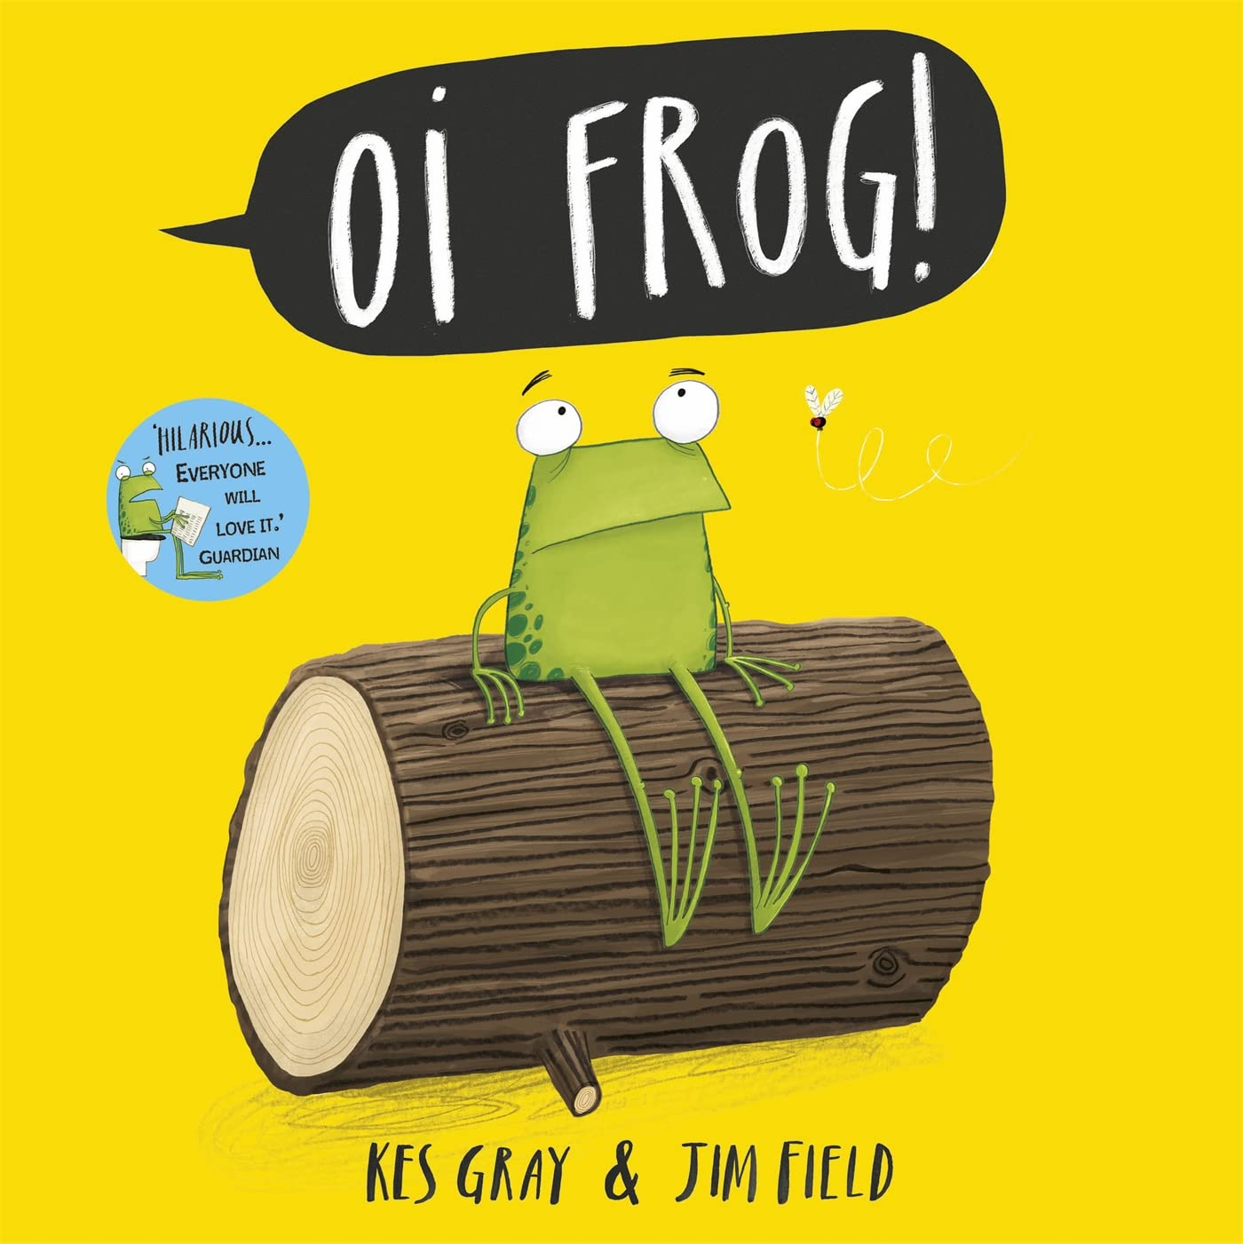  The Night Pirates Pete  Harris and Deborah Allwright  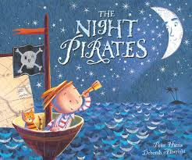 | And tango makes three  Justin Richardson and Peter Parnell  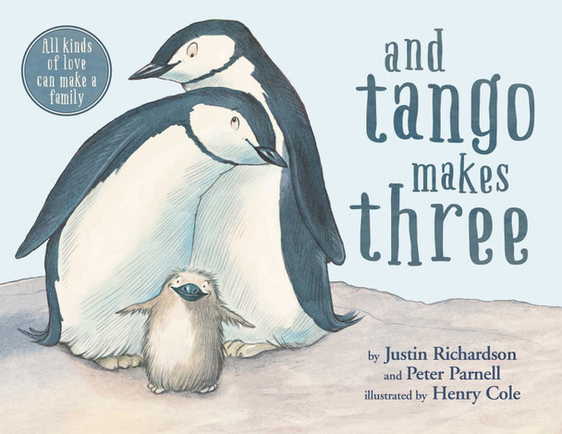  So Much Trish Cooke and Helen Oxenbury  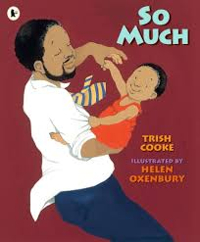
Reading for Pleasure (subject to change | Traditional Tales  Goldilocks  Three Little Pigs  Billy Goats Gruff  Gingerbread Man  Body book  Room on a Broom  Tree | Owl Babies by Martin Waddell, Mr Grumpy’s Motor Car by John Burningham, Duck in the Truck by Jez Alborough, Naughty Bus by Jan and Jerry Oke  We All Go Traveling By  Stickman | The Marvellous Moon Map by Teresa Heapy and David Litchfield, ,Man on the Moon by Simon Bartram, Meet the planets by Caryl Hart | Oliver’s Vegetables by Vivian French, Jack and the Beanstalk, The Hungry Caterpillar by Eric Carle, Jasper’s Beanstalk, Monkey Puzzle by Julia Donaldson | The Queen’s Hat by Steve Anthony  The Queen’s Knickers by Nicholas Alan  King Charles, Matt Hunt, Maria Isabel Sanchez Vegara | George and the Dragon
Mathematics | Early Mathematical Experiences  Pattern and early number | Numbers within 6  Addition and Subtraction within 6  Measures  Shape and sorting | Numbers within 10  Calendar and time  Addition and subtraction within 10  Grouping and sharing  Numbers within 15  Grouping and sharing | Number patterns within 15  Doubling and halving  Shape and Pattern | Securing addition and subtraction facts  Number patterns within 20  Number patterns beyond 20 | Money  Measures  Exploration of patterns within number
Provision and provocations linked to the theme:
Small World | Homes and families  Woodland forest and Autumn animals  Small world linked to key texts | Transport – train track and roads  Streets in our community  Lost and Found – Winter wonderland  Small world linked to key texts | The surface of the moon, rocket, spaceship  Chinese New Year – linked to story. River, animals etc  Small world linked to key texts | Farm – linked to Farmer duck story.  Small world linked to key texts | Castle  pirates  Small world linked to key texts | Fairy tale characters and animals  Traditional tales  Small world linked to key texts
Creative | Explore use and refine a variety of artistic effects to express their ideas and feelings through:  - Creating 3D pictures using a range of Autumn items e.g. conkers, cones, leaves etc  - Leaf rubbing to explore the structure of leaves and choosing the colours based on Autumn colours and changes.  - Observational drawings of seasonal items | Return to and build on their previous learning, refining ideas and developing their ability to represent them through:  - Painting: Colour mixing – exploring different shades of secondary colours  - Painting: Brush strokes – selecting the appropriate size brush to paint details  - Wax pictures with paint wash – winter snowflakes | Safely use and explore a variety of materials, tools and techniques, experimenting with colour, design, texture, form and function through:  - Using fine brushes and various tools to draw fine lines and flowers – Blossom pictures  - Pastel drawings and blending – planets  - Creating planets | Safely use and explore a variety of materials, tools and techniques, experimenting with colour, design, texture, form and function through:  - Creating flowers using a range of different materials  - Observational drawings of flowers to include the various parts of the flower learnt about during science. | Safely use and explore a variety of materials, tools and techniques, experimenting with colour, design, texture, form and function and sharing their creations, explaining the process they have used.  - Make use of props and materials when role playing characters in narratives and stories.  - Using a range of different materials to create crowns, clothing. | Safely use and explore a variety of materials, tools and techniques, experimenting with colour, design, texture, form and function and sharing their creations, explaining the process they have used.  - Make use of props and materials when role playing characters in narratives and stories.  - Using junk materials making 3D creatures  - Creating 3D landscapes for small world.
Role Play | Home corner | Home corner  South pole base station  Jolly Christmas Postman post office and wrapping station | Home corner –enhance with letters to astronaut, post cards from space on wall. Writing to the astronaut  Fantasy role play: space station | Farm shop in Sun Stream  Home corner enhanced to link with Farmer Duck. | Royal household – home corner  Castle | Fantasy – a forest area that develops and is enhanced with props and links to key text.  Home corner
Physical Development  Handwriting  Gross and Fine Motor / Health and Safe Care  Within provision  (See PE for specific PD skills and development) | Revise and refine the fundamental movement skills they have already acquired:  - Rolling  - Crawling  - Walking  - Jumping  - Running  - Hopping  - Skipping  - Climbing  Develop their small motor skills so that they can use a range of tools competently, safely and confidently.  Suggested tools: pencils for drawing and writing, paintbrushes, scissors, knives, forks, spoons.  Be increasingly independent in meeting their own care needs. E.g. Brushing teeth, using the toilet, washing and drying their hands thoroughly. | Confidently and safely use a range of large and small apparatus indoors and outside, alone and in a group.  Make healthy choices about food, drink, activity and tooth brushing. | Use their core muscle strength to achieve a good posture when sitting at a table or sitting on the floor.  Combine different movements with ease and fluency.  Linked to space, dance movements and control.  Develop the foundations of a hand writing style which is fast, accurate and efficient.  Further develop the skills they needs to manage the school day successfully:  - Lining up and queuing  - Mealtimes  - Personal; hygiene | Progress towards a more fluent style of moving, with developing control and grace.  Know and talk about the different factors that support their overall health and wellbeing:  - Regular physical activity  - Healthy heating  - Tooth brushing  - Sensible amounts of ‘screen time’  - Having a good sleep routine  - Being a safe pedestrian | Further develop and refine a range of ball skills including: throwing, catching, kicking, passing, batting and aiming.  Negotiate space and obstacles safely, with consideration for themselves and others.  Hold a pencil effectively in preparation for fluent writing – using the tripod grip in almost all cases.  Use a range of small tools, including scissors, paintbrushes and cutlery. | Develop the overall body strength, co-ordination, balance and agility needed to engage successfully with future physical education sessions and other physical disciplines including dance, gymnastics, sport and swimming.  Demonstrate strength, balance and coordination when playing.  Develop confidence, precision and accuracy when engaging in activities that involve a ball.  Move energetically, such as running, jumping, dancing, hopping, skipping and climbing.  Begin to show accuracy and care when drawing
Communication & Language | Become familiar with our repeated reads and begin talking about the settings and the characters  • Begin to build a bank of specific vocabulary when talking about families and autumn  • Enhance their repertoire of songs and rhymes  • Begin to share non-fiction books  Comprehension  Retell the repeated read books  • Share non-fiction books as a group to understand vocabulary about ourselves, family, and school, our local community and city  -Looking after our community and ourselves | Develop a range of social phrases for use throughout the day  • Know why it is important to listen in a range of different contexts  • Share their ideas with their friends and a familiar adult  • Begin to ask questions to find out more  • Use taught vocabulary with growing confidence when playing and talking  • Use past tense appropriately when talking about things that have happened  • Use phrases from the repeated read stories when looking at the books independently.  • Begin to pay attention to how rhymes and songs sound  • Know that non-fiction books can be used to find out information  Comprehension  Use phrases from the repeated read stories when looking at the books independently.  • Begin to pay attention to how rhymes and songs sound  • Know that non-fiction books can be used to find out information  • Begin to talk about characters from familiar books | Continue to develop their knowledge of subject specific and every day vocabulary • Talk about a range objects and events in greater detail.  • Share their thoughts and ideas with increasing confidence with a larger group  • Begin to use future tense correctly when talking about things that are going to happen Retell the repeated read stories using their own words and familiar phrases  • Show an awareness of rhyming words in familiar rhymes and songs  • Listen to and talk about familiar non-fiction books  Comprehension  Retell the repeated read stories using their own words and familiar phrases  • Show an awareness of rhyming words in familiar rhymes and songs  • Listen to and talk about familiar non-fiction books based on appropriate themes | Use taught vocabulary with confidence when talking and playing  • Use vocabulary gained from books when talking and playing. Listen attentively in a greater range of contexts  • Be able to talk about their thoughts and ideas using longer sentences  • Begin to use a range of tenses when speaking  • Talk about familiar stories in greater detail  • Begin to suggest an appropriate rhyming word to complete a phrase from a familiar rhyme or song  Comprehension  Talk about familiar stories in greater detail (character, settings)  • Begin to predict what might happen next in stories  • Begin to suggest an appropriate rhyming word to complete a phrase from a familiar rhyme or song | Continue to learn and use new vocabulary throughout the day  • Narrate events and talk about previous events  • Describe events in some detail  • Use talk to help work out problems  • Begin to ask questions to gain a better understanding / clarify their thinking  • Begin to use connectives to connect their ideas when speaking  • Talk about what might happen and how things work  • Hold conversation when engaged in back-and-forth exchanges with their teacher and peers.  • Begin to ‘clap out’ longer, interesting words in familiar rhymes and songs  • Continue to explore non-fiction texts linked with new knowledge and vocabulary  Comprehension  Begin to ‘clap out’ longer, interesting words in familiar rhymes and songs • Continue to explore non-fiction texts linked with new knowledge and vocabulary  • Sequence events from familiar stories | Listen attentively and respond to what they hear when being read to and in whole class discussions  • Make comments about what they have heard and ask questions to clarify their understanding  • Participate in discussions in a range of different contexts  • Offer explanations for why things might happen using learned vocabulary  • Express their ideas and feelings about their experiences using full sentences, including use of past, present and future tenses and making use of conjunctions, with support  Comprehension  Demonstrate understanding of what has been read to them by retelling stories and narratives using their own words and recently introduced vocabulary  • Anticipate – where appropriate – key events in stories  • Use and understand recently introduced vocabulary during discussions about stories, non-fiction, rhymes and poems and during role-play
Writing | Words, lists, cards and captions  Writes their name independently  Form the capital letter at the start of their name correctly  Form some recognisable letters  Spell CVC words using Fred Fingers  Begin to write simple labels and captions | Words, lists, cards and captions  Form capital letters correctly in words that are important to them e.g. family names  Form recognisable letters  Begin to write simple labels and captions  Begin to combine words to write short phrases | Simple sentences  Begin to combine words to write short phrases  Spell words confidently using Fred Fingers  Form letters with increasing accuracy | Simple sentences  Spell a range of words using single sounds and taught special friends  Form letters with increasing accuracy  Write simple phrases with increasing confidence, using Fred Fingers to help sound out words  Hold simple sentences to write independently | Sentences using high frequency words  Be able to form lower-case and some capital letters correctly  To begin to write simple sentences that can be read by others  Begin to spell some common exception words correctly | Sentences using high frequency words  Use a capital letter and full stop when writing sentences.  Re-read their writing to check that it makes sense.  Spell a range of common exception words correctly  Writing of simple sentences and phrases in a variety of different areas.

UNDERSTANDING THE WORLD – Links to support transition into National Curriculum
Science | Ourselves- My body Seasons- Autumn  Signs of autumn  -look at conkers, leaves, acorns, pinecones  Woodland animals & habitats  Understand where different things grow, e.g. pumpkins | Forces – Push, pull, twist – air and water transport  Changes in weather | Seasons- Winter  Space, solar system, stars, planets, universe, beyond our universe. | Growing and changing  Seasons – Spring  Plants – labelling the different parts, what they need to grow  Different types of plants – plants that we eat and plants we don’t. | Revisiting Growing and Changing as plants grow | Seasons – Summer  Woodlands and forests – who lives there and the types of plants and trees that make up a forest.  Which creatures / minibeasts live in these areas.
History Past and Present | Talking about members of their family (preparation for Y1 family tree work) Members of their community – naming and describing people who are familiar. | Compare and contract modes of transport from past and present - Transport in the past: Motor cars, steam trains, tall ships. Look at images of ‘old fashioned’ cars and aeroplanes and discuss how they look different today. | Events of historical importance - What scientists and astronomers know about our Solar System now; our sun, the planets in our solar system. The Moon landings; Neil Armstrong The International Space Station; when and why it was built and launched | Growing and Changing  Our past; How have we changed since we were born? What could we do then and what can we do now? | Similarities and differences between things in the past and now. Understand the past through settings, characters and events encountered in books read in class and storytelling.  History of the royal family and how the crown is passed down through the generations. | The Legend of St George and the Dragon and other stories from the past (based on child-led)
People and Communities | Talk about members of their immediate family and community.  Name and describe people who are familiar to them.  Harvest  My Birthday  Talk about members of their immediate family and community  • Name and describe people who are familiar to them • Recognise the differences between themselves and their friends (appearance, likes/dislikes, families) | Recognise that people have different beliefs and celebrate different times in different ways.  Christmas  Talk about how people celebrate Christmas around the world  • Talk about the features of different celebrations for different faiths  • Know why different people celebrate different things | Recognise that people have different beliefs and celebrate different times in different ways.  Chinese New Year  Find out about how Chinese New Year is celebrated around the world including the UK | Recognise that people have different beliefs and celebrate different times in different ways.  Easter  Listen to the Christian story of Easter. Discuss the features of the celebration and how people celebrate in different ways. | Special places  Westminster, Buckingham palace, Windsor Castle – linked to the Royal family.

EXPRESSIVE ART AND DESIGN – Links to support transition into National Curriculum
Art | Explore use and refine a variety of artistic effects to express their ideas and feelings.  Drawing: self portraits  Painting: exploring primary colours | Return to and build on their previous learning, refining ideas and developing their ability to represent them.  Leaf rubbing to explore the structure of leaves and choosing the colours based on Autumn colours and changes.  Painting:  Colour mixing – exploring different shades of secondary colours  Brush strokes – selecting the appropriate size brush to paint details  Firework paintings | Safely use and explore a variety of materials, tools and techniques, experimenting with colour, design, texture, form and function.  Wax pictures with paint wash – winter snowflakes  Using fine brushes and various tools to draw fine lines and flowers – Blossom pictures  Pastel drawings and blending – planets | Safely use and explore a variety of materials, tools and techniques, experimenting with colour, design, texture, form and function.  Creating flowers using a range of different materials  Creating cards for Mother’s day – linked to Science, parts of a plant  Observational drawings of flowers to include the various parts of the flower learnt about during science. | Safely use and explore a variety of materials, tools and techniques, experimenting with colour, design, texture, form and function.  Share their creations, explaining the process they have used. Make use of props and materials when role playing characters in narratives and stories.  Using a range of different materials to create crowns, clothing. Link with Coronation Day. | Safely use and explore a variety of materials, tools and techniques, experimenting with colour, design, texture, form and function.  Share their creations, explaining the process they have used. Make use of props and materials when role playing characters in narratives and stories.  Using a range of materials create fantasy creatures and settings  Artist Gerald McDermott
Design Technology | Creating 3D pictures using a range of Autumn items e.g. conkers, cones, leaves etc |  | Creating light sabers (space theme) using various materials. |  | Joining materials in different ways | Joining materials in different ways.
Music | Listen attentively, move to and talk about music, expressing their feelings and responses.  Learning Christmas songs and performing to parents. |  | Sing in a group or on their own, increasingly matching the pitch and following the melody.  Explore and engage in music making and dance, performing solo or in groups. |  | ELG Being Imaginative and Expressive  Sing a range of well-known nursery rhymes and songs.  Perform songs, rhymes, poems and stories with others, and (when appropriate) try to move in time with music.

PHYSICAL DEVELOPMENT – Links to support transition into National Curriculum
PE Get Set 4 PE | Introduction to PE  Change direction  Balance  Move different body parts at same time  Be faster  Move for longer | Dance  Actions  Dynamics  Spatial awareness | Games  Run  Balance  Throw  Catch  Be part of a team | Ball skills  Roll  Catch  Bounce kick  Track a ball  Dribble a ball with hands and feet  Stop a rolling ball

PERSONAL, SOCIAL, EMOTIONAL DEVELOPMENT – Links to support transition into National Curriculum
PSED | Red needs the toilet  Purple is poorly  Orange brushes her teeth  Pink goes to school  Pink is feeling sad  Pink misses mummy  Blue Learns to Share  Yellow Wants to Play with Orange | Blue explores road safety  Blue’s indoor voice  Blue gets lost  Purple the passenger  Orange moves house  Blue’s best friend  Why does purple play differently |  | Green stays in hospital  Yellow play fights  Pinks screen time  Red visits the dentist  Orange Helps Out  Purple Watches the News |  | Purple’s Pet Bird  Yellow learns about germs  Rainbow’s Food Journey  Green’s Greens  Red’s nut allergy |  | Rainbows feels angry  Rainbow Helps at Home  Rainbow’s Day Out  Green Gets Glasses  Green’s Daddy Moves Out  Yellow’s Bedtime |  | Green is moving up a year  Red Goes Swimming  Rainbow visits the seaside  Orange Sleeps Over  Yellow goes on holiday  Orange Feels Worried  Pink Has a New Brother  Orange feels worried  Red goes swimming
RE NATRE | Where do we belong? |  | Why is Christmas special for Christians |  | Why is the word God so important to Christians |  | Traditions-Easter Story |  | What places are special and why
Visits/visitors |  | Visit by police/fire with emergency vehicle |  | Visit by a Christian to talk about their faith |  | Visit to the Farm  Visit to the local church |  | Visit by a Muslim to talk about their faith. |  | Visit to Doncaster library

