Hexthorpe FS2 Long Term Curriculum Plan
The ‘starting points’ have been planned for the academic year; however, there is scope for adaptations to meet the interests of the children at the time and so the information below may change slightly as the year progresses.
Autumn 1  All about me | Autumn 2  Transport: Past & Present |  | Spring 1  Space |  | Spring 2  Growing and Changing |  | Summer 1  Kings and Queens |  | Summer 2  Stories from the Past
Fundamental British Values and Hexthorpe Core Values (Ongoing)
Democracy: Making decisions together (PSED: BR, MS and SR) Children to know their views count, value each other’s views and values and talks about their feelings. When appropriate demonstrate democracy in action, for example children sharing views on the theme of their role play area with a show of hands.

Rule of Law: Understanding rules matter (PSED: BR, MS and SR) Children understand their own and others’ behaviour and its consequences and learn to distinguish right from wrong. Rules and codes of behaviour, for example, to agree the rules about tidying up and rules apply to everyone.

Individual Liberty Freedom for all: (PSED: BR, MS and SR; UW: P, C and C) Develop a positive sense of themselves, develop their self-knowledge, self-esteem and increase their confidence and their own abilities. For example, talking about their experiences and learning. Explore language of feelings and responsibility, reflect on their differences, and understand we are free to have different opinions.

Mutual respect and tolerance: Treat others as you want to be treated (PSED: BR, MS and SR, UW: P, C and C) Ethos of inclusivity and intolerance where views, faiths cultures and races are valued. Children are engaged with the wider community. Acquire tolerance and appreciation of and respect from their own and other cultures. Know about similarities and differences about themselves and others and among families, faiths, communities’ cultures and traditions. Share and discuss practises, celebrations, and experiences. Importance of tolerant behaviours such as sharing and respecting other opinions, promote diverse attitudes and challenge stereotypes, for example, sharing stories that reflect and value the diversity of children’s experiences and providing resources and activities that challenge gender, cultural and racial stereotyping.

Scholarship  Developing and celebrating a positive attitude to learning.  Understanding links between learning and applying skills and knowledge taught to different areas of learning. |  | Curiosity  Developing a sense of curiosity through different areas of learning.  Allowing the children’s interests and own enquiry to lead routes of learning. |  | Tenacity  Providing children with challenges that encourage independence and exploration.  Developing resilience to persevere with challenges and gaining sense of success/achievement. |  | Aspiration  Providing the children with a wide range of experiences and opportunities to broaden their understanding of the world.  Encouraging goals to aim for and achieve – short term and longer term. |  | Unity  Providing a wide variety of opportunities for children to develop their communication and social interactions.  Developing their understanding of the world through learning about each other’s cultures and celebrating the diversity in the school.

 | Autumn 1  All about me | Autumn 2  Transport: Past and Present |  | Spring 1  Space | Spring 2  Growing and Changing | Summer 1  Kings and Queens |  | Summer 2  Stories from the Past
Literacy Key Texts | My Body  Love Makes a Family by Sophie Beer  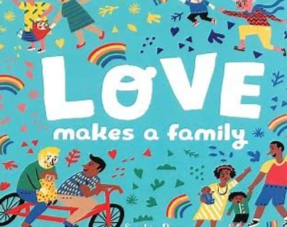  Here we are by Oliver Jeffers  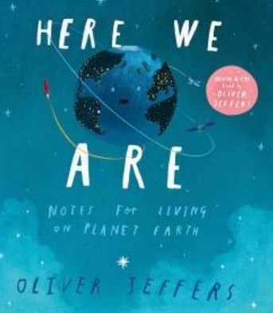  The Tree by Britta Teckentrup  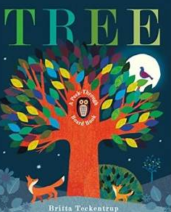 | Room on a Broom by Julia Donaldson  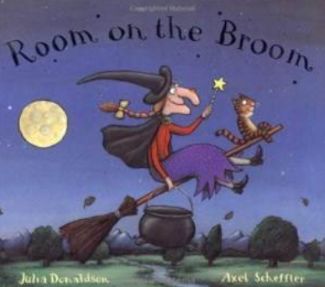  Lost and Found by Oliver Jeffers  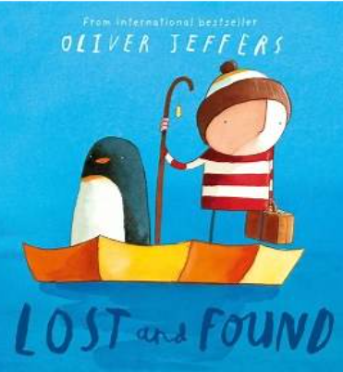  The Christmas Story  The Jolly Postman by Allan Ahlberg  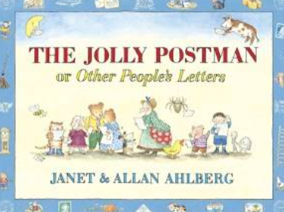 |  | Book Trust Focus – We’re Going to Find a Monster by Malorie Blackman  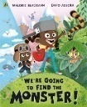  The Great Race  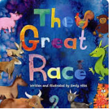  Whatever Next by Jill Murphy  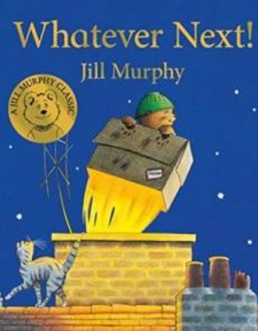  How to catch a star by Oliver Jeffers  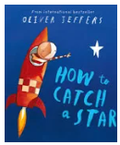  Meet the Planets by Caryl Hart  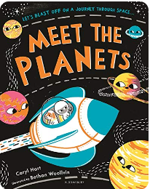 | Farmer Duck by Martin Waddell  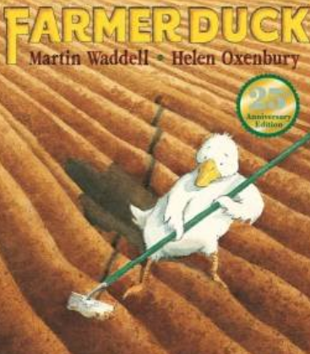  The Tiny Seed by Eric Carle  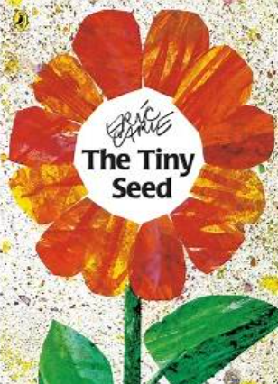  The Runaway Pea by Kjartan Poskit  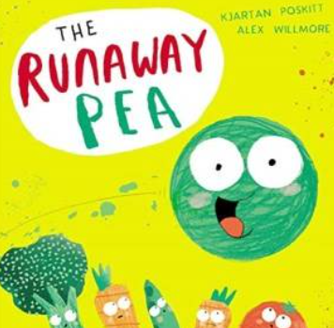 | Where the Wild things are by Maurice Sendak  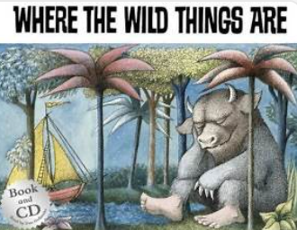  The King’s Pants, by Nicholas Allen  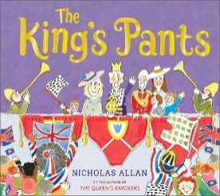  King Charles III Coronation Paperback book by Andrea Mills,  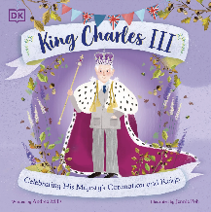 |  | The Foggy, Foggy Forest by Nick Sharrott  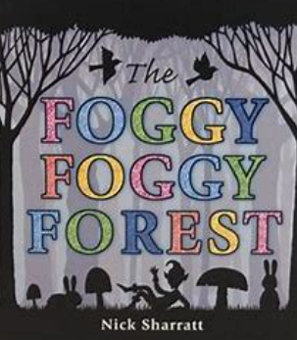  George and the Dragon by Chris Wormell  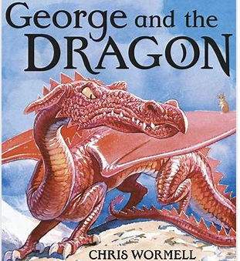  Anansi the Spider by Gerald McDermott  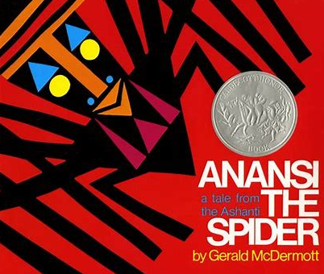
Literacy  Repeated Texts  (Fiction, Poem, non-fiction) | Wow said the Owl by Tim Hopgood  Brown Bear, Brown Bear, What Can you See? By Eric Carle  Aliens love Underpants by Clare Freedman  Five Minutes Peace by Jill Murphy  Squirrels who Squabble by Rachel Brigh | Owl Babies by Martin Waddell, Mr Grumpy’s Motor Car by John Burningham, Duck in the Truck by Jez Alborough, Naughty Bus by Jan and Jerry Oke |  | Beegu by Alexis Deacon, Look up! By Nathan Bryon, The Marvellous Moon Map by Teresa Heapy and David Litchfield, ,Man on the Moon by Simon Bartram, Meet the planets by Caryl Hart | Oliver’s Vegetables by Vivian French, Jack and the Beanstalk, The Hungry Caterpillar by Eric Carle, Jasper’s Beanstalk, Monkey Puzzle by Julia Donaldson | The Queen’s Hat by Steve Anthony  The Queen’s Knickers by Nicholas Alan  King Charles, Matt Hunt, Maria Isabel Sanchez Vegara |  | Greek Myths  Aesop’s Fables, Return by Aaron Becker, Billy and the Dragon by Nadia Shireen, The Paper Bag Princess by Robert Munsch
Deliberate  Teaching of new language | Head, shoulders, arms, knees, hands, feet, ankles, wrists, elbows, knuckles, fingers, fingernails, ears, eyes, nose, bones, muscles, skin, brain, skull, sensory, deaf, blind. baby, toddler, teenager, adult, elderly, mother, mum, father, dad, sister, brother, cousin, aunt, uncle, grandmother, grandfather, stepmother (mum), step father (dad), step brother, step sister. | Transport, journey, vehicle, distance, bus, car, train, taxi, tram, ferry, plane, danger, safety, rules, North Pole, South Pole, Equator, Arctic, Antarctic, endurance, dangerous, challenging.  Transport, roads, tuk-tuk, Thailand, Bullet Train, Japan, miles per hour, tracks, sailing boat, ship, car ferry, container ship, sailor, captain, gondola, gondolier, canal, river, sea, ocean, horse and cart, carriage, motor, penny farthing, astronaut, past, present, future. steam, coal, power, chimney, funnel, Rocket, speed, railway, wheels, axle, turn, move. |  | Earth, planet, land, ocean, gravity, sun, daylight, night time, orbit, astronomer, telescope, comets, stars, planets, rocket, shuttle, astronaut, space suit, space boots, helmet, gravity, oxygen, scientists, telescopes, gravity, Mercury, Venus, Earth, Mars Jupiter, Saturn, Uranus, Neptune, galaxy, solar system, distance, constellation. | Spring, summer, autumn, winter, sun, snow, wind, rain, warmth.  Seed, soil, seedling, plant, grow, water, light, wilt, Deciduous, evergreen, spring, summer, autumn, winter, leaves,  Recap from Nursery: Cow (calf), pig (piglet), bird (chick), Dog (puppy), Cat (kitten)  New: Horse/foal Chicken/chick Duck/duckling Goose/gosling Hedgehog/ hoglet Change, grow, caterpillar, cocoon, transform, butterfly, (metamorphosis), Plant, vegetable, fruit, ground, crops, farmer, harvest Farm, tractor, field, harvest, crops, seeds, Various types of jobs. | Queen, King, Commonwealth, United Kingdom, crown, throne, Union Jack, Royal Standard, flag, throne, crown, family tree, cypher, Buckingham Palace, Palace, castle, Royal Standard, Architect, design. King’s Guard, protect, ceremony, uniform, bearskin hat, march, coronation, orb, sceptre, ceremony, oath, Westminster Abbey, sovereign, ceremony, army, ships |  | Fairytale, fiction, hero, problem, imagination, past. Storytellers, imagination, retell, problem, solve, magic. Legend, brave, true, myth, explain, storyteller, lessons, learn, mistakes, hare, tortoise, race, steady. Aesop’s Fables, (key words inc. animals from the chosen fable), Folk Tales, West Africa, wise, mischievous, falcon, Name. Character, wise, mischievous,
Maths  Arc Maths | Early Mathematical Experiences  Pattern and early number | Numbers within 6  Addition and Subtraction within 6  Measures  Shape and sorting | Numbers within 10  Calendar and time  Addition and subtraction within 10  Grouping and sharing  Numbers within 15  Grouping and sharing |  | Number patterns within 15  Doubling and halving  Shape and Pattern | Securing addition and subtraction facts  Number patterns within 20  Number patterns beyond 20 | Money  Measures  Exploration of patterns within number
Provision and provocations linked to the theme:
Small World | Woodland forest and Autumn animals | Transport – train track and roads  Lost and Found – Winter wonderland | The surface of the moon, rocket, space ship  Chinese New Year – linked to story. River, animals etc |  | Farm – linked to Farmer duck story.  Small world house – linked to Runaway pea | Wild things setting – island, bedroom, boat etc  Castle | Using a range of different animals and landscape settings linked to the text. Children will have n influence on creating the setting for the small world and create the landscape.
Creative | Explore use and refine a variety of artistic effects to express their ideas and feelings.  Creating 3D pictures using a range of Autumn items e.g. conkers, cones, leaves etc  Leaf rubbing to explore the structure of leaves and choosing the colours based on Autumn colours and changes. | Return to and build on their previous learning, refining ideas and developing their ability to represent them.  Painting:  Colour mixing – exploring different shades of secondary colours  Brush strokes – selecting the appropriate size brush to paint details | Safely use and explore a variety of materials, tools and techniques, experimenting with colour, design, texture, form and function.  Wax pictures with paint wash – winter snowflakes  Using fine brushes and various tools to draw fine lines and flowers – Blossom pictures  Pastel drawings and blending – planets  Creating light sabers (space theme) using various materials. |  | Safely use and explore a variety of materials, tools and techniques, experimenting with colour, design, texture, form and function.  Creating flowers using a range of different materials  Creating cards for Mother’s day – linked to Science, parts of a plant  Observational drawings of flowers to include the various parts of the flower learnt about during science. | Safely use and explore a variety of materials, tools and techniques, experimenting with colour, design, texture, form and function.  Share their creations, explaining the process they have used. Make use of props and materials when role playing characters in narratives and stories.  Using a range of different materials to create crowns, clothing. Link with Coronation Day. | Safely use and explore a variety of materials, tools and techniques, experimenting with colour, design, texture, form and function.  Share their creations, explaining the process they have used. Make use of props and materials when role playing characters in narratives and stories.  Using junk materials making 3D creatures from texts or own imagination.  Creating 3D landscapes for small world.
Role Play | Home corner | Home corner with outside garden  South pole base station  Jolly Christmas Postman post office and wrapping station |  | Linked to Book trust text – A den  Home corner –enhance with letters to astronaut, post cards from space on wall. Writing to the astronaut  Fantasy role play: space station | Farm shop in Sun Stream  Outside – Create digging area to role play farm.  Home corner enhanced to link with Farmer Duck. | Royal household – home corner  Theme role play linked with Coronation – Westminster Abbey.  Castle |  | Fantasy – a forest area that develops and is enhanced with props and links to key text.  Home corner – bring outside in creating a fantasy tree house
Physical Development  Handwriting  Gross and Fine Motor / Health and Safe Care  Within provision  (See PE for specific PD skills and development) | Revise and refine the fundamental movement skills they have already acquired:  - Rolling  - Crawling  - Walking  - Jumping  - Running  - Hopping  - Skipping  - Climbing  Develop their small motor skills so that they can use a range of tools competently, safely and confidently.  Suggested tools: pencils for drawing and writing, paintbrushes, scissors, knives, forks, spoons.  Be increasingly independent in meeting their own care needs. E.g. Brushing teeth, using the toilet, washing and drying their hands thoroughly. | Confidently and safely use a range of large and small apparatus indoors and outside, alone and in a group.  Make healthy choices about food, drink, activity and tooth brushing. |  | Use their core muscle strength to achieve a good posture when sitting at a table or sitting on the floor.  Combine different movements with ease and fluency.  Linked to space, dance movements and control.  Develop the foundations of a hand writing style which is fast, accurate and efficient.  Further develop the skills they needs to manage the school day successfully:  - Lining up and queuing  - Mealtimes  - Personal; hygiene | Progress towards a more fluent style of moving, with developing control and grace.  Know and talk about the different factors that support their overall health and wellbeing:  - Regular physical activity  - Healthy heating  - Tooth brushing  - Sensible amounts of ‘screen time’  - Having a good sleep routine  - Being a safe pedestrian | Further develop and refine a range of ball skills including: throwing, catching, kicking, passing, batting and aiming.  Negotiate space and obstacles safely, with consideration for themselves and others.  Hold a pencil effectively in preparation for fluent writing – using the tripod grip in almost all cases.  Use a range of small tools, including scissors, paintbrushes and cutlery. |  | Develop the overall body strength, co-ordination, balance and agility needed to engage successfully with future physical education sessions and other physical disciplines including dance, gymnastics, sport and swimming.  Demonstrate strength, balance and coordination when playing.  Develop confidence, precision and accuracy when engaging in activities that involve a ball.  Move energetically, such as running, jumping, dancing, hopping, skipping and climbing.  Begin to show accuracy and care when drawing
Communication & Language  Listening, Attention and Understanding  Speaking | Understand how to listen carefully and why listening is important.  Learn new vocabulary.  Engage in story times  Use new vocabulary through the day. | Listen carefully to rhymes and songs, paying attention to how they sound.  Engage in non-fiction books.  Articulate their ideas and thoughts in well-formed sentences.  Connect one idea or action to another using a range of connectives. |  | Share their understanding and familiarity of stories they know well.  Learn rhymes, poems and songs.  Listen to and talk about selected non-fiction to develop deep familiarity with new knowledge and vocabulary.  Develop social phrases.  Use new vocabulary in different contexts. | Developing the skills to ask their own questions to check their understanding.  Retelling stories, once they have developed a deep familiarity with the text; some as exact repetition and some in their own words.  Describe events in some detail.  Use talk to help work out problems and organise thinking and activities, and to explain how things work and why them might happen. | Listen attentively and respond to what they hear with relevant questions, comments and actions when being read to and during whole class discussions and small group interactions.  Participate in small group, class and one-to-one discussions, offering their own ideas, using recently introduced vocabulary. |  | Hold conversation when engaged in back-and-forth exchanges with their teacher and peers.  Make comments about what they have heard and ask questions to clarify their understanding.  Express their ideas and feelings about their experiences using full sentences, including use of past, present and future tenses and making use of conjunctions, with modelling and support from their teacher.  Offer explanations for why things might happen, making use of recently introduced vocabulary from stories, non-fiction, rhymes and poems when appropriate.
Reading | Develop their phonological awareness to:  - Spot rhymes in familiar stories and poems.  - Count or clap syllables in a word.  - Recognise words with the same initial sound.  Begin to read individual letters by saying the sounds for them.  Begin to blend sounds into words, so that they can read short words made up of known letter– sound correspondences.  Begin to read CVC words containing known letter-sound correspondences.  Asks questions about stories.  Repeat words and phrases from familiar stories.  Repeat new vocabulary in a context of a story.  Has favourite books and seeks them out, to share with an adult, with another child, or to look at alone. |  |  | Develop their phonological awareness to:  - Able to complete a rhyming string.  - Begin to sound buttons to identify how many sounds are in a word.  - Can supply words with the same initial sound for phase 2 single sounds.  Recognise all taught Set 1 – Set 5 sounds, including some digraphs.  Re-read phonetically decodable books to build up their confidence in word reading, their fluency and their understanding and enjoyment.  Blend sounds into words, so that they can read short words made up of known letter– sound correspondences.  Read simple sentences containing known letter-sound correspondences containing 1 or 2 common exception words.  Answer questions about a text that has been read to them.  Begin to predict what might happen next in a story.  Begin to use modelled vocabulary during role play for example in the Small World.  Seeks familiar texts or stories to re-read in the book area. Requests favourite stories and poems for example during Vote for a story. |  | Develop their phonological awareness to:  - Recognise and use rhyme in daily conversation.  - Use sound buttons to segment and read words.  - Can identify words containing the same digraph or trigraph e.g. ay- may, day, play.  ELG Reading  Say a sound for each letter in the alphabet and at least 10 diagraphs  ELG Reading  Read words consistent with their phonic knowledge by sound-blending.  ELG Reading  Read aloud simple sentences and books that are consistent with their phonic knowledge, including some common exception words.  Can share a favourite book with a peer, retelling the story in their own way repeating known phrases from the text.  ELG Comprehension  Demonstrate understanding of what has been read to them by retelling stories and narratives using their own words and recently introduced vocabulary.  ELG Comprehension  Anticipate – where appropriate – key events in stories.  ELG Comprehension  Use and understand recently introduced vocabulary during discussions about stories, non-fiction, rhymes and poems and during role-play.
Writing | Form lowercase letters and capital letters correctly  Spell words by identifying the sounds and then writing the sound with letter/s.  Copy full name from a name label.  Physical Development  Use a range of small tools competently and confidently. Suggested tools: pencils, paint brushes, scissors and knives. |  |  | Write short sentences with words with known sound- letter correspondences, using a capital letter and a full stop.  Begin to use capital letters, finger spaces and full stops in independent writing.  Begin to use capital letters, finger spaces and full stops in independent writing.  Physical Development  Develop the foundations of a handwriting style which is fast, accurate and efficient.  Begin to use tripod grip. |  | Use a capital letter at the beginning of a sentence and a full stop at the end.  Use finger spaces most of the time.  Is able to write their first name and starting to write their surname independently.  ELG Writing  Write recognisable letters, most of which are correctly formed.  ELG Writing  Spell words by identifying sounds in them and representing the sounds with a letter or letters.  ELG Writing  Write simple phrases and sentences that can be read by others.  ELG Fine Motor  Hold a pencil effectively in preparation for fluent writing.  Using the tripod grip in almost all cases.
UNDERSTANDING THE WORLD – Links to support transition into National Curriculum
Science  Working  Scientifically | Ourselves- My body Seasons- Autumn  Signs of autumn  -look at conkers, leaves, acorns, pinecones  -Changes in weather | Seasons- Autumn  British Wildlife  What are things made off?  Woodland animals & habitats  Understand where different things grow, e.g. pumpkins |  | Seasons- Winter  Space, solar system, stars, planets, universe, beyond our universe. | Growing and changing  Seasons – Spring  Plants – labelling the different parts, what they need to grown  Different types of plants – plants that we eat and plants we don’t. |  |  | Seasons – Summer  Woodlands and forests – who lives there and the types of plants and trees that make up a forest.  Which creatures / minibeasts live in these areas.
Computing | Busy Things - | Busy Things |  | E- Safety | E-safety | Bee-bots
Geography | Draw information from a simple map.  My classroom and my school  Name and locate different parts of the local community around them  -Focus on Hexthorpe  Throughout Reception children will use different types of maps to explore their local environment and places of significance to them, | Explore the natural world around them.  Seasonal Change  My Home  Using the local area to explore the natural and built environment |  | Recognise some environments that are different to the one in which they live.  Know some similarities and differences between the natural world around them and contrasting environments, drawing on their experiences and what has been read in class.  Link to space and different planets. Compare to earth and our environment. | Describe their immediate environment using knowledge from observation, discussion, stories, non-fiction texts and maps.  Know some similarities and differences between the natural world around them and contrasting environments, drawing on their experiences and what has been read in class.  Understand some important processes and changes in the natural world around them, including the seasons and changing states of matter.  Comparing our urban environment to that of a farm and the countryside. |  |  | Know some similarities and differences between the natural world around them and contrasting environments, drawing on their experiences and what has been read in class.  Compare and contrast with urban area that we live in.
History  Past and Present | Comment on images of familiar situations in the past. | Compare and contract characters from stories, including figures from the past.  Talk about Ernest Shackleton and his polar exploration  Past and present – transport over time |  | Recognise that people have different beliefs and celebrate different times in different ways.  How people past and present celebrate Chinese New Year |  | Know some similarities and differences between things in the past and now, drawing on their experiences and what has been read in class. Understand the past through settings, characters and events encountered in books read in class and storytelling.  Link with the Coronation, the history of the royal family and how the crown is passed down through the generations.
People, cultures & communities | Talk about members of their immediate family and community.  Name and describe people who are familiar to them.  Harvest  My Birthday  Talk about members of their immediate family and community  • Name and describe people who are familiar to them • Recognise the differences between themselves and their friends (appearance, likes/dislikes, families) | Recognise that people have different beliefs and celebrate different times in different ways.  Christmas  Talk about how people celebrate Christmas around the world  • Talk about the features of different celebrations for different faiths  • Know why different people celebrate different things |  | Recognise that people have different beliefs and celebrate different times in different ways.  Chinese New Year  Find out about how Chinese New Year is celebrated around the world including the UK | Recognise that people have different beliefs and celebrate different times in different ways.  Easter  Listen to the Christian story of Easter. Discuss the features of the celebration and how people celebrate in different ways. | Special places  Westminster, Buckingham palace, Windsor Castle – linked to the Royal coronation and family.
EXPRESSIVE ART AND DESIGN – Links to support transition into National Curriculum
Art | Explore use and refine a variety of artistic effects to express their ideas and feelings.  Leaf rubbing to explore the structure of leaves and choosing the colours based on Autumn colours and changes. | Return to and build on their previous learning, refining ideas and developing their ability to represent them.  Painting:  Colour mixing – exploring different shades of secondary colours  Brush strokes – selecting the appropriate size brush to paint details |  | Safely use and explore a variety of materials, tools and techniques, experimenting with colour, design, texture, form and function.  Wax pictures with paint wash – winter snowflakes  Using fine brushes and various tools to draw fine lines and flowers – Blossom pictures  Pastel drawings and blending – planets | Safely use and explore a variety of materials, tools and techniques, experimenting with colour, design, texture, form and function.  Creating flowers using a range of different materials  Creating cards for Mother’s day – linked to Science, parts of a plant  Observational drawings of flowers to include the various parts of the flower learnt about during science. | Safely use and explore a variety of materials, tools and techniques, experimenting with colour, design, texture, form and function.  Share their creations, explaining the process they have used. Make use of props and materials when role playing characters in narratives and stories.  Using a range of different materials to create crowns, clothing. Link with Coronation Day. |  | Safely use and explore a variety of materials, tools and techniques, experimenting with colour, design, texture, form and function.  Share their creations, explaining the process they have used. Make use of props and materials when role playing characters in narratives and stories.  Using a range of materials create fantasy creatures and settings
Design and Technology | Creating 3D pictures using a range of Autumn items e.g. conkers, cones, leaves etc | Post office role play – Wrapping parcels, fitting objects in boxes and adapting to fit. |  | Creating light sabers (space theme) using various materials. |  | Joining materials in different ways |  | Joining materials in different ways.
Music | Listen attentively, move to and talk about music, expressing their feelings and responses.  Learning Christmas songs and performing to parents. |  |  | Sing in a group or on their own, increasingly matching the pitch and following the melody.  Explore and engage in music making and dance, performing solo or in groups. |  | ELG Being Imaginative and Expressive  Sing a range of well-known nursery rhymes and songs.  Perform songs, rhymes, poems and stories with others, and (when appropriate) try to move in time with music.
PHYSICAL DEVELOPMENT – Links to support transition into National Curriculum
Physical Education |  |  |  | Pupils will respond to words and music using their bodies and props. Pupils will explore movements such as creeping, tiptoeing and hiding as they try becoming different characters. | Pupils will explore walking using different body parts in different directions, at different levels and at different speeds. Pupils will learn how to apply their walking skills into games. | Pupils will explore moving with a ball using their feet. Pupils will develop their technique of dribbling the ball and understand where and |  | Pupils will explore different ways of using our hands to move with a ball, keeping control. Pupils will explore rolling, pushing and bouncing a ball with a partner.
PERSONAL, SOCIAL, EMOTIONAL DEVELOPMENT – Links to support transition into National Curriculum
PSED | Staying Safe:  Identifying risks to keep ourselves and others safe  Understand that rules help to keep ourselves and others safe | Keeping/Staying Healthy:  Develop an understanding of the importance of making healthy choices  Relationships Managing friendships and social interaction  Being aware of our own needs and having empathy for our understanding of others |  | Being Responsible:  Understand that sometimes we have to do things that we don’t like doing  Developing a sense of responsibility  Computer and Online Safety:  Understand the risk and how to stay safe when using technology | Feelings and Emotions:  Understanding emotions  Develop strategies for managing feelings  Understand that it is ok to ask for help | Our World:  Understand similarities and differences  Identify people who help us in our local community  Respecting the local environment |  | Change and Transition:  Building confidence  Managing changes at home
Religious Education |  | Traditions- Christmas- Nativity Story |  | Traditions-  Chinese New Year | Traditions-Easter Story
Visits and Visitors |  |  |  |  |  |  |  | Visit to RSPB – Old Moor

