Hexthorpe Primary DT Intent, Implementation and Impact Statements

Intent

At Hexthorpe, our Design and Technology curriculum is an inspiring, rigorous and practical subject. Design and Technology encourages children to learn and think creatively to solve problems. We encourage children to use their creativity and imagination, to design and make products that solve real and relevant problems. We aim to link work to other subjects such as mathematics, science, engineering, computing and art. We aim to inspire our children to be engineers, designers, chefs and architects.

Implementation

In order to successfully implement a knowledge-rich curriculum that meets the needs of all learners we teach the National Curriculum through a bespoke curriculum, supported by a clear skills and knowledge progression. This ensures that skills and knowledge are built on year by year and sequenced appropriately to maximise learning for all children. All teaching of DT should follow the design, make and evaluate cycle. Each stage should be rooted in technical knowledge. The design process should be rooted in real life, relevant contexts to give meaning to learning. While making, children should be given choice and a range of tools to choose freely from. To evaluate, children should be able to evaluate their own products against design criteria. Each of these steps should be rooted in technical knowledge and vocabulary ensuring our learners see the world through a designer’s eyes.

Impact

The impact of this bespoke, knowledge-rich and carefully sequenced design and technology curriculum will enable all children to become critical thinkers, know how to take risks, become resourceful, innovative, enterprising and capable citizens. We aim to develop skills and attributes they can use beyond school and into adulthood, ensuring they are able to take care of themselves in an ever-changing world.

 | EYFS | Year 1 | Year 2 | Year 3 | Year 4 | Year 5 | Year 6
Autumn 1 | All about me  PD – Fine motor  Small tools; cutlery, tweezers, pipettes, scissors. Cutting paper, card, fabric, tracing, using templates, playdough  Creating 3D pictures  Communication and Language  Understand use of objects and tools in the classroom | Structures  To begin to build structures, joining components together to create a finished product  - house  Exploring joining and stability  END OUTCOME: Make a free-standing house with opening window/door. Reflect and evaluate. | Mechanisms  Explore and use winding mechanisms. Begin to incorporate wheels and axles into their products.  Make a breaking mechanism for a train - Primary Engineer Project.  END OUTCOME: Make a model car with a moving mechanism. Reflect and evaluate. | Mechanisms  Begin to understand that mechanical systems such as levers and linkages can create movement. Begin to incorporate levers and linkages into their products.  END OUTCOME: Make a poster linked to recycling using more than one lever/linkage. Reflect and evaluate. | Textiles  To use a pattern and make a prototype of a product. Sewing skills are to become more accurate. To join fabrics using a range of stitches with increasing independence. They learn how to add further decoration to their work using buttons, beads, sequins etc  To learn how to add lettering to their product –  Design, make, evaluate a cushion  END OUTCOME: Make own cushion. Reflect and evaluate. | Food  As designers, scale up or down a recipe, having accurately calculated ratios and carefully measured ingredients.  To understand that seasons may affect the food available. To understand how food is processed into ingredients that can be eaten or used in cooking. Gain confidence in the skills of peeling, chopping, slicing, grating, mixing, kneading and baking.  Global food recipes  END OUTCOME: Making quesadillas with guacamole dip – taste, reflect and evaluate. | Mechanism  To understand how mechanical systems such as cams create movement. Design and make a product that incorporates a cam mechanism.  END OUTCOME: Make a mechanical toy. Evaluate and reflect
Autumn 2 | Transport  PD – Fine motor  Small tools; cutlery, tweezers, pipettes, scissors  EAD – Creating with materials  Cutting: snowflake design
Spring 1 | Space  PD – fine motor  Small tools; cutlery, tweezers, pipettes, scissors  EAD – Creating with materials  Puppets: Chinese New Year | Mechanisms  Exploring levers  Begin to explore and use simple mechanisms, e.g. use sliders in moving pictures  END OUTCOME: Magic bed moving poster using sliders and levers. Reflect and evaluate. | Textiles  To cut out shapes which have been created by a template onto the fabric. Children begin to sew using a range of basic stitches: running stitch and back stitch  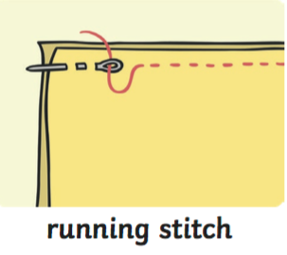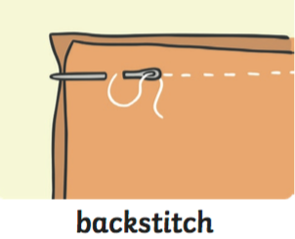  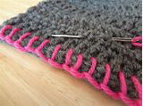  blanket stitch  joining two pieces of felt together using running stitch, back stitch or blanket stitch.  END OUTCOME: Make flag (Scotland/UK). Reflect and evaluate. | Food  Follow a recipe, using appropriate utensils and measuring skills to prepare a savoury food.  To begin to know that foods is grown (such as tomatoes, wheat and potatoes), reared (such as pigs, chickens and cattle) and caught (such as fish) in the UK, Europe and the wider world.  To be able to use a range of techniques such as peeling, chopping, slicing and grating.  END OUTCOME: Make pizza rolls. Reflect and evaluate.  Plant and grow seeds (food) in science. | Food  Follow a recipe, using appropriate utensils and measuring ingredients to the nearest gram accurately in order to prepare food.  To understand that food is grown and caught in the UK, Europe and the wider world. Understand how to prepare and cook a variety of savoury dishes safely and hygienically.  To further develop skills including mixing, kneading and baking.  END OUTCOME: Make own savoury breads – ‘Bake Off’ style competition for SLT to judge. | Structures  Build innovative functional, appealing structures that are fit for purpose. Evidence how structures can be made stronger and more stable.  Use finishing techniques to strengthen and improve their appearance of their models.  END OUTCOME: build stable, free-standing marble run structure. Reflect and evaluate. | Textiles  To pin and tack fabric pieces together. They join fabric by over sewing, back stitch, blanket stitch and running stitch.  Children are to make quality products using increased accuracy and independence. Reflect and evaluate.  To design and make a phone case  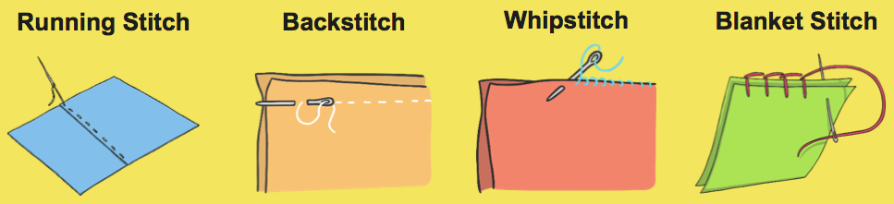  END OUTCOME: Make own pencil case/pouch
Spring 2 | Growing and Changing  PSED  Healthy diets to help us grow; what we need to eat, how we look after our bodies and keep ourselves clean.  PD – Fine motor  Small tools; cutlery, tweezers, pipettes, scissors. Cutting shapes e.g. spirals
Summer 1 | Foundation 2  Kings and Queens  PD – Fine motor  Small tools; cutlery, tweezers, pipettes, scissors. Cutting shapes e.g. spirals | Food.  Assemble ingredients to prepare food using simple tools to cut, peel or grate safely and hygienically  Combining seasonal foods  To understand which foods come from plants or animals. Begin to develop children’s peeling and chopping skills.  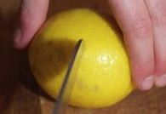  the bridge  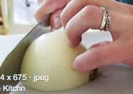  the claw  Dips and Dippers  END OUTCOME: Make a potato salad with celery and carrot sticks as dippers. Reflect and evaluate. | Food  Prepare food safely and hygienically, measuring and weighing ingredients using measuring cups and scales.  To know that food has to be farmed, grown elsewhere(home) or caught.  To understand how to name and sort foods into the five groups in the ‘The Eat well plate’.  Begin to use techniques such as cutting, peeling and grating  the bridge  the claw  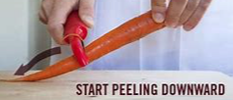  peeling  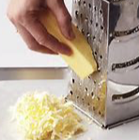  grating  END OUTCOME: Make a salad. Reflect and evaluate. | Structures  Build structures with increasing independence. Demonstrate an understanding of how they can be made stronger and more stable.  Explore vocabulary:  Girder  Rafter  Strut  kites  END OUTCOME: Build and fly own kite Reflect and evaluate. | Mechanism  With increased independence produce a model that incorporates an electrical circuit that switches on a light – design and make a torch  END OUTCOME: make own torch. Reflect and evaluate. | Mechanism  To understand how mechanical systems such as cams create movement. Design and make a product that incorporates gears mechanism and an electrical motor –  Primary Engineer Project  END OUTCOME: Design a train that will run along the tracks and stop at the correct place. Reflect and evaluate. | Food  Create and refine recipes that demonstrate a range of cooking and baking techniques, applying previously learned skills.  To use their knowledge and skills to prepare and cook dishes  To know how to keep food safely and be aware of best before and use by dates.  To become increasingly skilled at peeling, chopping, slicing, grating, mixing, kneading and baking.  END OUTCOME: Following WWII recipes to make a range of dishes to share with parents.
Summer 2

