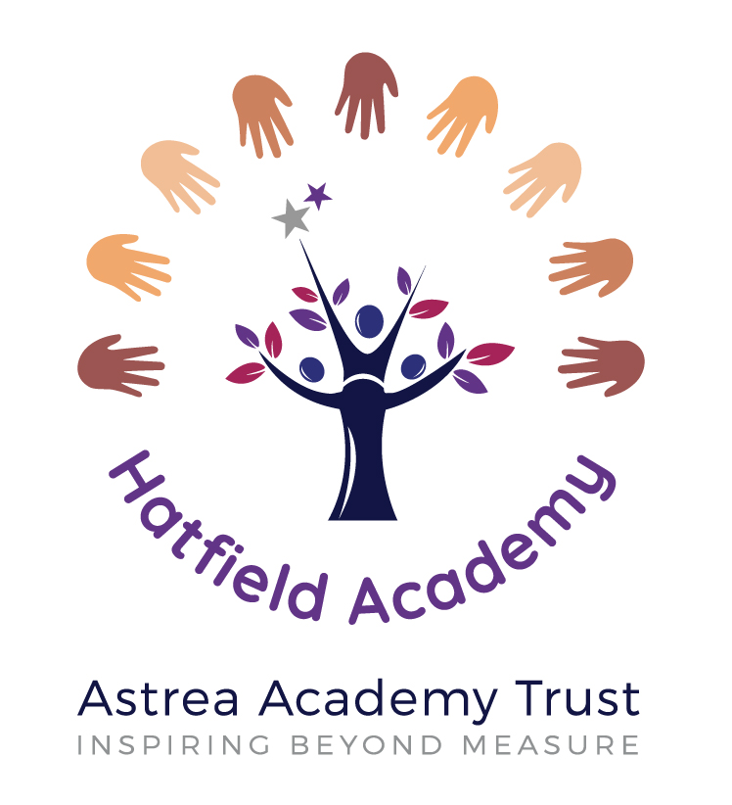

**Personal Social Health Education Policy**

**2021-2022**

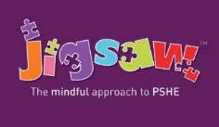

**Jigsaw Personal, Social, Health Education Policy including**

**Relationships and Health Education**

|  |  |
| --- | --- |
| Name of school | Hatfield Academy |
| Date of policy | September 2021 |
| Member of staff responsible | Katy Richards |
| Review date | July 2022 |

**Introduction**

All schools must provide a curriculum that is broadly based, balanced and meets the needs of all pupils. Under section 78 of the Education Act 2002 and the Academies Act 2010, a Personal Social Health Education including Relationships and Health Education curriculum:

• Promotes the spiritual, moral, cultural, mental and physical development of pupils at the school and of society, and

• Prepares pupils at the school for the opportunities, responsibilities and experiences of later life.

The Relationships Education, Relationships and Sex Education and Health Education (England) Regulations 2019, made under sections 34 and 35 of the Children and Social Work Act 2017, make Relationships Education compulsory for all pupils receiving primary education and Relationships and Sex Education compulsory for all pupils receiving secondary education. They also make Health Education compulsory in all schools except independent schools. Personal, Social, Health and Economic Education continues to be compulsory in independent schools.

**Rationale**

The purpose of the Personal Social Health Education including Relationships and Health Education curriculum is to provide all pupils with opportunities to:

• Develop confidence and responsibility and make the most of their abilities

• Prepare to play an active role as citizens through developing skills for living and valuing themselves and respecting others

• Develop a healthy lifestyle

• Contribute to their community and the wider world and becoming morally and socially responsible

• Develop good relationships and respect the differences between people.

**Vision**

Personal, Social, Health Education enables children to become healthy, independent and responsible members of society. We encourage our pupils to play a positive role in contributing to the life of the school and the wider community. In so doing we help develop their sense of self-worth. We teach them how society is organised and governed. We ensure that they experience the process of democracy in school through the school council. We teach them about rights, respect and responsibilities. They learn to appreciate what it means to be a positive member of a diverse multicultural society.

**Aims and Objectives**

The aims and objectives of learning Personal Social Health Education including Relationships and Health Education:

• Help children develop lively, enquiring minds, to acquire knowledge and develop the skills of communication and information handling which equip them for adult life.

• Help children to appreciate and be concerned about their environment and understand the interdependence of individuals, groups and nations.

• Help children achieve self-discipline and commitment so that they reach the highest standards of which they are capable.

• Encourage children to develop creativity and expression.

• Encourage children to take an active and responsible role in their learning.

**What is Personal, Social, Health Education?**

Personal Social Health Education encompasses all areas designed to promote children’s personal, social, health and economic development. It gives children the knowledge, skills and understanding that they need to stay healthy and safe, develop worthwhile relationships, respect differences, develop independence and responsibility, and make the most of their own abilities and those of others. Additionally, children will come to appreciate difference and diversity.

Personal Social Health Education is very closely linked to Social, Moral, Spiritual and Cultural development (SMSC). Explicit opportunities to promote pupils' development in these areas are provided in framework for personal, social and health education and citizenship.

We believe that Personal Social Health Education is central to the educational entitlement of all of our children. Although it will be taught in part through discreet lessons, elements of Personal Social Health Education permeate all aspects of school life. During Key Stages 1 and 2, learners gradually build on the skills, attitudes and values, knowledge and understanding they have started to acquire and develop during the Early Years/Foundation Stage.

Personal Social Health Education offers learning opportunities and experiences which reflect the increasing independence and physical and social awareness of learners as they move through the primary phase. They learn skills to develop effective relationships assume greater personal responsibility and keep themselves safe. It is important to remain flexible as events such as bereavement might require learning to be drawn from Key Stage 2 into Key Stages 1. Personal Social Health Education assists pupils to cope with the changes at puberty, introduces them to a wider world and enables them to make an active contribution to their communities.

At Hatfield Academy we have chosen to deliver Personal, Social, Health Education (including Relationships Education and Health Education) using Jigsaw, the mindful approach to Personal Social Health Education.

**What is Relationships Education?**

Relationships Education is about the emotional, social and cultural development of pupils, and involves learning about positive relationships, sexuality, healthy lifestyles, diversity and personal identity.

Relationships Education involves a combination of sharing information and exploring issues and values.

Relationships Education is not about the promotion of sexual activity.

Relationships Education, Health Education, and Science Education work together to protect children by ensuring they have knowledge of their bodies, the human life-cycle, emotions, acceptable behaviour and right and wrong.

Effective Relationships Education can make a significant contribution to the development of the personal skills needed by pupils if they are to establish and maintain relationships. It also enables children and young people to make responsible and informed decisions about their health and well-being.

"The right to education includes the right to sexual education, which is both a human right in itself and an indispensable means of realising other human rights, such as the right to health, the right to information and sexual and reproductive rights." Report to the UN General Assembly - July 2010 | Item 69, paragraph 18.

**Jigsaw Personal Social Health Education including Relationships and Health Education** **Content**

Jigsaw covers all areas of Personal Social Health Education including Relationships and Health Education.

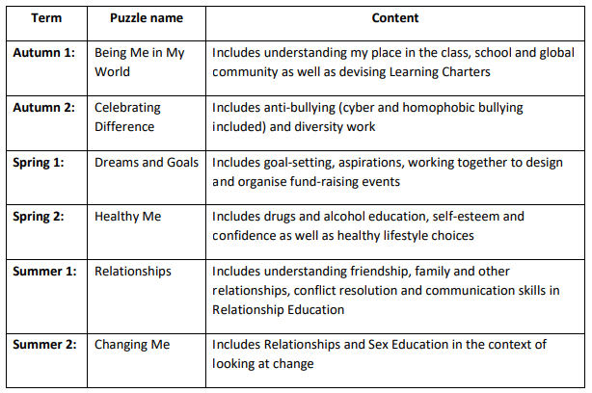

Please refer to the Sex Education policy for further information with regards to the Changing Me Puzzle.

**Objectives/pupil learning intentions within the Jigsaw programme of study:**

Jigsaw Personal Social Health Education including Relationships and Health Education will support the development of the skills, attitudes, values and behaviour, which enable pupils to:

• Have a sense of purpose

• Value self and others

• Form relationships

• Make and act on informed decisions

• Communicate effectively

• Work with others

• Respond to challenge

• Be an active partner in their own learning

• Be active citizens within the local community

• Explore issues related to living in a democratic society

• Become healthy and fulfilled individuals

**Organisation / Provision**

Personal Social Health Education including Relationships and Health Education is delivered within a whole school approach which includes:

* Dedicated curriculum time
* Teaching Personal Social Health Education including Relationships and Health Education through and in other subjects/curriculum areas (e.g. Science, English, History, P.E.)
* Circle Time
* Assemblies
* Personal Social Health Education including Relationships and Health Education activities and school events e.g. Anti Bullying Week, Mental Health Week
* Pastoral care

**Who does the policy apply to?**

The policy applies to:

• The Principal

• All school staff

• The governing body

• Pupils

• Parents/carers

• School nurse and other health professionals

• Partner agencies working in or with the school

• Religious leaders/faith groups

**Key responsibilities for Personal Social Health Education including Relationships and Health Education**

All staff will:

* ensure that they are up to date with school policy and curriculum requirements regarding Personal Social Health Education including Relationships and Health Education
* attend and engage in professional development training around Personal Social Health Education including Relationships and Health Education provision, including individual and whole staff training/inset, where appropriate
* attend staff meetings to be introduced to any new areas of work and review the effectiveness of the approaches used
* report back to the Personal Social Health Education including Relationships and Health Education Coordinator on any areas that they feel are not covered or inadequately provided for in the school’s Personal Social Health Education including Relationships and Health Education provision
* encourage pupils to communicate concerns regarding their social, personal and emotional development in confidence and listen to their needs and support them seriously
* follow the school’s reporting systems if a pupil comes to a member of staff with an issue that they feel they are not able to deal with alone
* ensure that their personal beliefs and attitudes will not prevent them from providing balanced Personal Social Health Education including Relationships and Health Education in school
* tailor their lessons to suit all pupils in their class, across the whole range of abilities, faiths, beliefs and cultures, including those pupils with special educational needs
* ask for support in this from the school SENDCO or the PSHE Led, should they need it

|  |  |
| --- | --- |
| **Specific responsibilities** | **Who is responsible?** |
| Co-ordinating the Personal Social Health Education including Relationships and Health Education provision | Katy Richards (PSHE led and SENCO) |
| Accessing and co-ordinating training and support for staff | Katy Richards (PSHE led and SENCO) |
| Establishing and maintaining links with external agencies/other health professionals | Katy Richards (PSHE led and SENCO) |
| Policy development and review, including consultation | Katy Richards (Principal) |
| Implementation of the policy; monitoring and assessing its effectiveness in practice | Katy Richards (PSHE led and SENCO) |
| Managing child protection/safe guarding issues | Jill Gibson (Designated Safeguarding Lead) |
| Establishing and maintaining links with parents/carers | Katy Richards (Principal) |
| Liaising with the media | Katy Richards (Principal) |

**Pupils**

All pupils:

* should support one another with issues that arise through the teaching of Personal Social Health Education including Relationships and Health Education
* will listen in class, be considerate of other people’s feelings and beliefs, and comply with confidentiality rules that are set in class
* will be made to feel comfortable to talk to a member of staff, in confidence, regarding any concerns they have in school related to Personal Social Health Education including Relationships and Health Education or otherwise
* will be asked for feedback on the school’s Personal Social Health Education including Relationships and Health Education provision termly/yearly and be expected to take this responsibility seriously; opinions on provision and comments will be reviewed by the lead member/s of staff for Personal Social Health Education including Relationships and Health Education and taken into consideration when the curriculum is prepared for the following year’s pupils

**Parents/carers**

The school recognises the key role that parents/carers fulfil in supporting their children through their personal development and the emotional and physical aspects of growing up. Therefore, we seek to work in partnership with parents/carers when planning and delivering Personal Social Health Education including Relationships and Health Education.

The school will encourage this partnership by:

* keeping parents/carers informed about all aspects of the Personal Social Health Education including Relationships and Health Education curriculum, including when it is going to be delivered
* gathering parent /carers’ views on the policy and take these into account when it is being reviewed
* providing access to resources and information being used in class and do everything to ensure that parents/carers are comfortable with the education provided to their children in school through parent workshops/websites
* expecting parents/carers to share the responsibility of Personal Social Health Education including Relationships and Health Education and support their children
* encouraging parents/carers to create an open home environment where pupils can engage, discuss and continue to learn about matters that have been raised through Personal Social Health Education including Relationships and Health Education
* providing support and encourage parents/carers to seek additional support in this from the school where they feel it is needed

**Inclusion and Equal Opportunities**

All pupils, whatever their experience, background and identity, are entitled to quality Personal Social Health Education including Relationships and Health Education that helps them build confidence and a positive sense of self, and to stay healthy. All classes include pupils with different abilities and aptitudes, experiences and religious/cultural backgrounds, gender and sexual identities. To encourage pupils to participate in lessons, teachers will ensure content, approach, and use of inclusive language reflects the diversity of the school community, and helps each and every pupil to feel valued and included in the classroom.

We promote the needs and interest of all pupils. The school’s approaches to teaching and learning take into account the ability, age, readiness and cultural backgrounds of pupils to ensure all can access the full Personal Social Health Education including Relationships and Health Education provision. We promote social learning and expect our pupils to show a high regard for the needs of others. Personal Social Health Education including Relationships and Health Education is an important vehicle for addressing both multicultural and gender issues and ensuring equal opportunities for all.

Inclusive Personal Social Health Education including Relationships and Health Education will foster good relations between pupils, tackle all types of prejudice, including homophobia, and promote understanding and respect, enabling us to meet the requirements, and live the intended spirit, of the Equality Act 2010.

**Ethnicity, religion and cultural diversity:**

Our policy values the different backgrounds of all pupils in school and, in acknowledging and exploring different views and beliefs, seeks to promote respect and understanding. We do not ask pupils to represent the views of a particular religious or cultural group to their peers, unless they choose to do so.

**Special educational needs and learning difficulties:**

We ensure that all pupils receive Personal Social Health Education including Relationships and Health Education and we offer provision appropriate to the particular needs of our pupils, taking specialist advice where necessary. Staff will differentiate lessons to ensure that all members of the class can access the information fully. The school will use a variety of different strategies to ensure that all pupils have access to the same information. Some pupils will be more vulnerable to abuse and exploitation than their peers, and others may be confused about what is acceptable public behaviour. These pupils will need help to develop skills to reduce the risks of being abused and exploited, and to learn what sorts of behaviour are, and are not, acceptable.

**Pupils who are new to English:**

The school should take into account the language skills of individual pupils, ensuring that all pupils have equal access to the Personal Social Health Education including Relationships and Health Education provision and resources.

**Learning environment and ground rules**

Staff are careful to ensure their personal beliefs and opinions do not influence the teaching of Personal Social Health Education including Relationships and Health Education. To this end, ground rules have been agreed to provide a framework of common values within which to teach. There are clear parameters as to what will be taught in a whole-class setting, and what will be dealt with on an individual basis.

If pupils are to benefit fully from a Personal Social Health Education including Relationships and Health Education programme, they need to be confident speakers, good listeners and effective, sensitive communicators. When the needs of pupils are analysed, of overriding importance are two key areas: they need to feel safe and be safe. A set ground rules will help staff to create a safe and relaxed environment in which they do not feel embarrassed or anxious about unexpected questions or comments from the pupils. They also reduce the possibility of inappropriate behaviour and the disclosure of inappropriate personal information.

Our ground rules are:

• We listen to each other.

• We do not say or do anything that would hurt another person.

• We do not use people’s names within an open forum.

• We signal when we want to say something.

• We may say pass.

• If a game involves touch we may sit and watch before making a decision to join in.

We will develop these ground rules through:

• Whole class discussion and these will be displayed during each Personal Social Health Education including Relationships and Health Education session.

**Safeguarding and Child Protection**

Please refer to Hatfield Academy’s Child Protection and Safeguarding policies.

**Confidentiality**

What will the school do in order to minimise the risk of disclosure in a Personal Social Health Education including Relationships and Health Education lesson?

The nature of Personal Social Health Education including Relationships and Health Education means that pupils may disclose personal information that staff will respond to appropriately. The classroom is never a confidential place to talk, and that remains true in Personal Social Health Education including Relationships and Health Education. Pupils will be reminded that lessons are not a place to discuss their personal experiences and issues, or to ask others to do so, through the establishment of ground rules. Any visitor to the classroom will be bound by the school’s policy on confidentiality, regardless of whether they have, or their organisation has, a different policy. We will make sure visitors are aware of this, and make sure there are enough opportunities for pupils to access confidential support after the lesson if they need it.

Any information disclosed to a staff member or other responsible adult, which causes concern about the pupil’s safety, will be communicated to the designated person as soon as possible and always within 24 hours, in line with our safeguarding and child protection policy.

If a pupil tells a health professional, such as the school nurse, something personal on a one-to-one basis outside of the classroom, our school’s confidentiality policy will help us to decide whether that person can keep that information confidential, or whether they need to seek help, advice, or refer to someone else. We will also signpost pupils and their families, where appropriate, to on and offline community, health and counselling services so pupils know where to go for confidential help and advice.

Techniques used in school to minimise the chance of pupils making a disclosure in class include:

• depersonalising discussion

• puppets

• using role play to ‘act out’ scenarios

• appropriate DVDs and TV extracts

• case studies with invented characters

• visits to/from outside agencies

**Support**

We hope that pupils will feel safe in the school environment to talk to any member of staff in confidence about any areas of concern regarding their personal, social and emotional development. We promote the school ethos as one of inclusion and acceptance throughout all areas of school activity and hope that pupils respond to this by feeling comfortable to ask questions and continue their learning both in and outside of the classroom.

**Complaints**

Parents/carers who have complaints or concerns regarding the Personal Social Health Education including Relationships and Health Education provision should contact the school and follow the school’s Complaints policy.

**Review and Monitoring**

The policy will be monitored and evaluated by:

* PSHE Led
* Senior Leadership Team (SLT)

This policy will be reviewed annually.

This Personal Social Health Education including Relationships and Health Education Policy has been informed by existing DfE guidance on:

• **Relationships Education, Relationships and Sex Education (RSE) and Health Education** (February 2019)

• **Preventing and tackling bullying** (Preventing and tackling bullying: Advice for head teachers, staff and governing bodies, July 2013, updated 2017)

• **Drug and Alcohol Education** (DfE and ACPO drug advice for schools: Advice for local authorities, Head Teachers, school staff and governing bodies, September 2012)

• **Safeguarding** (Working Together to Safeguard Children: A guide to inter-agency working to safeguard and promote the welfare of children, March 2013 Keeping Children Safe in Education, 2018)

• **Equality** (Equality Act 2010: Advice for school leaders, school staff, governing bodies and local authorities, revised June 2014). Schools should pay particular attention to the Public sector equality duty (PSED) (s.149 of the Equality Act).

• **Respectful School Communities: Self Review and Signposting Tool** (a tool to support a whole school approach that promotes respect and discipline)

• **Behaviour and Discipline in Schools** (advice for schools, including advice for appropriate behaviour between pupils)

• **SEND code of practice: 0 to 25 years** (statutory guidance)

• **Alternative Provision** (statutory guidance)

• **Mental Health and Behaviour in Schools** (advice for schools)

• **Preventing and Tackling Bullying** (advice for schools, including advice on cyberbullying)

• **Sexual violence and sexual harassment between children in schools** (advice for schools)

• **The Equality and Human Rights Commission Advice and Guidance** (provides advice on avoiding discrimination in a variety of educational contexts)

• **Promoting Fundamental British Values as part of SMSC in schools** (guidance for maintained schools on promoting basic important British values as part of pupils’ spiritual, moral, social and cultural (SMSC)

• **SMSC requirements for independent schools** (guidance for independent schools on how they should support pupils' spiritual, moral, social and cultural development)

• **National Citizen Service** guidance for schools

**Links to other policies**

This Personal Social Health Education including Relationships and Health Education Policy links with other school policies aimed at promoting pupils’ spiritual, moral, social and cultural development, including the following:

• Anti-Bullying Policy

• Behaviour Policy

• Equal Opportunities Policy and Objectives

• Health and Safety Policy

• ICT Policy and Safe Internet Use Policy

• Inclusion Policy

• Religious Education Policy

• Safeguarding/Child Protection Policy

• Sex Education Policy

• SMSC Policy