Uniform Standards
Dear Parents and Carers
As we approach the end of another successful academic year, I would like to take this opportunity to thank you for your continued support and remind everyone of our expectations regarding school uniform for September.
Wearing the correct uniform helps children feel part of our school community, builds confidence, and creates a sense of pride in belonging to Hartley Brook. With your support, we can continue to maintain high standards that help children feel ready to learn and do their very best.
Our uniform is simple and inclusive, helping to reduce distractions so that children can focus on their learning.
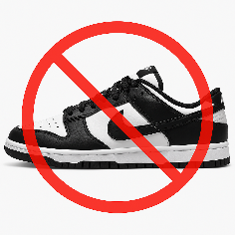
We understand that getting everything in place for the start of term can sometimes be difficult. Please remember we are here to help. We offer support through our Pre-Loved Uniform Shop and can also provide spare uniform on loan if needed. If a child arrives at school in incorrect uniform, we will provide suitable spare clothing from our uniform bank for them to change into. School shoes or trainers must be all black. Nike Dunks are not permitted. From September, we will also have black pumps available in school for children to change into if they are not wearing all-black trainers. If you need any help with uniform, please don’t hesitate to contact the school office.
Please help your child by ensuring they:
- Bring a water bottle every day (no energy drinks)
- Have their name clearly written in all items of uniform
Our full uniform policy is available on the school website and is attached for your reference.
Thank you, as always, for your continued support. It really does make a difference in helping us create a positive, calm, and focused environment where every child can thrive.

Claire Costello
Principal
Hartley Brook Primary Academy

