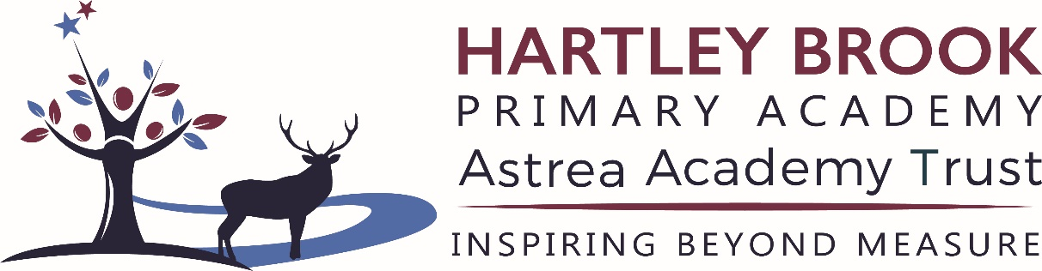

Changes to Free School Meals from September 2026
We want to make families aware of some upcoming changes to Free School Meals (FSM), which may affect pupils from 1 September 2026.

What is changing?
On 8 May 2026, the Department for Education announced changes to how Free School Meals eligibility will work in future, linked to Universal Credit.
These changes will affect:
- Families who currently receive free school meals
- Families who may be eligible but are not currently claiming

Important change to current protections
Since April 2018, once a child became eligible for FSM, they have continued to receive them even if their family’s circumstances changed.
This protection will end at the end of the 2025–26 school year.

Checking eligibility (June to August 2026)
Sheffield City Council will be checking free school meal eligibility for all pupils between:
1 June and 31 August 2026
This applies to:
- Pupils who currently receive FSM
- Families who wish to apply for FSM for the first time

What families need to know
- If a child is confirmed as eligible at the start of the academic year, they will receive free school meals for the whole of the 2026–27 school year, even if circumstances change.
- From 2026 onwards, eligibility will normally be checked every year.

Who may be eligible?
Targeted Free School Meals (with additional funding for schools)
Families may be eligible if they receive:
- Universal Credit with a household income of £7,400 a year or less
- Income-related Employment and Support Allowance
- The guaranteed element of Pension Credit
- Support under Part VI of the Immigration and Asylum Act 1999
- Support as a family with no recourse to public funds (NRPF)

Expanded Free School Meals (meals only)
Families may also be eligible if:
- They receive Universal Credit with a household income above £7,400

How to apply
Families who are not currently receiving free school meals but think they may be eligible should apply online:
Free school meals | Sheffield City Council
You can also:
- ask the school to apply on your behalf
- contact Sheffield city Council, Customer Services Team at 0114 2734567 (option 4, option 3)

Further information
Sheffield City Council will provide further updates before September 2026.
Schools are encouraged to remind families to check their eligibility to make sure all children receive the support they are entitled to.

