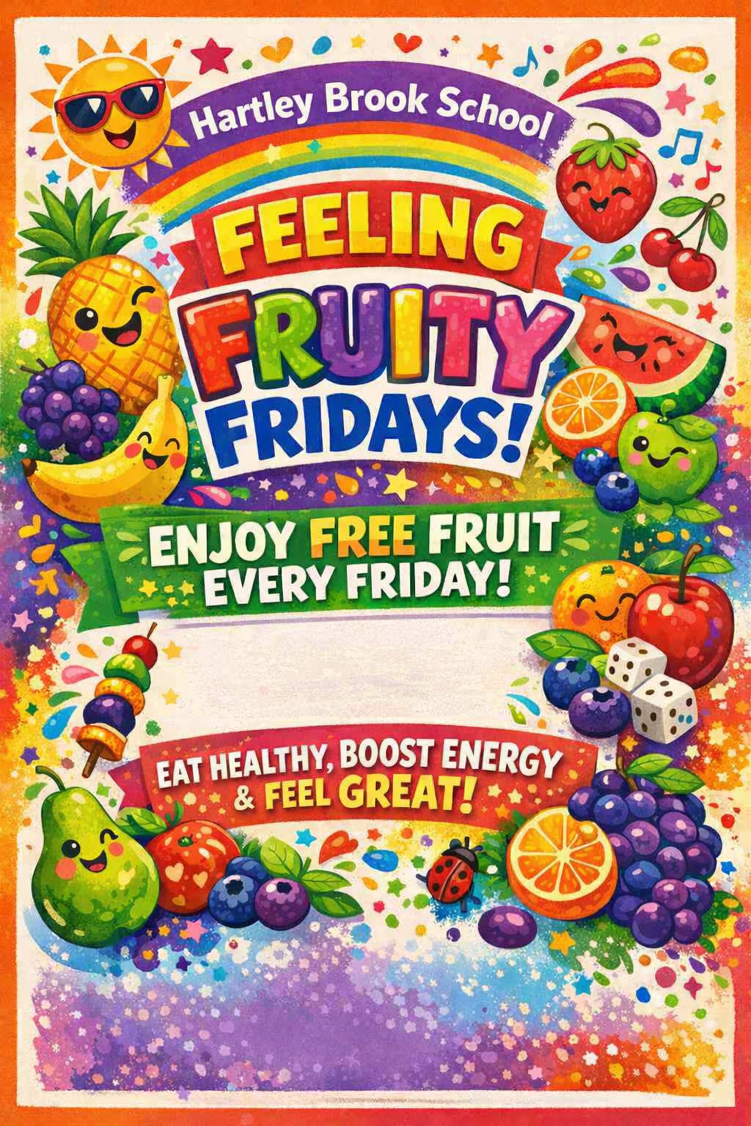
fDDDhAH
Starting Friday 13th March 2026 for Year 3 Pupils.
Each week different year groups will get to enjoy free fruit every Friday!!

