Friday
Fish Finger Chips and Peas Salad Bar Selection
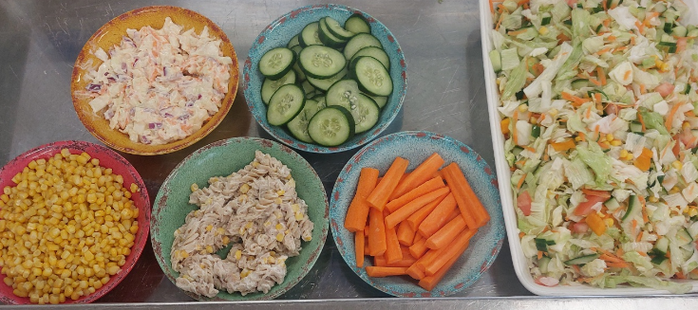
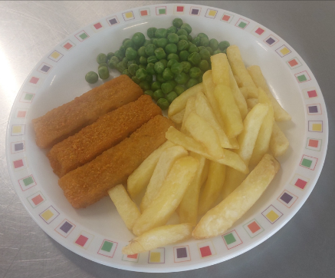

Vanilla Ice Cream
