Thursday
Quorn Bolognese with Pasta and Broccoli Beef Bolognese with Pasta and Broccoli
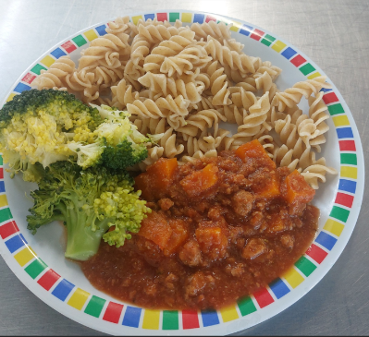
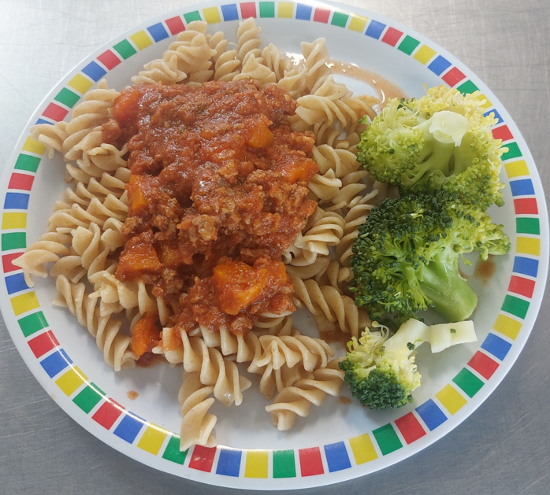

Ham Sandwich with Salad Bar Selection Coconut Sponge/Yoghurt and Fruit
