Wednesday
Pork or Quorn Sausage with Mashed Potato, Yorkshire Pudding and Seasonal Veg (gravy optional)
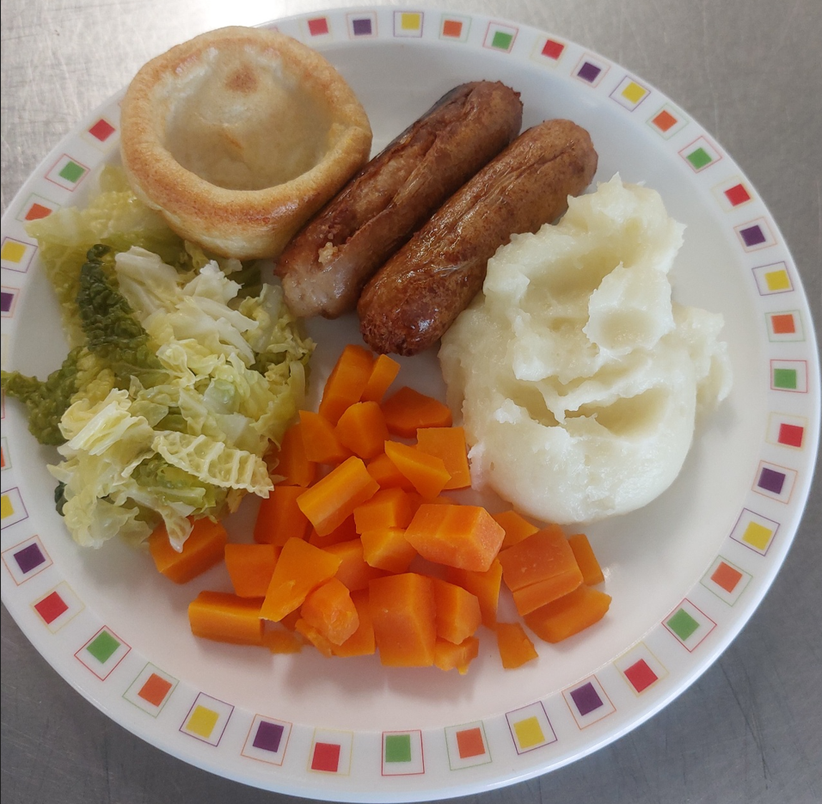 Apple Crumble/Apple Sponge (custard optional)/Fruit or Yoghurt
