Tuesday
Chicken Curry (rice and peas) Sweet Potato and Chickpea Curry (rice and peas)
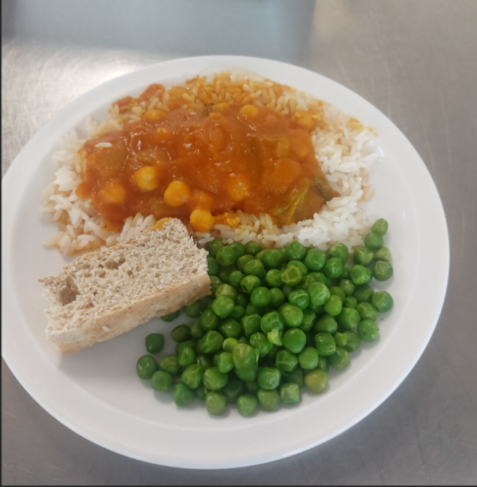
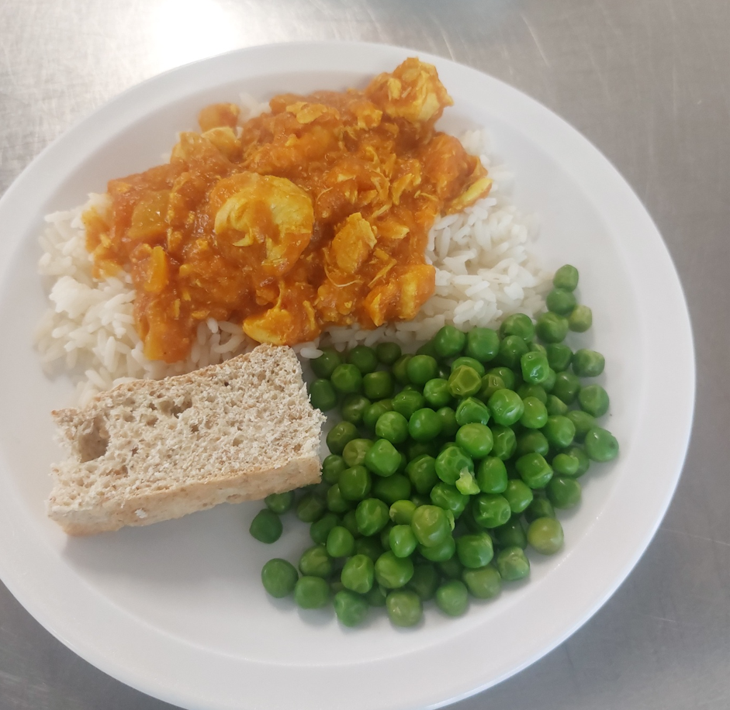

Blueberry Muffin
