Monday
Cheese & Tomato Pizza (wedges and beans) Cheese & Tomato Pizza (sweetcorn and pasta)
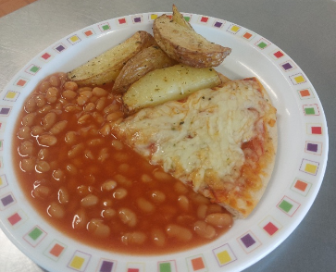
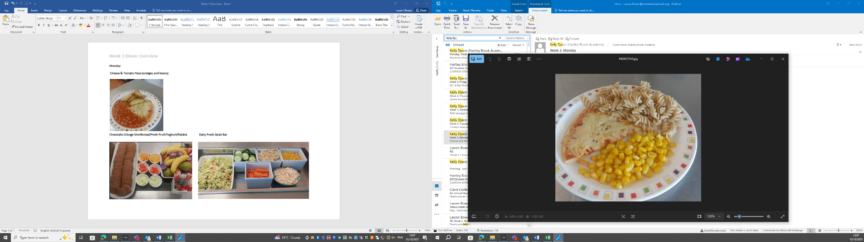

Chocolate Orange Shortbread/Fresh Fruit/Yoghurt/Raisins Daily Fresh Salad Bar
