Wednesday

Roast Chicken Dinner (Gravy Optional) Vegetable Wellington (Gravy Optional) Chocolate Brownie/Fresh Fruit Salad

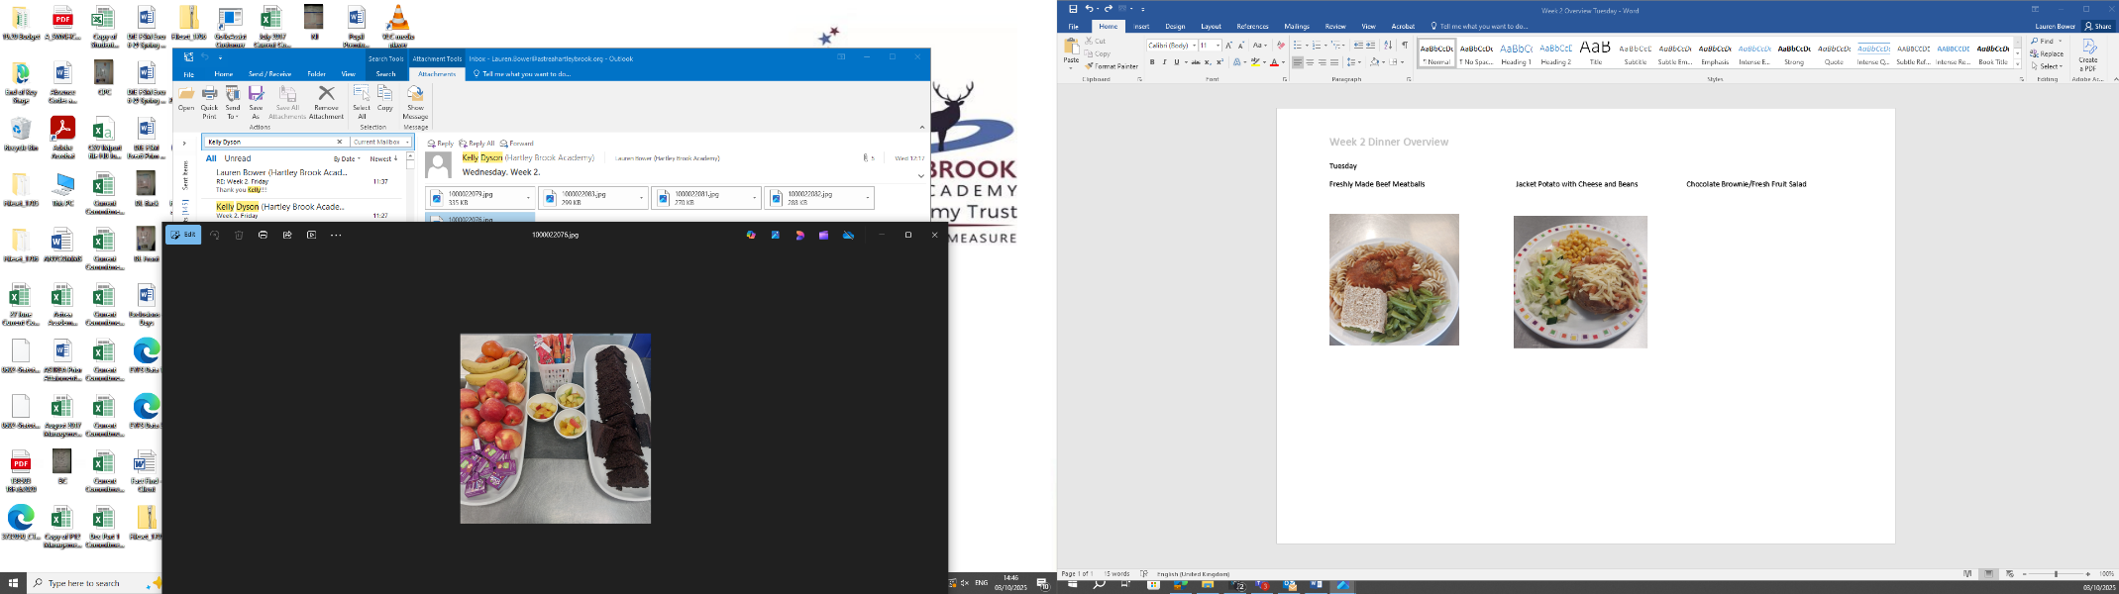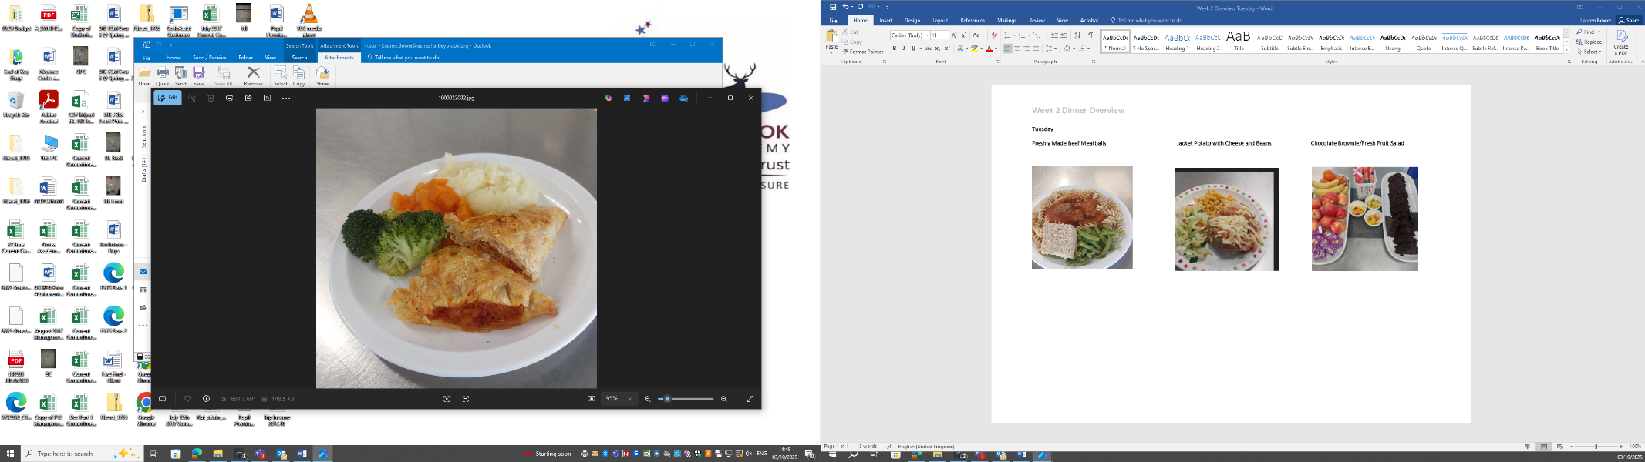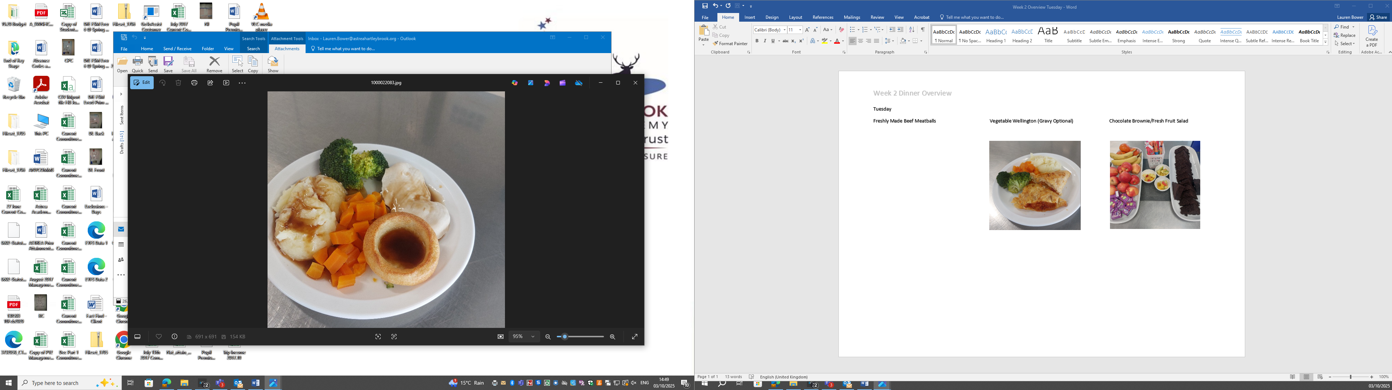

Jacket Potato with Cheese and Salad

