Monday

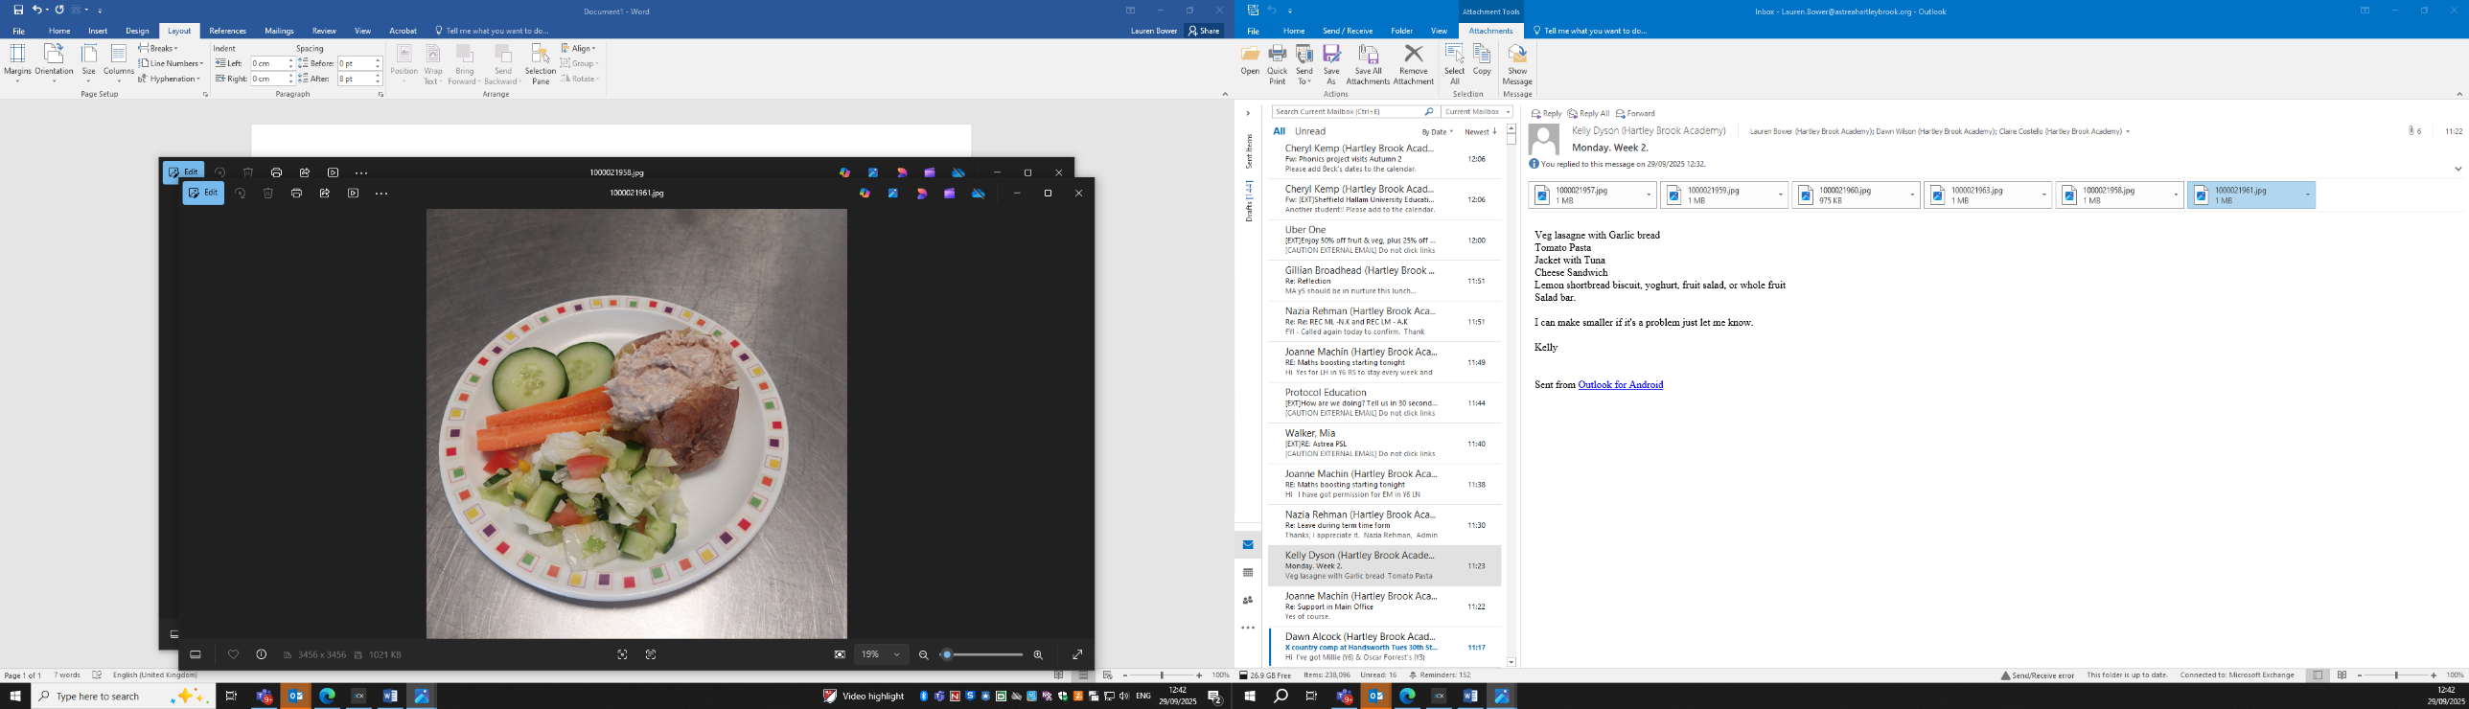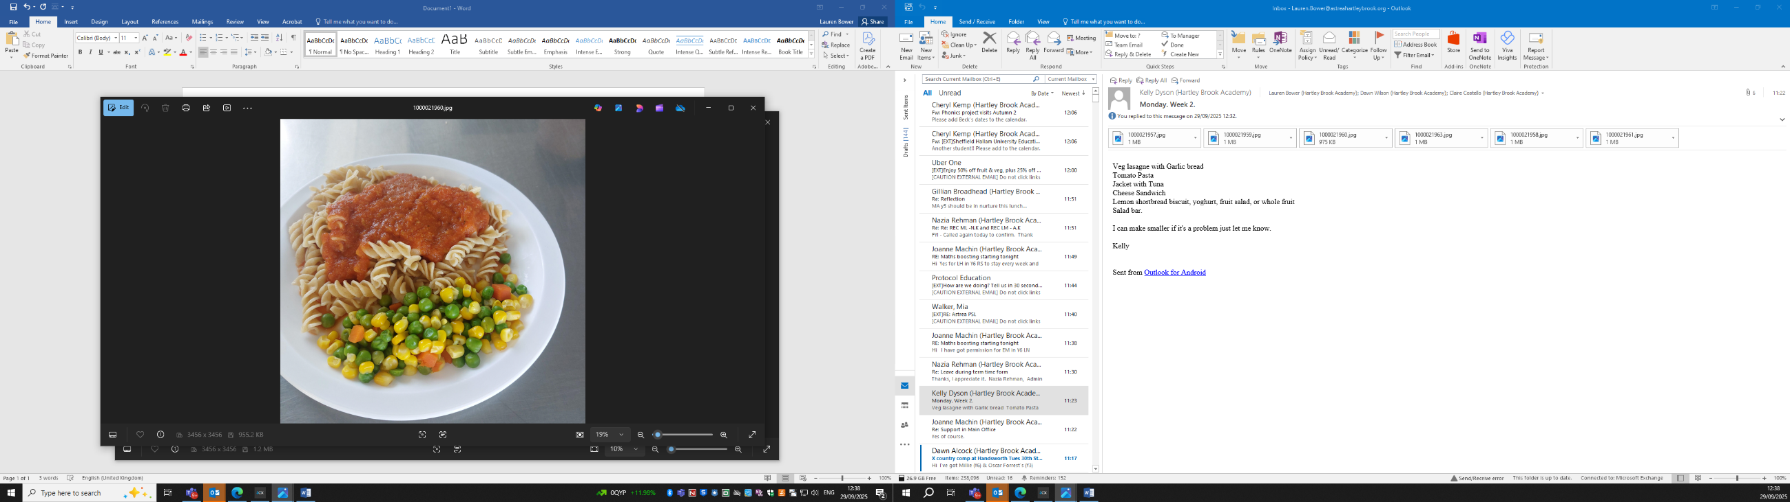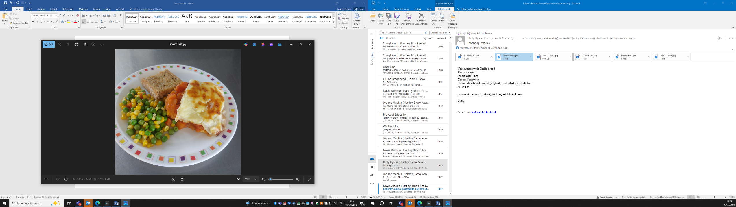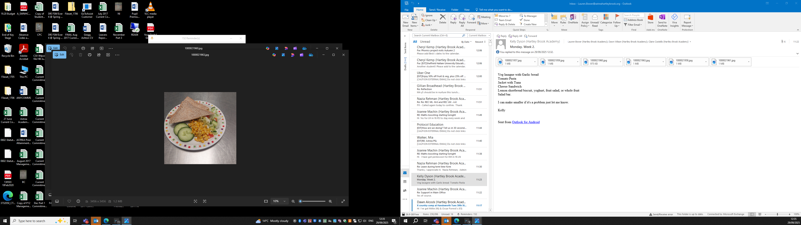 Cheese Sandwich Tomato Pasta Vegetable Lasagne Jacket Potato with Tuna

Lemon Shortbread/Fresh Fruit Salad Daily Fresh Salad Bar

