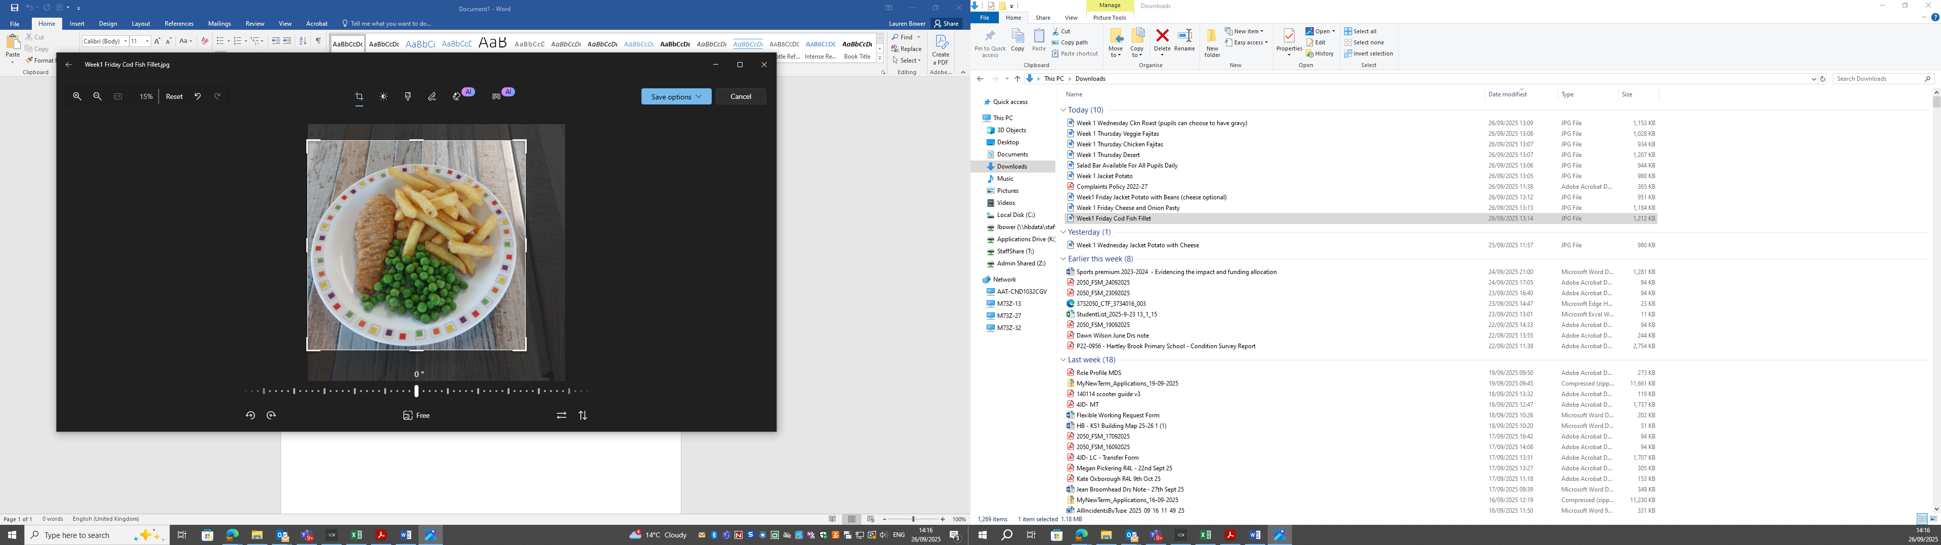
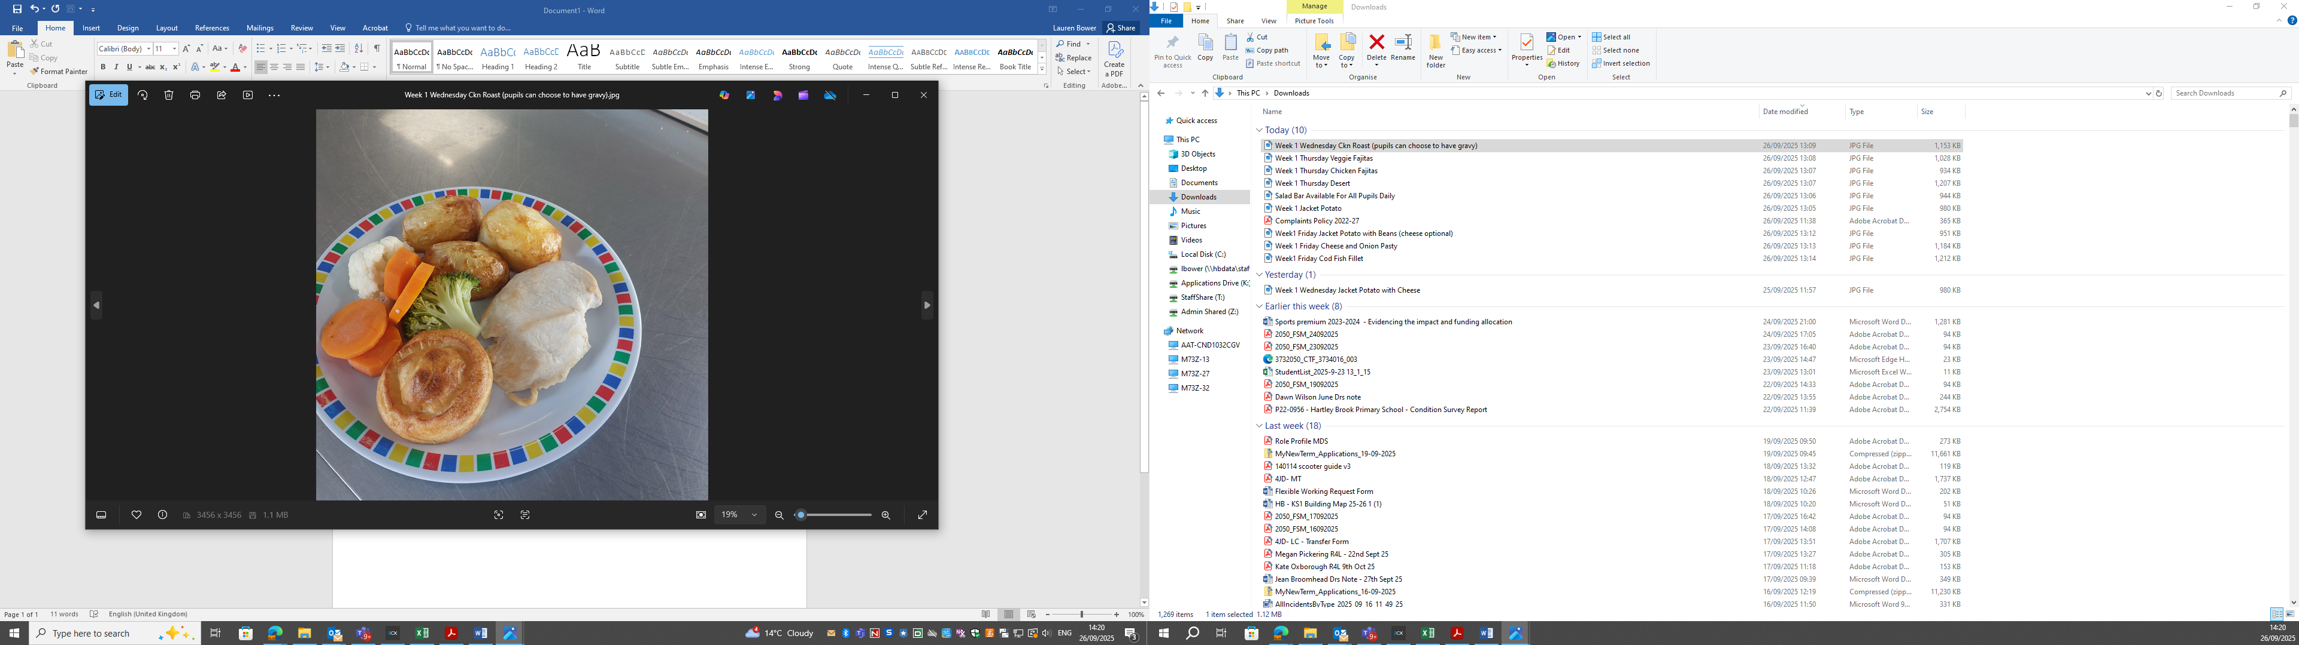
Cod Fillet and Chips Chicken Roast Dinner
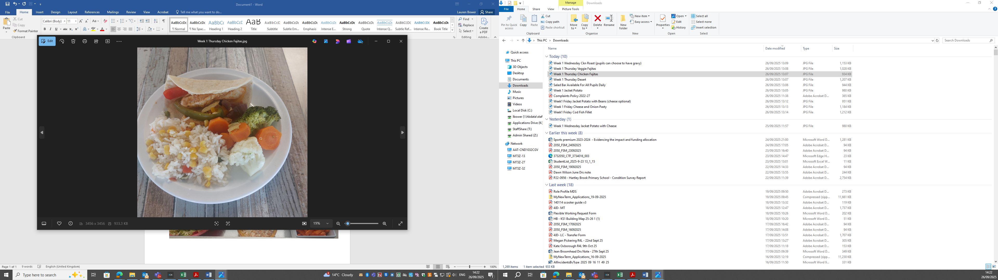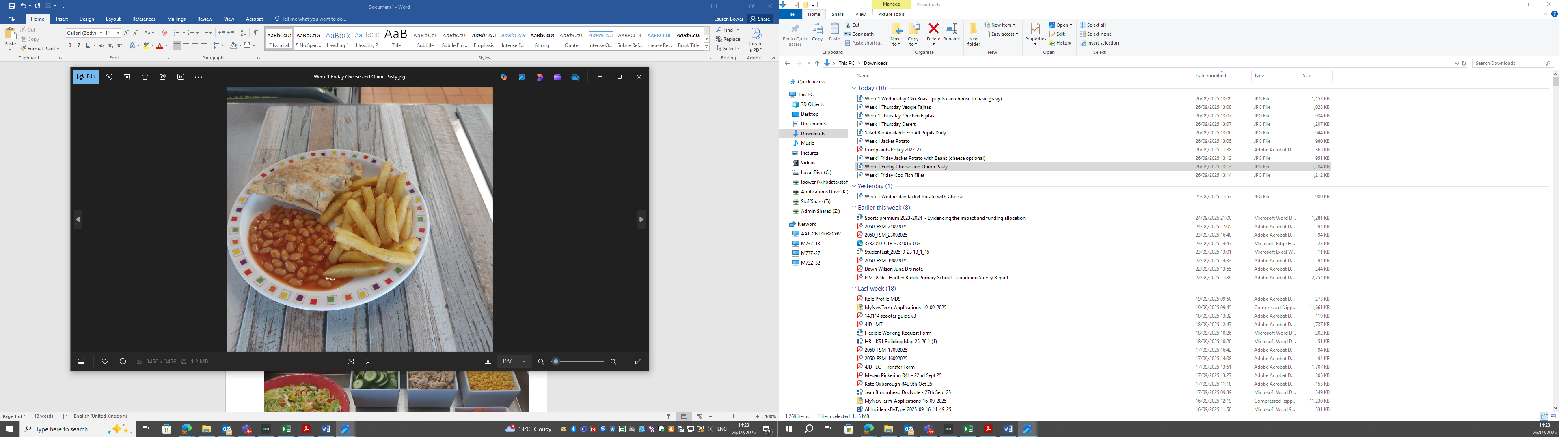
Chicken Fajitas Cheese and Onion Pasty
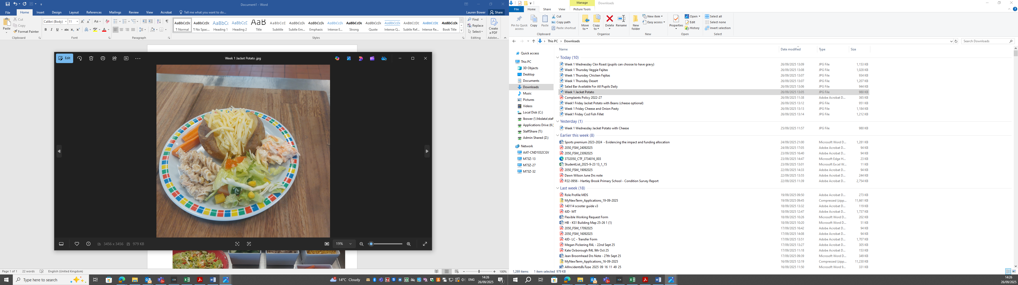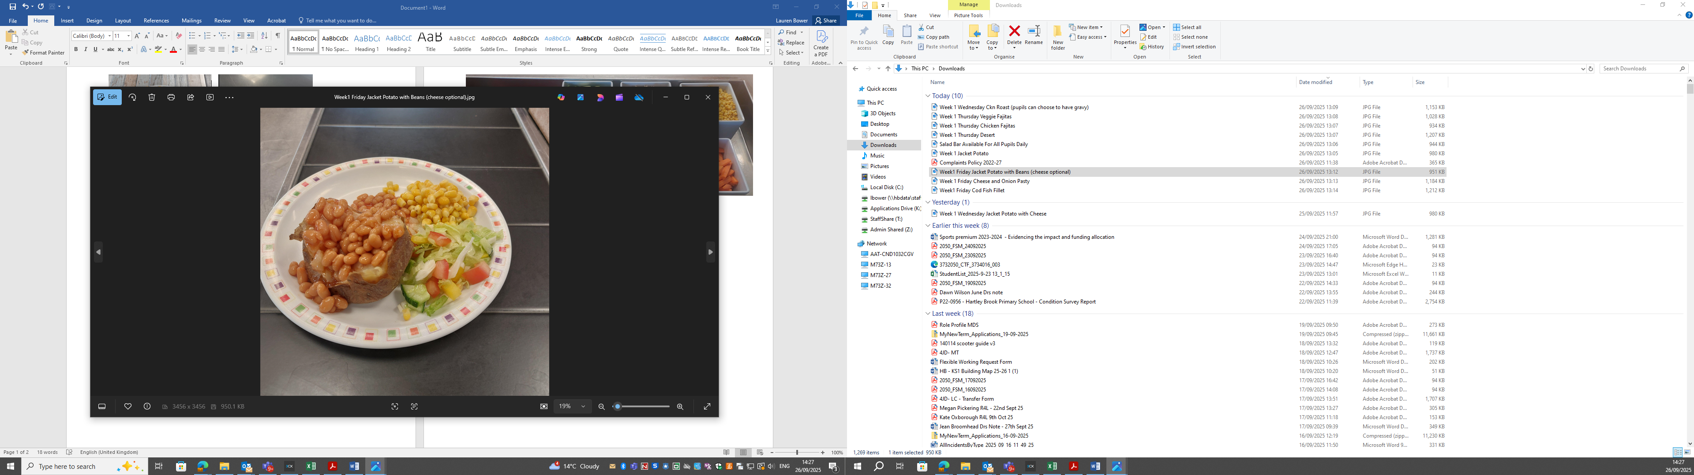
Daily Jacket Potato Option (Cheese/Beans/Tuna)
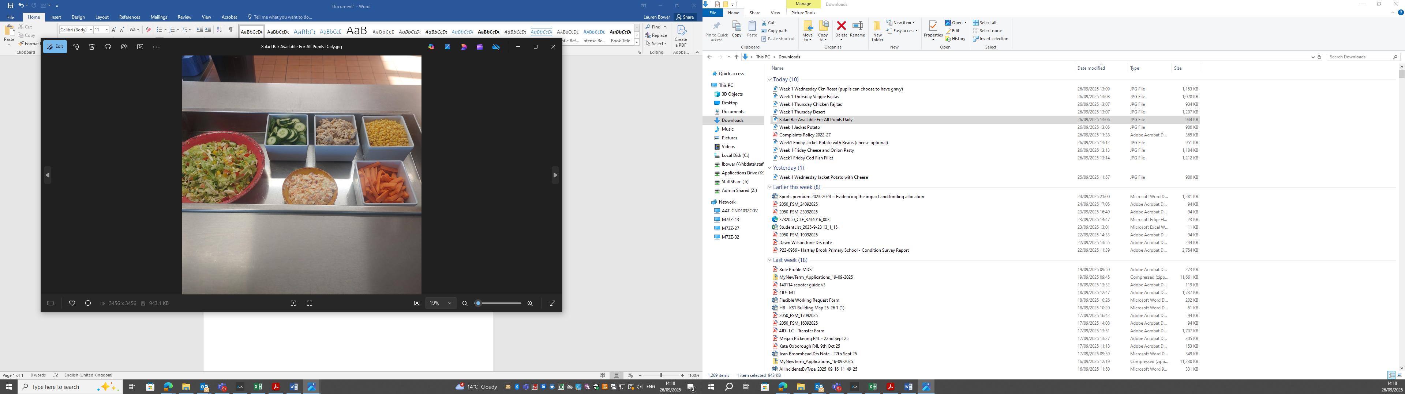
Fresh Salad Bar – Available to All Pupils Every Day
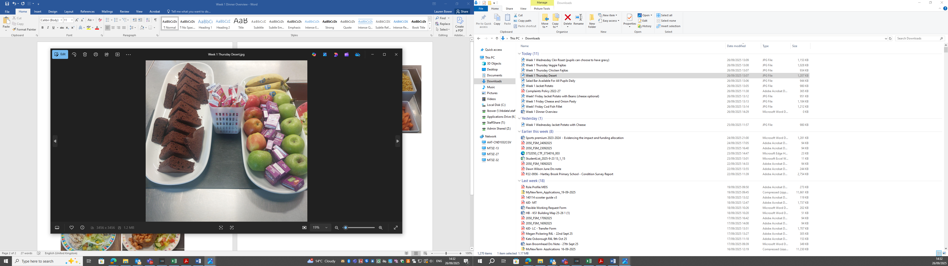
Chocolate and Orange Sponge – Fresh Fruit and Yoghurts Available to All Pupils Every Day

