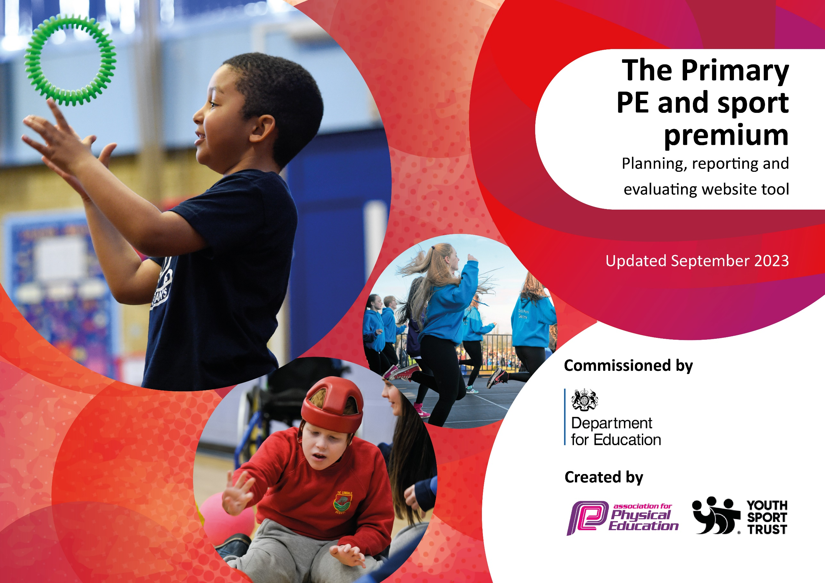

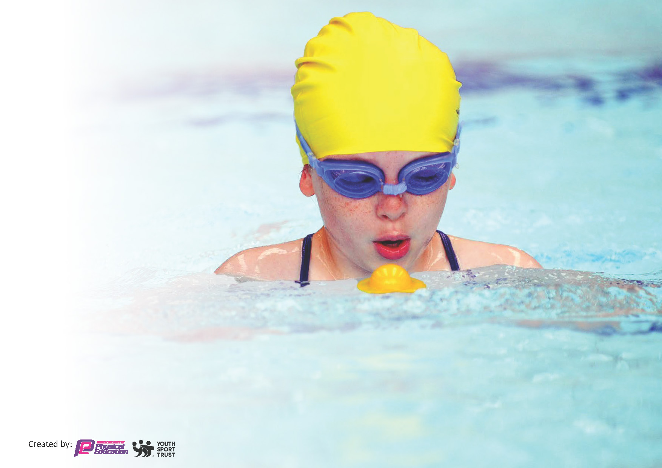
This template can be used for multiple purposes:
by:
- It enables schools to effectively plan their use of the Primary PE and sport premium
- It helps schools to meet the requirements (as set out in guidance) to publish information on their Primary PE and sport premium
- It will be an effective document to support Ofsted inspections enabling schools to evidence progress in Physical Education (PE) and evidence swimming attainment, which forms part of the PE National Curriculum. We would recommend schools consider
the Intent, Implementation and Impact of any spend, as examined within the Education Inspection Framework.

It is important that your grant is used effectively and based on school need.

Schools must use the funding to make additional and sustainable
improvements to the quality of the PE, School Sport and Physical Activity (PESSPA)
they offer. This means that you should use the Primary PE and sport premium to:

- Build capacity and capability within the school to ensure that improvements made now will benefit pupils joining the school in future years
- Develop or add to the PESSPA activities that your school already offers.

The Primary PE and sport premium should not be used to fund capital spend projects; the school’s core budget should fund these. Further detail on capital expenditure can be found in the updated Primary PE and sport premium guidance.

The Primary PE and sport premium guidance, outlines 5 key priorities that funding should be used towards. It is not

necessary that spending has to meet all the key priorities, you should select the priorities that you aim to use any funding towards.

Although completing this template is not a requirement for schools, schools are required to publish details of how they spend this funding. Schools must also outline what the impact this funding has had on pupils’ PE and sport participation and attainment and how any spending will be sustainable in the future. All funding must be spent by 31st July 2024.

The Department for Education has worked closely with the Association for Physical Education (afPE) and the Youth Sport Trust (YST) to develop this template and encourages schools to use it. This template is an effective way of meeting the reporting requirements of the Primary PE and sport premium.
Review of last year’s spend and key achievements (2022/2023)

We recommend you start by reflecting on the impact of current provision and reviewing your previous spend.

Activity/Action | Impact | Comments
1.To continue to provide opportunities to increase the amount of activity that each child in school engages with every day.  2. We maintained a raised profile of PESSPA (PE/School Sport and Physical Activity) by  - all KS2 children visiting the EIS for their sports day and assemblies to celebrate success.  - Effective communication with parents.  - Recognition and celebration of sporting achievements at Trust level – Sheffield Schools Astrea Awards.  - Recognition of outstanding contribution to PESSPA (PE/School Sport and Physical Activtity)  3. Increased confidence, knowledge and skills of all staff in teaching PE and Sport continued because of all staff observing and working alongside the PE lead on a weekly basis receiving coaching /feedback.  4 Broader experience of a range of sports activities offered to all pupils during the Pe session and extra curricular clubs.  Sheffield Eagles coaching - during lesson time to all Y5 & 6 children (approx. 180 children)  Gymnastics after school club ran by level 4 coach from Attercliffe Academy to 75 children  Sheffield Hatters coached during lessons and & lunchtime clubs  Caribbean Cricket coaches provided coaching during PE lessons to over 200 children  5 Increased participation in Competitive sports  Targeted coaching through after-school clubs and high quality PE lessons have seen the following results | Increase in activity levels  Increase in the number of Lunchtime clubs offered to KS2.  Sport leaders & lunchtime supervisors have received training from Arches School sports partnership to run structured activities on the yards which has seen an increase in activity levels and the number of activities on offer.  Pupil voice has shown that 90% of children who attended the EIS had never been before and they preferred this venue to having sports day at school  100% of parents who attended the EIS to watch the sports day said it was a brilliant venue, and their children loved it – such a positive experience  Twitter and parent app are actively used weekly to report to parents. The newsletter informs parents of PESSPA events.  Hartley Brook had finalists in 7 out of the 8 Categories at the Sheffield Schools Astrea Awards ceremony and won 4 out of 8 categories.  - Winner of Primary School of The Year at the Sheffield Schools Get Active Awards 2023  - Awarded School games Platinum Sports Mark  Lesson Observations showed areas for improvement which once acted upon resulted in higher quality lessons. Staff received help with planning their lesson and continuous feedback throughout the year - and therefore showed higher confidence/competence in teaching their subject.  PE lead trialed new Pe scheme “Get set for PE” during the summer term.  Tag Rugby Competitions & results  Y5/6 SSSP – city finals – 1st  South Yorkshire Finals – 1st  Gymnastics Comp & results  -Key steps – Y5/6 - 4th & 5th  Y3/4 2nd & 5th  Basketball - Y4 City finals – 2nd  Football Y5/6 Boys S.F.S.S league winners & local cup winners 2 x city finals EFL Kids Cup winners. Y5/6 girls S.F.S.S. league winners & through to city finals.  Netball Y5/6 Astrea schools 1st .  S.F.S.S City finals – 5th  Athletics Y5/6 SSSP. Sportshall Athletics City finals 3^{rd..} S.F.S.S. City finals Y5/6 Relay Team 1st. Y5/6 Boy 60m 1^{st.}  Astrea Schools X country – 1^{st.}  Astrea Olympics – 2nd.  Dodgeball –Y5/6 comp semifinalists.  HandballY5 Hillsborough college comp – 1st  Y3/4 City finals – 1st | Further extend this offer to include more activities before school. Potential to further develop by introducing intra competitions at lunchtimes.  Sports day at the EIS to continue in future years as this was enjoyed by so many children.  PE Lead to continue supporting staff with teaching PE.  Get Set for PE to be rolled out across all the Astrea schools from Sept 2023.  To continue to provide as many opportunities as possible and network with relevant partners to introduce new opportunities.

Key priorities and Planning
Key Indicators for PE Premium Spend

1 – Increased confidence, knowledge and skills of all staff in teaching PE and Sport.

2 – Engagement of all pupils in regular physical activity.

3 – The profile of PE and Sport is raised across the school as a tool for whole school improvement.

4 – Broader experience of a range of sports and activities offered to all pupils.

5 – Increased participation in competitive sport.

Action – what are you planning to do | Who does this action impact? | Key indicator to meet | Impacts and how sustainability will be achieved? | Cost linked to the action
Allow every child the opportunity to have 30 active minutes every day. KS2 have 3 x 30min lunchtime clubs everyday targeting all Y3-6 to run as well as daily lunchtime playground activities. Sports leaders to help.  TA to support targeted children’s physical and mental wellbeing and use sport as a tool to improve behaviours and engagement in and out of the classroom  Arches School Sports partnership  Subject leader support, training and networking  Networking of PE and local sports contacts across the city of Sheffield, developing strategic support for school  Access to any central resources that help with the delivery of PE and School Sport (Activity Cards, Lesson Plans. Assessment Toolkit etc.). Access to any sports equipment that school may require (if available centrally)  Access to emerging sport and physical activity programs/ projects within Sheffield/nationwide.  Information and links to local exit routes for school pupils (sports clubs, physical activity opportunities)  Opportunity to purchase further individual services (eg. Sports Coaching,  Further CPD. PE subject lead support)  Wider CPD Opportunities for school staff throughout the academic year  Access to further School Sport Festivals/ Competitions per year- Non School Games Competitions.  Enrichment opportunities as spectators  Nominations for attendance at Sheffield Schools sport partnership Annual awards | All pupil, staff and Midday supervisors  SEND pupils and some children who are disengaged from PE and who don’t work well in big social settings  PE Lead  PE Lead -  All staff and pupils  All staff and pupils, Midday supervisors  PE Lead and pupils/parents.  Staff & Pupils  All school staff  All Pupils including specific targets groups for inclusion for all  PE lead, Staff, Principal | Key Indicator 2: Engagement of all pupils in regular physical activity  Key indicator 4: Broader experience of a range of sports and activities offered to all pupils  Key indicator 2: The engagement of all pupils in regular physical activity – the Chief Medical Officer guidelines recommend that all children and young people aged 5 to 18 engage in at least 60 minutes of physical activity per day, of which 30 minutes should be in school.  Key indicator 4: Broader experience of a range of sports and activities offered to all pupils.  Key Indicator 1: Increased confidence, knowledge, and skills of all staff in teaching PE and sport  Key Indicator 1: Increased confidence, knowledge, and skills of all staff in teaching PE and sport  Key indicator 4: Broader experience of a range of sports and activities offered to all pupils.  Key indicator 5: Increased participation in competitive spor  Key Indicator 1: Increased confidence, knowledge, and skills of all staff in teaching PE and sport  Key indicator 2: The engagement of all pupils in regular physical activity – the Chief Medical Officer guidelines recommend that all children and young people aged 5 to 18 engage in at least 60 minutes of physical activity per day, of which 30 minutes should be in school.  Key indicator 3: The profile of PE and sport is raised across the school as a tool for whole school improvement  Key indicator 4: Broader experience of a range of sports and activities offered to all pupils.  Key indicator 5: Increased participation in competitive sport  Key Indicator 1: Increased confidence, knowledge, and skills of all staff in teaching PE and sport  Key indicator 4: Broader experience of a range of sports and activities offered to all pupils.  Key indicator 5: Increased participation in competitive sport  Key indicator 4: Broader experience of a range of sports and activities offered to all pupils.  Key indicator 5: Increased participation in competitive sport  Key indicator 3: The profile of PE and sport is raised across the school as a tool for whole school improvement | Trained Middays and sports leaders to run playground activities. Children are introduced to new activities. Co-operation between children of different year groups Due to the variety of stimulating opportunities for creative play we hope to see a reduction in behavior issues at break times and lunch times.  Learning behaviours improved and classes less impacted by negative behaviours. Pupils become more physically active and challenged in their lessons.  2 x Network meetings per academic year  1 x School place on annual Sheffield Physical Education Conference attended by Keynote speakers & local & national sports providers.  PE lead to inform staff of how to access the support and resources.  PE Lead to network with relevant people involved to enable inclusion in these programs.  PE lead to facilitate links and inform parents and pupils of opportunities via website/app and newsletters.  PE lead to use pupil voice to identify gaps in provision and facilitate extra opportunities.  PE lead to conduct staff audits to identify areas of CPD required and provide opportunities for this via Arches SSP.  Increased staff confidence will allow an increase in extracurricular sports club/activity provision.  PE lead to facilitate attendance at competitions /events throughout the year. These will be for a range of ability and ages and variety of sports for children to attend as a participator /leader/spectator  To complete nominations in a variety of categories and attend awards in July if successful nominations. | £569 equipment  £50 Safe practice in PE book  Arches SSP Silver package membership = £1480.  £15 Archery Coaching Course – Ashleigh Gough  £75 Boxing CPD -Dawn Alcock (PE lead)  Arches Cluster package = £600  £30 - Arches dance performance props.  £100 – Aquafest entry fee

Astrea Promise  Accurately record extra-curricular club and competition attendance in Bromcom.  Analyse the resulting data in Athena to identify strengths and weaknesses.  Create tailored opportunities to remove barriers and meet the needs of identified under-represented groups.  Nominations for, facilitation of and attendance at Astrea Annual Sports Awards  To develop PE Leader confidence, knowledge and skills including preparation for Trust sports events, preparation for School Games Mark Platinum application in Summer 2024.  To implement the Get Set 4 PE scheme across KS1 and KS2.  To increase teaching staff confidence, knowledge and skills in teaching PE.  Promote the local sporting club offer  Offer new PESSPA clubs to enable pupils to explore a wider range of sports and activities.  To engage in region wide competitions across the Astrea Academy Trust group.  Specialist PE lead  To lead and develop PESSPA across the school EYFS – KS2 to allow high quality PE lessons/ experiences for all children and provide staff with continued support/CPD.  To develop a broad and balanced curriculum and extracurricular experience for all children  To raise the profile of PESSPA across the school.  Visit /perform in state-of-the-art  sports facilities.  To identify talent and facilitate individual pupils’ engagement in local and regional elite pathways beyond those provided by the school. | PE Lead  Class Teachers  TAs  PE Lead  PE Lead  PE Lead  Class Teachers  PE Lead  PE Lead  PE Lead  PE Lead  PE lead  Pupils & staff  PE Lead  PE lead  Pupil /staff – KS2 Sports day at English Institute of sport Sheffield  Pe lead /staff | Key indicator 2: The engagement of all pupils in regular physical activity – the Chief Medical Officer guidelines recommend that all children and young people aged 5 to 18 engage in at least 60 minutes of physical activity per day, of which 30 minutes should be in school.  Key indicator 3: The profile of PE and sport is raised across the school as a tool for whole school improvement.  Key indicator 3: The profile of PE and sport is raised across the school as a tool for whole school improvement.  Key Indicator 1: Increased confidence, knowledge, and skills of all staff in teaching PE and sport  Key Indicator 1: Increased confidence, knowledge, and skills of all staff in teaching PE and sport  Key Indicator 1: Increased confidence, knowledge, and skills of all staff in teaching PE and sport  Key indicator 3: The profile of PE and sport is raised across the school as a tool for whole school improvement.  Key indicator 4: Broader experience of a range of sports and activities offered to all pupils.  Key indicator 5: Increased participation in competitive sport.  Key Indicator 1: Increased confidence, knowledge, and skills of all staff in teaching PE and sport  Key indicator 4: Broader experience of a range of sports and activities offered to all pupils.  Key indicator 5: Increased participation in competitive sport.  Key indicator 3: The profile of PE and sport is raised across the school as a tool for whole school improvement  Key indicator 4: Broader experience of a range of sports and activities offered to all pupils.  Key indicator 5: Increased participation in competitive sport.  Key indicator 4: Broader experience of a range of sports and activities offered to all pupils | Under-represented groups in clubs and competitions enabled to take part in PESSPA.  To celebrate individual pupil, team and staff PESSPA achievements at a regional level.  PE Leader to attend Astrea PE Network meetings  PE lead to liase with staff and provide Continued support through learning walks, coaching and feedback.  PE Leader to liaise with Trust PESSPA Lead to source staff CPD  Engage with providers identified in the Astrea Local Club Offer to promote their offer, both generally to the school community and to target talented individuals.  Facilitate and attend:  - Trust Cross Country Event  - Trust Tri-golf Event  - Trust Netball Event  - Trust Olympics  Plan & implement curriculum to include monitoring – learning walks/staff CPD & coaching. Pupil voice.  Sports leadership  Oversee all clubs/enrichment activities and monitor.  Use pupil voice to offer additional opportunities. Attend competitions at both participation and elite level.  Weekly assemblies /PE star of the week. Star of the lesson.  Newsletters/ Reporting to governors and reporting to parents via App and X.  All children in KS2 to experience performing on an indoor athletics arena.  Identify Talented pupils and network to provide effective links with outside clubs to further develop Elite pupils’ opportunities.  Create opportunities to support the families of talented pupils in engaging in the regional offer for relevant sporting pursuits. Work closely with Sheffield city trust to facilitate partner school benefits. | £3362  £8032 -  PE lead specialist training.  Minibus Hire to attend competitions and festivals.  Supply cover to attend meetings and conferences  Competitions and festivals.  £729 The Print room – Kit for extra curricular teams.  £120 – Partnership games.  £50 – Colour - smash entry Fee  £885 – Sports directory – Football & Dodgeballs  £106 Sheffield Federation School Sport Block Entry (40p per child Y4-6 x 265)  £1590 – Hire of EIS  £2700 – Heatons coaches.  £171 – Ice Sheffield show tickets  £105 – Hire of Concord Sports Centre.  £188.40 -PTS Stickers sports day

Key achievements 2023-2024
This template will be completed at the end of the academic year and will showcase the key achievements schools have made with their Primary PE and sport premium spending.

Activity/Action | Impact | Comments
Allow every child the opportunity to have 30 active minutes every day.  Equipment – stock take and replenishment  Arches school sports partnership membership  - CPD and resources provided for staff  - Festivals/Competitions  - Sheffield schools’ sports partnership Awards.  “Outstanding PE, Sport and Physical Activity Award” Winner  ASTREA Promise  - Trust competitions  - Astrea awards –  - Get Set 4 PE Scheme | New activities introduced by trained midday supervisors supported by sports leaders saw an increase in participation and cooperation between students.  Learning behaviours improved and classes less impacted by negative behaviours  Ensuring there is enough equipment for every PE lesson allows children to develop their skills more effectively.  Ensure high quality PE lessons and clubs.  Boxing and Archery introduced and very popular amongst children.  Network meetings allow us to shape our PESSPA offer.  Lots of opportunities for children to attend these events - including targeted SEND opportunities. Cluster events allow B & C teams to compete.  Awarded to the school because they are continually engaged in the School Games Competition Programme, and compete in line with the spirit of the games and have provided opportunities to a range of different pupils to engage in competition or events, regardless of ability”  Competitive and inclusive events held for all Astrea Schools. Variety of sports such as Netball, Cross Country, Dragon Ball and Athletics. Provision for both Elite and low ability and SEND  Hartley Brook very successful at these -  KS1 & KS2 Athletics Olympics Winners  Y6 Netball - Winners  Our excellent broad extra curricular offer has allowed children to achieve recognition for their hard work and commitment in the following award categories.  Winners :  Positive attitude Award/Most improved Award/Fair Play Award/Sports Leader Award/Team of the Year Award (Sport Hall Athletics squad)  Runners up:  Sports Boy & Sports Girl of the Year Award.  The implementation of the GetSet4PE curriculum has significantly impacted our school enhancing our students' physical fitness, coordination, and overall well-being. The GetSet4PE curriculum also supports the development of essential life skills such as teamwork, resilience, and leadership | To continue to provide training for sports leaders every year with a view to having them run activities on both KS2 and KS1 yards as lots of children asking to be trained as sports leaders.  Continue to replace any damaged /lost equipment -use pupil voice to purchase new equipment.  To continue working closely with the Arches SSP as they offer brilliant opportunities for students and excellent coaching knowledge.  We attended a record number of competitions and reached a record number of city finals. Pinnacle moment – representing Sheffield Schools in the South Yorkshire Sport hall Athletics finals and coming 1st!  This outstanding engagement in PESSPA enabled Hartley Brook to be Awarded the Platinum sports mark.  Sporting events offer our pupils greater opportunities to take part in competitive events. As well as promoting Key Indicators 2, 4 & 5.  The awards allow children to celebrate their achievements and further promote the schools PESSPA offer.  The scheme is to be used in all Astrea schools going forward.

Swimming Data
Meeting National Curriculum requirements for swimming and water safety.
Priority should always be given to ensuring that pupils can perform safe self-rescue even if they do not fully meet the first two requirements of the National Curriculum programme of study

Question | Stats: | Further context  Relative to local challenges
What percentage of your current Year 6 cohort can swim competently, confidently and proficiently over a distance of at least 25 metres? | 27% | This cohort has 18 weeks of 1 hours lessons during Y4. Of those non-swimmers, there are very few children that are exposed to swimming other than their school sessions.
What percentage of your current Year 6 cohort can use a range of strokes effectively [for example, front crawl, backstroke, and breaststroke]? | 29% | Very few children that are exposed to swimming other than their school sessions.

What percentage of your current Year 6 cohort are able to perform safe self-rescue in different water-based situations? | 93% | Of all the children in attendance, every child completed the safe self rescue. All children in the cohort had the opportunity to cover this when they swam in Y4.
If your schools swimming data is below national expectation, you can choose to use the Primary PE and sport premium to provide additional top-up sessions for those pupils that did not meet National Curriculum  requirements after the completion of core lessons. Have you done this? | No
Have you provided CPD to improve the knowledge and confidence of staff to be able to teach swimming and water safety? | No | Staff who accompany the children do get in the pool with the children and help but they have not had any CPD.

Signed off by:

Head Teacher: | Claire Costello
Subject Leader or the individual responsible for the Primary PE and sport premium: | Dawn Alcock
Governor: | Jane Williams
Date: | 19/07/24

