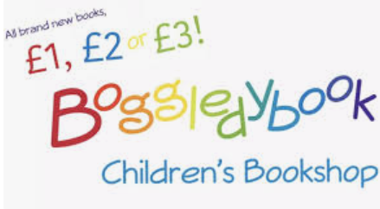

5th September 2025

Dear Parents/Carers,

On Thursday 11th September we will be visited by Boggledybook Children’s book shop. They will be selling books in the KS1 hall from 3pm and all books will be priced at £1, £2 or £3.

There will be lots of different books available for all ages and interests.

The book fayre is open to all year groups.

If your child walks home and you would like them to visit the fayre, please send them with the money in a sealed envelope with your child’s name on and hand this to their class teacher in the morning. Staff will then collect your child in the afternoon and take them to visit the book fayre.

Parents are able to come and look at the Fayre between 3pm and 3.30pm.

Many thanks,

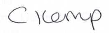

Miss Kemp
KS1 Assistant Principal

