**Uniform Standards – Start of Academic Year**

**Dear Parents/Carers,**

We are very much looking forward to seeing all the children very soon as we begin another exciting academic year at Hartley Brook Academy.

As we prepare for the term ahead, we’d like to take this opportunity to remind families about the importance of following our school uniform policy. School uniform plays a vital role in promoting consistency and a sense of belonging across all year groups. **It encourages confidence and helps children feel proud to be part of our school community.** With your continued support, we aim to maintain our high standards in appearance, which positively impacts how children feel about themselves and how they engage with school life.

Our uniform is designed to promote inclusivity and minimise distractions, allowing students to concentrate fully on their education.

When students do not follow the uniform policy, it can cause unnecessary disruptions to teaching and learning. Staff are required to address these issues during the school day, which takes time away from lessons and affects the learning environment for all.

We understand that ensuring your child has the correct uniform can sometimes be challenging. To support families, we help through our **Pre-Loved Uniform Shop**, and we can provide **spare uniform on loan** if needed. If a child arrives at school without the correct uniform, we will offer **spare uniform for them to change into** during the day. Please contact the school office if you require any help in obtaining the correct items.

Please ensure your child:

* 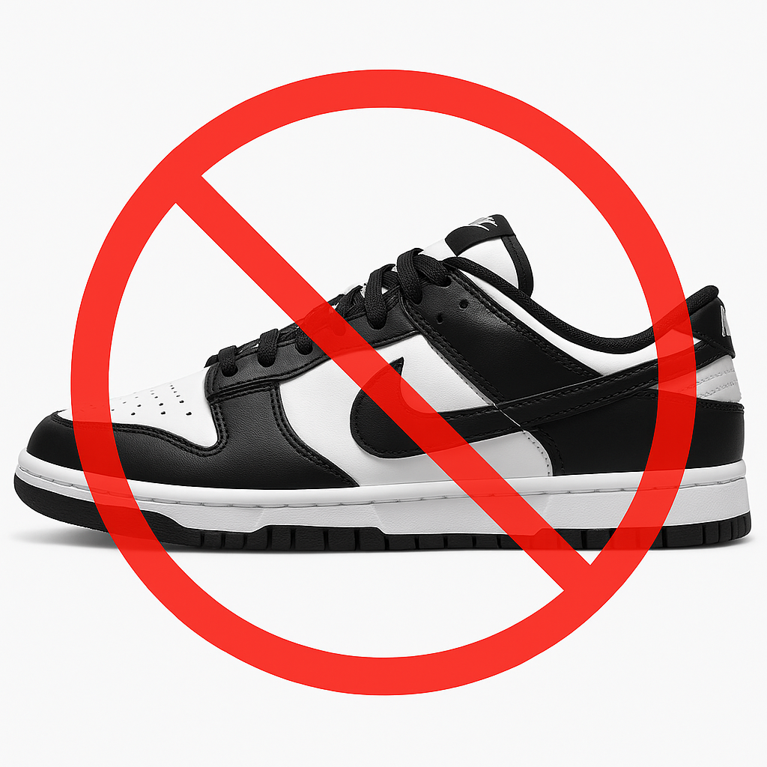Brings a **water bottle** everyday (no energy drinks)
* Has their name in all items of uniform

Please also note that **school shoes/trainers must be all black**. Nike dunks are not allowed.

Our full uniform policy is available on the school website and is attached to this letter for your reference.

The Pre-Loved uniform shop is open on September 1st 9am – 10.50am.

Thank you for your ongoing support in helping us maintain a positive and focused learning environment for all children.

Kind regards,  
Claire Costello  
Hartley Brook Academy