Pupil premium strategy statement

This statement details our school’s use of pupil premium (and recovery premium for the 2024 to 2025 academic year) funding to help improve the attainment of our disadvantaged pupils.

It outlines our pupil premium strategy, how we intend to spend the funding in this academic year and the effect that last year’s spending of pupil premium had within our school.

School overview
Detail | Data
School name | Edenthorpe Hall
Number of pupils in school | 194
Proportion (%) of pupil premium eligible pupils | 30%
Academic year/years that our current pupil premium strategy plan covers (3-year plans are recommended) | 2024-2027
Date this statement was published | November 2024  (Reviewed November 2025)
Date on which it will be reviewed | November 25, 26,27
Statement authorised by | Thomas Orr
Pupil premium lead | Thomas Orr
Governor / Trustee lead | Andrew Crossley
Funding overview
Detail | Amount
Pupil premium funding allocation this academic year | £81,400
Pupil premium funding carried forward from previous years (enter £0 if not applicable) | £0

Part A: Pupil premium strategy plan

Statement of intent
At Edenthorpe Hall, our core ambition is that every pupil—regardless of background or individual challenges—makes strong progress and achieves high standards across all subjects.
We recognise that the single most effective way to close the attainment gap for disadvantaged pupils, while raising achievement for all, is through consistently high-quality teaching in every classroom and every year group. Research clearly demonstrates that this approach has the greatest impact on outcomes.
To complement this, we are committed to enriching pupils’ experiences beyond the classroom. For those with limited access to extra-curricular opportunities, we will provide at least one free club each year. We also place a high value on health and wellbeing, investing in staff professional development to ensure pupils receive the support they need to thrive.
By focusing on these priorities, we are giving every child the best possible chance to achieve in line with their peers and reach their full potential. To ensure these strategies are effective, we will:
- Monitor progress rigorously, with regular reviews of disadvantaged pupils’ attainment
- Act swiftly, intervening as soon as a specific need is identified
- Adopt a whole-school approach, where every member of staff takes responsibility for disadvantaged pupils’ outcomes and maintains high expectations
- Be guided by evidence, selecting strategies informed by high-quality research

Challenges

This details the key challenges to achievement that we have identified among our disadvantaged pupils.
Challenge number | Detail of challenge
1 | Narrowing the gap to non-disadvantaged national is a priority. Disadvantaged pupils across all subjects do not yet achieve the same as non-disadvantaged pupils.  Ensuring that all teaching is of high quality and consistent across the school is a key priority as this is the most effective way to diminish gaps and ensure all pupils are ready for the next part of their education. to close these gaps as well as targeted interventions and group work
2 | To ensure pupils get a high-quality reading programme from reception to Y6. To ensure all pupils get the support required to make expected progress. Work closely with families to ensure they know how they can support pupils at home.
3 | To improve attendance rates for disadvantaged pupils, narrowing the gap to their peers. We recognise that pupils being in school, every day, receiving a high-quality education is the best way to diminish the disadvantage gap.
4 | There is an increasing number of pupils on the SEN register with SEMH. In some cases, this is affecting their education. School is working with these pupils, parents and external agencies to ensure they get the support they need

Intended outcomes
This explains the outcomes we are aiming for by the end of our current strategy plan, and how we will measure whether they have been achieved.
Intended outcomes | Success criteria
Reading, Writing and Maths.  To ensure the percentage of pupils achieving combined ARE in reading, writing and Maths is brought in line with national averages and the gap with non-disadvantaged is closed | - Invest in CPD for all staff all teacher and HLTAs are entitled to a high quality CPD programme which includes instructional coaching  - The ‘Edenthorpe Way’ vision and pedagogy handbook is evident across all classrooms. There is a clear, consistent approach to how we teach pupils effectively. This is understood by all staff, at all levels.  - Well designed and forensic pupil progress meetings ensure pupils are making good progress. Early intervention is vital and leaders support teachers to ensure pupils get this.
Reading and Phonics  All pupils will have access to a high-quality reading programme from R-Y6. Reading teachers will be highly skilled- teaching with fidelity to the programme and able to identify misconceptions quickly- closing them through fast track intervention  Targeted interventions will ensure those who are behind age related expectations catch up quickly and close gaps  Parents will know how to support children, so children read regularly at home and fluency is improved. | Pupils in vulnerable groups will make increased progress, narrowing the gap in attainment, this will be through:  - High quality deliver of RWI: supported by an expert RWI lead  - All reading teachers receive coaching 1 x per week offering coaching to all staff  - Targeted Intervention timetables in place for fast-track phonics  - Regular assessment identifies pupils who are ready to move on. Pupils who are struggling are offered 1:1 tuition  - Parental workshop to raise awareness of RWI and the importance of reading.  - Guidance given for how to support children at home through workshops and weekly communication
Extra-Curricular Experiences  To offer PP pupils a range of extra-curricular and out of school cultural experiences, including a range of clubs, visits and visitors | - Offer a wide range of activities in school (Astrea Promise)  - Regular monitoring shows all pupils attend a club either in school or out of school  - String links with local providers and the community to enhance our offer
Speech and Language  Catch up speech and language intervention to improve the speech and language skills of children in EYFS/Y1/Y2 | - Targeted interventions in KS1 show rapid progress within communication and language.  - Screening shows PP children shows progress in oral skills.  - Tracker to be updated and rag rated half termly and shared with SLT and staff.
Attendance  Attendance for disadvantaged pupils will improve across school compared to non-disadvantaged pupils | - The number of persistent absentees to be reduced amongst those pupils eligible for PP.  - Improve overall the attendance of PP pupils to be in line with non-PP pupils.  - Principal and Attendance leader to form strong relationships with families and offer bespoke support. Close links with external agencies ensure improvements are made  - Weekly ABSI meetings ensure attendance, behaviour, inclusion and safeguarding are interlinked. All staff know what barriers pupils may be facing to attendance
Behaviour  Support pupils with SEMH and behaviour needs to ensure learning behaviours improve. | - Behaviour points will reduce  - Suspensions will continue to decrease  - Principal, DSL and Learning mentor create strong relationships with families and external agencies. Pupils get the support they need to be successful in school  - Motional interventions are used to support pupils and track progress  - Astrea counselling is utilised to support pupils

Activity in this academic year
This details how we intend to spend our pupil premium (and recovery premium funding) this academic year to address the challenges listed above.

Teaching (for example, CPD, recruitment and retention)
Budgeted cost: £31,856
Activity | Evidence that supports this approach | Challenge number(s) addressed
Quality Teaching across the school. CPD to improve high quality teaching and learning throughout school:  Leader of teaching:  £18,000  Bespoke instructional coaching model for all teachers and HLTAS  £12,000  $ | https://sandbox.educationendowmentfoundation.org.uk/guidance-for-teachers/covid-19-resources/best-evidence-on-impact-of-covid-19-on-pupil-attainment shows that the attainment gap has grown as a result of national lockdowns. It is therefore more important than ever that school strategies focus on support for disadvantaged pupils.  https://www.suttontrust.com/wp-content/uploads/2011/09/2teachers-impact-report-final.pdf demonstrated a positive impact on outcomes from improving the quality of teaching and learning  https://www.gov.uk/government/publications/the-pupil-premium-how-schools-are-spending-the-funding-successfully In line with the research, improving the quality or teaching and learning of disadvantaged pupils improves outcomes.  https://educationendowmentfoundation.org.uk/education-evidence/teaching-learning-toolkit/social-and-emotional-learning? Social and emotional learning (SEL) interventions seek to improve pupils’ decision-making skills, interaction with others and their self-management of emotions, rather than focusing directly on the academic or cognitive elements of learning. |  | 1, 2,3,4,5
RWI  Support for phonics (RWI)  Phonics lead to support staff - weekly CPD in place for reading teachers.  Instructional coaching:  All staff reiceve coaching once per week  £5200  Reading leader (TA): release time to assess pupils, analyse data and provide fast track phonics  £2600  High quality reading books/RWI books / resources  £2000 | https://educationendowmentfoundation.org.uk/evidence-summaries/teaching-learning-toolkit/reading-comprehension-strategies/#closeSignup demonstrates impact of Reading Comprehension Strategy teaching  https://educationendowmentfoundation.org.uk/evidence-summaries/teaching-learning-toolkit/oral-language-interventions/ demonstrates the impact of provision of oral language intervention on pupil outcomes  https://educationendowmentfoundation.org.uk/evidence-summaries/teaching-learning-toolkit/reading-comprehension-strategies/ In-school monitoring demonstrated a need to develop reading comprehension strategies including higher order thinking |  | 1,2,3
Additional TA to run interventions and support pupil in KS1  £18.000 | Small group tuition | EEF (educationendowmentfoundation.org.uk)  Research which focuses on teaching assistants who provide one to one or small group targeted interventions shows a stronger positive benefit of between four and six additional months on average. Often interventions are based on a clearly specified approach which teaching assistants have been trained to deliver.  In the EEF Attainment Gap report, it states that what happens in the classroom makes the biggest difference: improving teaching quality generally leads to greater improvements…There is particularly good evidence around the potential impact of teacher professional development  Teaching Assistant Interventions | EEF (educationendowmentfoundation.org.uk)  The average impact of the deployment of teaching assistants is about an additional four months’ progress over the course of a year. |  | 1,3,4
Support pupil’s financial access to different educational experiences in order to build self-esteem, resilience, build social interaction skills and in order to prepare them for adult life.  £2,500 | http://scholarworks.umass.edu/dissertations/AAI3179892/ demonstrates the importance of life experiences on learning.  https://educationendowmentfoundation.org.uk/evidence-summaries/teaching-learning-toolkit/behaviour-interventions/ demonstrates impact of developing a positive school ethos |  | 4

Targeted academic support (for example, tutoring, one-to-one support structured interventions)
Budgeted cost: £ 2903
Activity | Evidence that supports this approach | Challenge number(s) addressed
Speech and language intervention – TA led  Fresh start intervention for Y5 and Y6 pupils x 3 sessions per week TA Led  £2900 | https://educationendowmentfoundation.org.uk/evidence-summaries/teaching-learning-toolkit/individualised-instruction/ demonstrates the impact of providing individualised instruction for learners  https://www.ruthmiskin.com/en/programmes/fresh-start/  Fresh Start is a successful intervention programme developed by Ruth Miskin to rescue pupils age 9 and above who are below age-related expectations | 2,3,4

Wider strategies (for example, related to attendance, behaviour, wellbeing)
Budgeted cost: £ 36774
Activity | Evidence that supports this approach | Challenge number(s) addressed
Attendance Lead /admin staff to monitor children’s attendance and follow up quickly on absences. First day response provision.  School attendance leader to monitor using the weekly tracker  Weekly, half termly and annual attendance incentives.  Class attendance incentives  £3000 | NfER briefing for school leaders identifies addressing attendance as a key step to improving attainment. Good attendance is also listed in the top 10 approaches for disadvantaged children  Attendance interventions rapid evidence assessment | EEF (educationendowmentfoundation.org.uk)  This rapid evidence assessment examines the existing research on interventions that aim to improve pupils’ school attendance and the characteristics of these interventions, based on a systematic search of existing literature
Breakfast club held daily  Free places for pupil premium  After school activities held daily  1x free club for pupil premium  £5,000 | The option is given to all children to attend a variety of afterschool activities. The option also extends to attend the daily breakfast club.  Many children who do not exceed as well in core subjects may thrive in extra-curricular activities, thus improving their self-esteem, motivation and enthusiasm to attend school regularly.  https://www.gov.uk/government/publications/the-pupil-premium-how-schools-are-spending-the-funding-successfully  Breakfast Clubs should improve attendance – attending breakfast club means that pupils are on time for school and ready to learn.  Good attendance is also listed in the top 10 approaches for disadvantaged pupils in  https://educationendowmentfoundation.org.uk/evidence-summaries/teaching-learning-toolkit/arts-participation/ | 2,4,5,6
Behaviour and pastoral support: Leaning mentor (partially funded)  £10,200 | Improving Behaviour in Schools | EEF (educationendowmentfoundation.org.uk)  Know and understand your pupils and their influences. Teach learning behaviours alongside managing misbehaviour. Use classroom management strategies to support good classroom behaviour. Use simple approaches as part of your regular routine. Use targeted approaches to meet the needs of individuals in your school  https://educationendowmentfoundation.org.uk/education-evidence/teaching-learning-toolkit/social-and-emotional-learning Social and emotional learning (SEL) interventions seek to improve pupils’ decision-making skills, interaction with others and their self-management of emotions

Externally provided programmes
Please include the names of any non-DfE programmes that you purchased in the previous academic year. This will help the Department for Education identify which ones are popular in England
Programme | Provider
RWI | Ruth Miskin
Primary KC | Knowledge Schools Trust
Charanga Music | Charanga
TT Rockstars | Maths Circle
Literacy Tree | Literacy Curriculum
Ark Maths | ARK
Sumdog | Sumdog

Part B: Review of outcomes in the previous academic year Pupil premium strategy outcomes This details the impact that our pupil premium activity had on pupils in the 2024 to 2025 academic year.
School context:

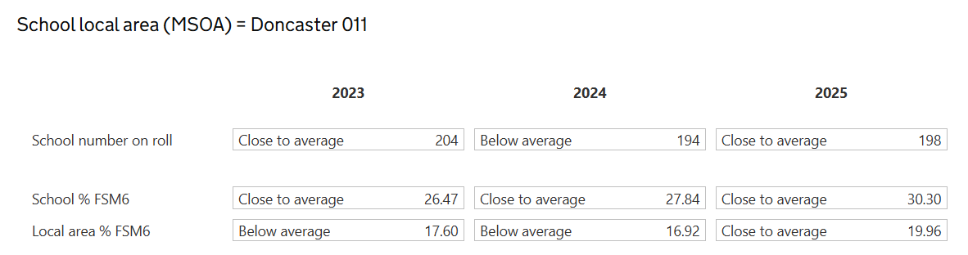
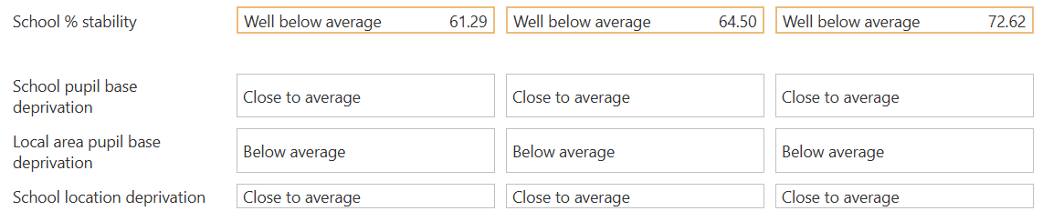

The school has 30% of pupils register as pupil premium: this is close to the national average (slightly above). It is important to note that the school is well below average in terms of stability (pupils leaving and joining the school after reception)

KS2Outcomes

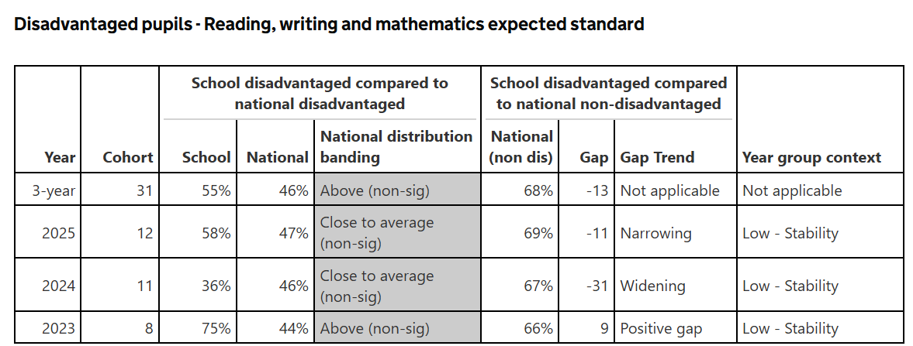
At the end of KS2, all pupils achieve close to the national average (School 59% - National; 61%). Disadvantaged pupils achieved 58% and are broadly in line with their peers in school. The gap to national disadvantaged pupils is narrowing.
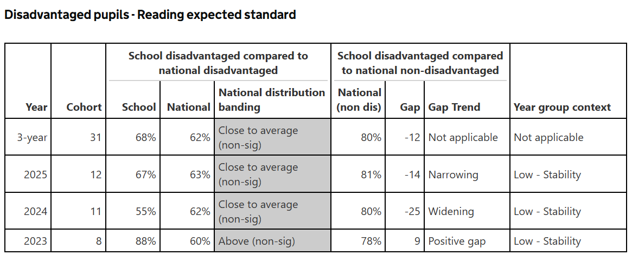
Reading data from KS2 shows an improving attainment over a 3-year period. The impact of our work on pedagogy is evident. Pupils who are not making expected Herts for Learning, reading gladiators and fresh start are used to fast track progress. Disadvantaged pupils achieve 5% above the national average. The gap to non-disadvantaged is narrowing. Strong phonics teaching inn school in KS1 and a robust catch-up programme is supporting learning in KS2.

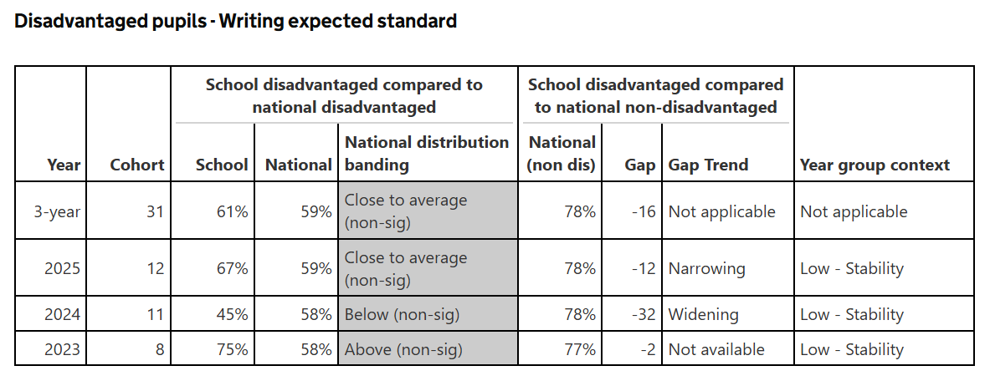
W
In writing there is a significant improvement from the previous year (22%).All pupils achieved 72% at the end of KS2. Disadvantaged pupils achieved 67% (2% gap) The gap to the gap to non-disadvantaged nationally is narrowing. The impact of work on pedagogy, a bespoke literacy curriculum, and a sharp focus on pupil progress has improved outcomes for disadvantaged pupils.
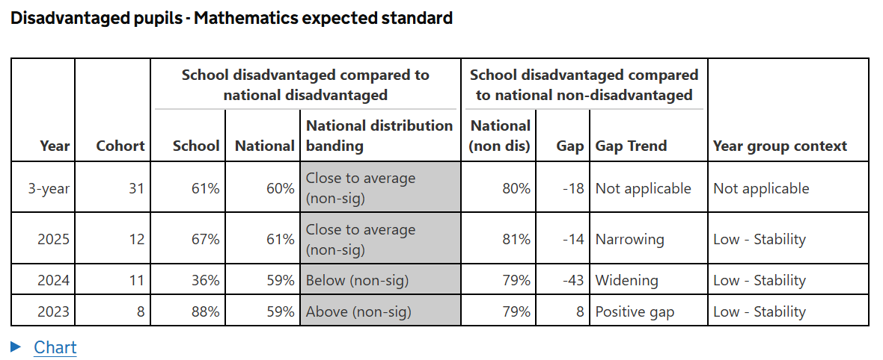
Work by leaders on the Ark Maths curriculum has taken place over the last academic year. Work on pedagogy, maths meetings and arithmetic lessons has shown a positive improvement for all pupils. A fast-track maths programme has also helped pupils to keep up with their learning and receive additional tuition as required. Disadvantaged pupils achieved 67% compared to 69% by all pupils. This was a significant increase from the previous year (59% - 55%). The gap to national non-disadvantaged is narrowing.

KS1 Phonics:

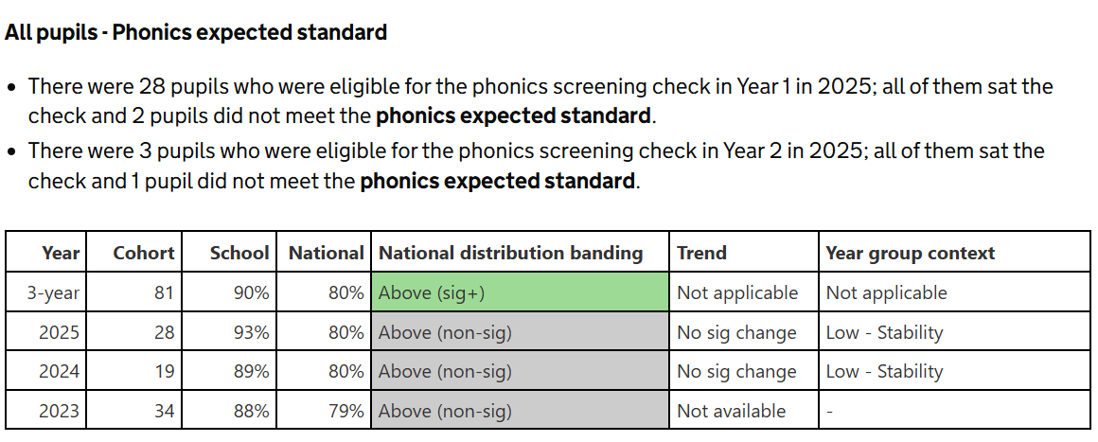
Phonics: The phonics scores for The school were above average (93% school: 80% national). Disadvantaged pupils

Attendance:
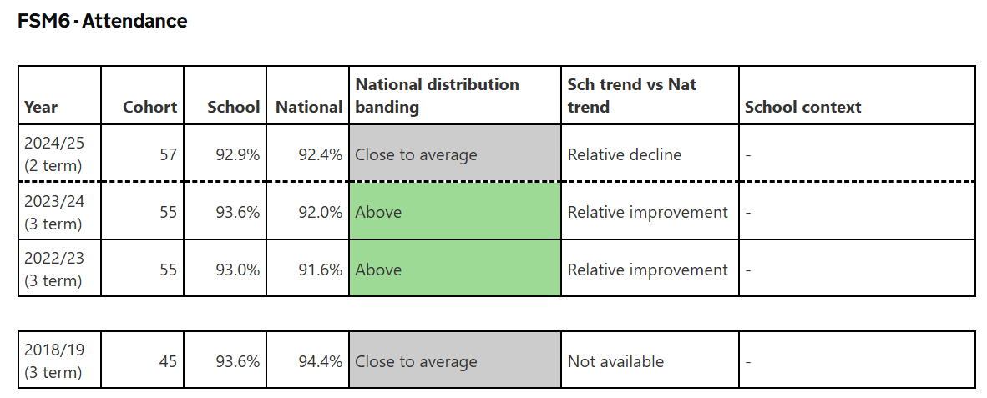

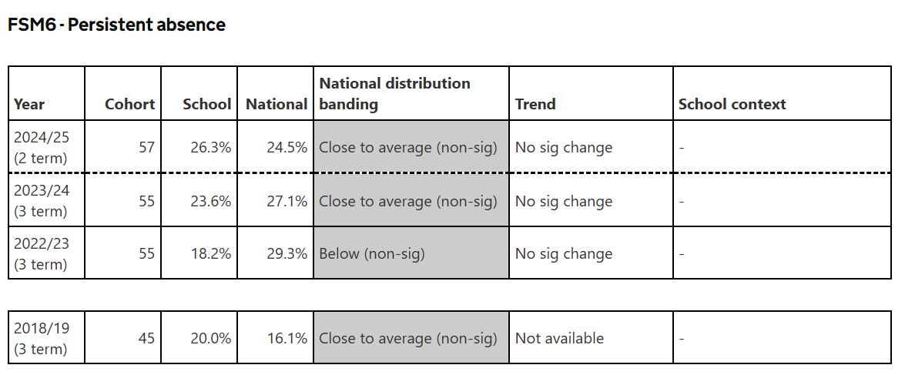
Last year, attendance for disadvantaged was 2.4% lower for the year than non-disadvantaged. It is 0.5% higher than the national average. This year there was a slight decline in attendance for disadvantaged pupils (0.7%). Persistent absence for disadvantaged pupils is higher than non-disadvantaged pupils (13%) and is close to the national average. The school has appointed a DSlL and attendance officer to work closely with # school leaders, external agencies, parents and pupils to raise attendance. Specific support and intervention is in place for families that require it.

