

Admissions Policy 2025/26
The Drive, Edenthorpe, Doncaster, DN3 2LS

- Admission Authority
Astrea Academy Trust is the admission authority for the school.

- Published Admission Number (PAN)
The School has a PAN of 30 for entry in Reception.

The School will admit this number of pupils if there are sufficient applications. Where fewer applicants than the published admission number for the relevant year group are received, the Academy Trust will offer places at the school to all those who have applied.
The number above is often the indicative admission number for subsequent year groups. From time to time, however, the true capacity of these year groups might vary and the Trust is entitled to limit the indicative admission number to a number below thirty where there are clear grounds to do so.

- Application Process and Timeline
Normal Round (for entry into Reception in September)

- Applications made during the main round for a place at the school are administered through Doncaster Metropolitan Borough Council (“the LA”). Parents resident in the Doncaster area can apply online at: https://www.doncaster.gov.uk/services/schools/primary-admissions

- Parents in other LA areas must apply through their home local authority.

- The LAs timetable will be used for all normal round applications each year.

- The deadline for an application for a place in Reception is 15th January, the year that your child will start school.

- Offers will be made by LA on behalf of the school, on 16th April or the next working day.

- In Year admission

- Applications for a place outside the main round are known as “in-year” applications. For example, if a Year 3 child moves into the area, an in-year application will be made.

- Astrea Academy Trust reserves the right to administer in-year admissions to the school. However, by agreement with the LA, the LA will administer these applications and parents should use the link provided above.

- Oversubscription criteria
When the school receives more applications than places available, after the admission of pupils with an Education, Health, and Care Plan (EHCP) which names the school, priority for admission will be given to those children who meet the criteria set out below, in priority order:
  - Looked After Children and children who were previously looked after but immediately after being looked after became subject to adoption, a child arrangements order, or special guardianship order.¹
  - Catchment Area - Children who normally reside with a parent or person with parental responsibility in the defined catchment area. https://www.doncaster.gov.uk/services/schools/school-catchment-areas
  - Siblings - Children who normally reside with a parent or person with parental responsibility in the defined catchment area and who will have a brother or sister (including step or half brother or sister) at the preferred school on the proposed date of admission and who lives at the same address as the child for whom the application is being made.
  - Children of staff in skills shortage posts - Children of staff at the school recruited to fill a skill shortage post – this will be subject to confirmation by the Astrea Executive Board that, on the evidence available, the post does indeed relate to a skills shortage in the area.
.

1 Children who are Looked After Children and all previously Looked After Children
Children who are Looked After Children and all previously Looked After Children
A 'looked after child' or a child who was previously looked after but immediately after being looked after became subject to an adoption, child arrangements, or special guardianship order including those who appear [to the admission authority] to have been in state care outside of England and ceased to be in state care as a result of being adopted. A looked after child is a child who is (a) in the care of a local authority, or (b) being provided with accommodation by a local authority in the exercise of their social services functions (see the definition in Section 22(1) of the Children Act 1989).

An adoption order is an order under the Adoption Act 1976 (see Section 12 adoption orders) and children who were adopted under the Adoption and Children Act 2002 (see Section 46 adoption orders). A ‘child arrangements order’ is an order settling the arrangements to be made as to the person with whom the child is to live under Section 8 of the Children Act 1989 as amended by Section 14 of the Children and Families Act 2014. Section 14A of the Children Act 1989 defines a ‘special guardianship order’ as an order appointing one or more individuals to be a child’s special guardian (or special guardians).

- Distance - Children living nearest the school; the distance to be measured by a
straight line between the centre point of the child’s ordinary place of residence and the main entrance to the school building.

- Tiebreaker for Equi-distant Applications

Where the offer of the last place in the relevant year group could be made for a number of eligible children resident equi-distant from the school the determination of the single offer will be by Random Allocation which will be managed by the LA.

- False Information
Any place offered on the basis of a fraudulent or intentionally misleading application will be withdrawn, e.g. giving a false address. It is for parents to satisfy the LA of their circumstances as they apply to the admission criteria at the time of application.

- Notes
- Home address - The home address is where a child normally lives. See LA website for definition.
- Shared parental responsibility - Where parents are separated and the child lives with each parent for part of the week, the home address will be the one where the child spends the majority of his or her time. The School will follow the policy used by the LA.
- Multiple births (twins, etc.) - In the case of multiple births or siblings in the same year group, where there is only one place available in the school, all will be considered together as one application.
- Service children and Crown servants - For families of service personnel with a confirmed posting to their area, or crown servants returning from overseas to live in that area, the Authority will allocate a place in advance of the family arriving in the area provided the application is accompanied by an official letter that declares a relocation date and a Unit postal address or quartering area address when considering the application against their oversubscription criteria. The Trust will not refuse a service child a place because the family does not currently live in the area.

- Late applications
All applications received after the deadline will be treated in accordance with the LA’s policy on late applications.

- Deferred entry for infants
Parents offered a place in reception for their child have a right to defer the date their child is admitted, or to take the place up part-time, until the child reaches compulsory school age. Places cannot be deferred beyond the beginning of the final term of the school year for which the offer was made.

Children reach compulsory school age on the prescribed day following their 5th birthday (or on their fifth birthday if it falls on a prescribed day). The prescribed days are 31 August, 31 December and 31 March.

- Admission of children outside their normal age group including Summer Born children (born between 1 April – 31 August)

Applications for children to be admitted to a school year outside of their chronological age group should be submitted to the home LA during normal round admissions, or to the LA as described above regarding the in-year admissions process clause 4. Each application will be considered and decided by the school on the individual circumstances of each case.

Applicants should provide documentation in support of their application regardless of whether they are asking for the child to be admitted in a lower or higher year group.

The School will take into account the parent’s views; information about the child’s academic, social, and emotional development; where relevant, their medical history and the views of a medical professional; whether they have previously been educated out of their normal age group; and whether they may naturally have fallen into a lower age group if it were not for being born prematurely.

The School will consider the information provided, taking into account the views of the head teacher, and will inform the parent in writing of their decision, including the reason. If the school agrees to this request the child will be considered with the other applicants under the published oversubscription criteria for the admission year and year group that they are applying for.

Parents have a statutory right to appeal against the refusal of a place at a school for which they have applied. This right does not apply if they are offered a place at the school, but it is not in their preferred age group.

- Waiting lists
The School will operate a waiting list for each year group. This will be maintained by the LA unless it is agreed that the LA will no longer have responsibility for in-year admissions.
Children’s position on the waiting list – and any offers made as places become available - will be determined solely in accordance with the oversubscription criteria. This means that the waiting list is not a ‘queue’ and it is possible to move down as well as up the waiting list if additional applications are received for children with higher priority.

The waiting list will operate for the full academic year. If at the end of the academic year a parent would like their child to be considered for entry to the subsequent year group, they will be required to apply afresh, see clause 4.

The Reception entry waiting list will be open until 31 December. All children who have not been offered a place at the school or where the school is ranked higher than the school where an offer was made will automatically be placed on the waiting list. Parents who would like their child to remain on the waiting list after the 31 December will need to contact the LA, see clause 4.

- Appeals
All applicants refused a place have a right of appeal to an independent appeal panel constituted and operated in accordance with the School Admission Appeals Code. Further information and contact details will be included in any refusal letter.

- Fair Access Protocol

The School will participate in the LAs Fair Access Protocol which will be used to place vulnerable and /or hard-to-place children, where they are having difficulty securing a school place in-year, and it can be demonstrated that reasonable measures have been taken to secure a place through the usual in-year admission procedures. Children admitted under this protocol will be prioritised over those on the in-year waiting list.

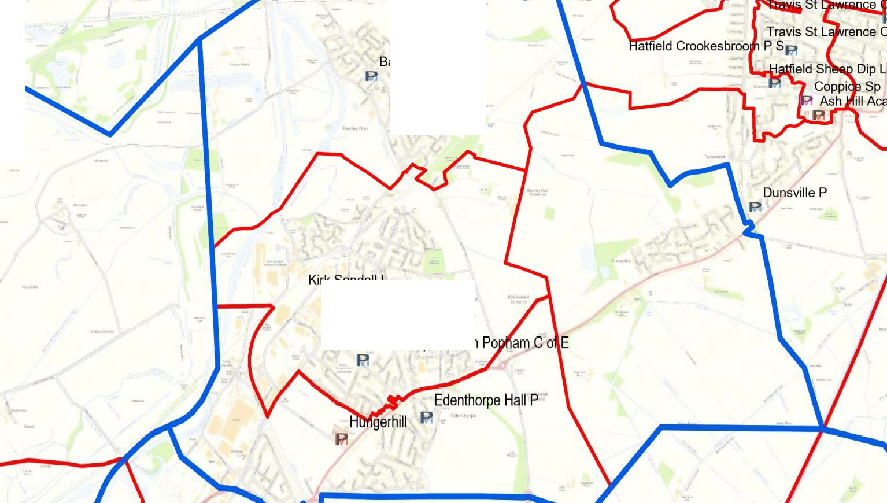

Bamby Dun P
A

