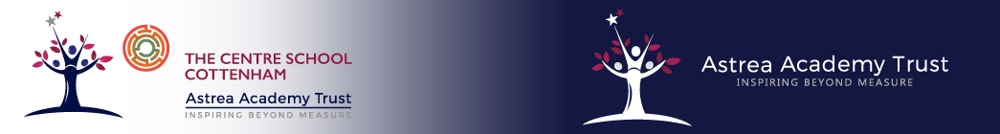

**PSHE Curriculum statement**

Personal, social and health education (PSHE) at key stage 3 & 4 helps pupils to lead confident, healthy and responsible lives as individuals and members of society. Through work in lesson time and a wide range of activities across and beyond the curriculum, pupils gain practical knowledge and skills to help them live healthily and deal with the spiritual, moral, social and cultural issues they face as they approach adulthood.

Our PSHE curriculum is a bespoke curriculum that is tailored to the needs of our students:

**‘Governing bodies and proprietors should ensure that children are taught about**

**safeguarding, including online safety, and recognise that a one size fits all approach**

**may not be appropriate for all children, and a more personalised or contextualised**

**approach for more vulnerable children, victims of abuse and some SEND children might**

**be needed.’** ***Keeping Children Safe in Education 2021-Ref 119.***