
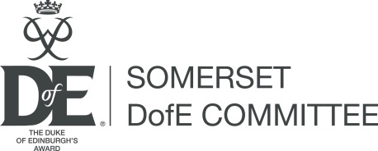
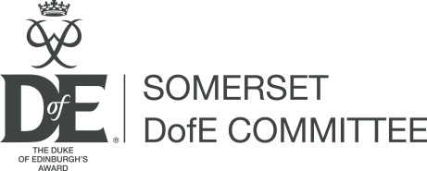

Somerset
Duke of Edinburgh’s Award
Committee

Bursary Fund - Individual

Information and application form

A grant programme to support young people aged 13- 24 complete a Duke of Edinburgh’s Award programme in Somerset

The initiative provides grants to help disadvantaged young people complete their DofE

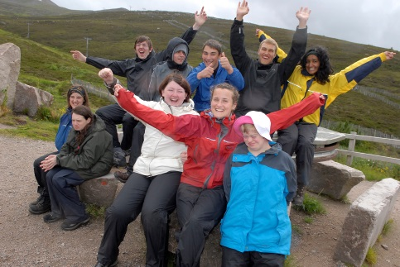
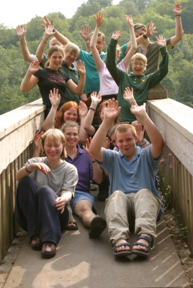

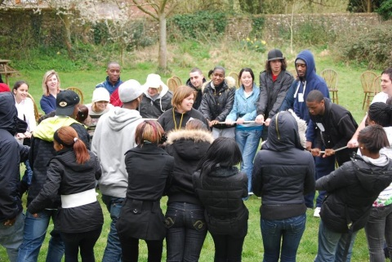



Somerset DofE Committee gratefully acknowledges the support provided to the Bursary by
The Fairfield Charitable Trust and the Provincial Grand Lodge of Somerset Freemasons

  What is the bursary fund??  The Somerset DofE Committee bursary fund offers grants to enable disadvantaged young people in Somerset to complete a DofE programme. The fund will provide up to £200 to support a Bronze, £300 for Silver and £400 for a Gold award.  Who decides on the grant?  Somerset DofE Committee includes:  - Somerset Council, which holds the DofE operating licence  - Organisations which support and provide DofE programmes  - Individuals with strong links to DofE  To find more about the committee and its work, please contact the DofE team DofE@somerset.gov.uk  Guidance notes:  - Please read the information carefully to ensure your application meets the criteria.  - Ensure you have completed every section of the form, and ask your supporting adult to complete their section.  - You can continue on a separate sheet if there isn’t enough room to give us as much information as you want.  - You can include supporting information with your application if you wish – but please make sure it’s all relevant and useful!  Please note:  - Bursary grants are available for disadvantaged young people. You should clearly state how you meet this criterion.  - The Bursary may not be able to provide 100% of the grant applied for.  - Successful applicants must provide updates on their progress as requested by the committee.  The panel’s decision is final | Criteria and Conditions  - Somerset DofE Committee intends the Bursary to help disadvantaged young people to complete a DofE programme.  - The Bursary will support young people to complete a programme in any Somerset DofE group – through Somerset Council’s licence, a National Operating Authority or Directly Licenced Centre.  - The young person should complete the form unless they are unable to do so, in which case the reason for this should be stated.  - Each application must be supported by a responsible adult - wherever possible this should be the DofE leader. This adult must not have a ‘personal’ connection to the applicant.  - The applicant must study and/or live in Somerset.  - Applicants can only make one application per DofE level (Bronze, Silver or Gold).  - The maximum grant available is £200/Bronze, £300/Silver and £400/Gold if the low income criterion is met.  - Otherwise the maximum is £100/Bronze, £150/Silver, £200/Gold.  - There is no minimum amount.  - The grant will be paid to the DofE group unless there are good reasons for us to pay another organisation.  - We will not pay the grant to an individual young person or their family.  - We will not fund the purchase of clothing or equipment which is available to hire from the DofE Store or other reputable organisation. Please email DofE@somerset.gov.uk for info. YP should speak to their DofE leader re kit requirements first, as often kit is available in a centre. Centre to apply for kit on the DofE store form  - The committee reserves the right to reclaim any unspent grant where a young person changes their DofE programme or fails to complete the level.  - The committee wants to publicise the Bursary fund and DofE, so may arrange presentations and photos. We expect anyone awarded a grant to participate in this unless there are good reasons not to.
Please email the completed application form to:
DofE@somerset.gov.uk

Please note: This page will be removed from your application to ensure it is anonymous when being assessed. Information on the rest of the form will be seen by the people assessing the application so please ensure you only use initials, so the information given does not identify you.

Young person’s contact details
Confidential information
Not to be seen by assessors
Name:
Address:
(including postcode)
Date of Birth:
Contact details:
Home phone:
Mobile:
Email:

Young person’s declaration:

I confirm that funding awarded will be spent on helping me complete my DofE programme. I confirm that I understand and will comply with the funding criteria and conditions set out at the beginning of this form.

Signed:
Name:  (please print) |  | Date:

This page is intentionally left blank

This sheet will be removed before assessment to ensure anonymity
About the applicant:

 | Applicant (Initials only): | Age:

Do you belong to any of the following group(s)? Please tick those that apply

 | Young carer |  | Looked after young person or care leaver
 | Young person with a disability  (please specify below) |  | Families in receipt of income support or maximum working credits (Provide Evidence)
 | Diagnosed mental health condition or supported by CAMHS* |  | Eligible for free school meals
 | * child and adolescent mental health services
Other – please give details below for consideration

Additional information:
Please give the committee a statement supporting the above, use initials only

Details

How much are you applying for?  Max £200/ Bronze, £300/Silver, £400/Gold- see criteria | £

Please tell us about your DofE programme

Level: |  | Bronze Silver Gold
DofE group:
Date started (or due to start):
Programme activities - Please input plans for each section
Physical | Skill |  | Volunteering | Expedition (travel method and date
How will completing your DofE programme benefit you?

Please explain how you will benefit from doing an award

Please provide a breakdown of the costs:

Show how you arrived at the figure

Who should the grant be paid to?

Please provide BACS details below

Account # Sort code#

Account name

Ref
Are you applying for any other funding to help with the cost of your DofE programme? If so, please explain:

Supporting adult’s details
Please ask your supporting adult to fill in this section and sign the declaration on the next page

Name:
Organisation:
Job title or position:
Relationship to applicant:
Address:
Telephone:  Office: |  | Mobile:
Email address:
Supporting adult’s comments to support this application:
NB – For anonymity please use applicants initials only within your comment

Supporting adult’s declaration:
I confirm that I will support the young person applying for this grant to complete their DofE programme. I will inform the DofE Committee if they change their programme or fail to complete the level.

Signed:
Name:  (please print) |  | Date:

