

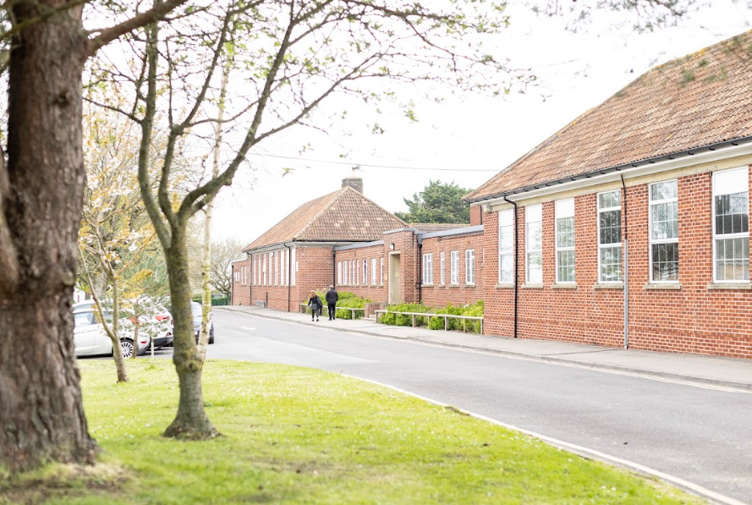

**IN YEAR APPLICATION FOR A SCHOOL PLACE AT ANSFORD ACADEMY**

**PLEASE READ THESE NOTES BEFORE COMPLETING THIS FORM**

This form should be used by parents/carers requesting a place at Ansford Academy. You must complete a separate application for each child.

**You must include proof of address such as a utility bill, bank statement, driving licence, exchange of contract letter from a solicitor or a six month tenancy agreement signed by yourself and landlord. Photocopies will be accepted. Your application will not be processed without this.**

All relevant sections of the form **must** be completed and signed by the applicant or the form will be returned to you.

Applications will be processed in strict date order. The applicant will be notified of the decision in **writing** within ten school days.

If you have any queries about the in year application process, please telephone Ansford Academy on 01963 350895 or email **admissions@ansford.mnsp.org.uk.**

Please do not complete this form if your child has an EHCP. If this is the case please contact the Special Education Needs Casework Team on 0300 123 2224.

This form can be made available in large type upon request.

**Part 1 – Reason for your application**

Please tick the relevant box

1. Moving into Somerset ⬜

2. Moving within Somerset ⬜

3. Not moving but wanting to change school ⬜

What is your preferred start date?

(within 6 weeks/half term in advance. Service families may apply up to a year in advance with proof of posting to the area)

It will not always be possible to provide a place at Ansford Academy, therefore you are encouraged to arrange a meeting with the Principal, before completing this form.

Have you previously applied for a place at this school? **YES/ NO**

**Please note:** Ansford Academy will not consider more than one application within the same academic year unless there has been a significant material change, such as a change of address.

**Part 2** **- Pupil Details**

Child’s Legal Surname: Child’s Forename(s):

Date of Birth: Female/Male

|  |  |
| --- | --- |
| Current Address | (If applicable) Address moving to |
| Date since | Date of moving |

|  |  |
| --- | --- |
| Current/Previous School | If previous school, last date on roll |
| Address | |

**Part 3 – Applicants Details**

Title Mr/Mrs/Ms/Miss/Other - Please state

Parent/Carer’s Surname : Parent/Carer’s Forenames:

Relationship to child: Email Address:

|  |  |
| --- | --- |
| Address (if different from child’s) | |
| Daytime Tel No - | Mobile Tel No - |

**Do you have Legal Parental Responsibility for this child?**

**Name and address of other parties with parental responsibility:**

|  |  |
| --- | --- |
| Name | Relationship to student: |
| Address  Telephone number | |

**Part 4 – Supporting Information**

Your answers to the following questions are important. Ansford Academy Admissions Authority will use this information in conjunction with the appropriate published over-subscription criteria to help determine whether your child has a priority for a place at Ansford Academy.

A ‘Child In Care’ is a child who is in the care of the Local Authority (LA) or provided with accommodation by that LA. If you are applying on behalf of a 'Child In Care', please circle 'Yes' and obtain the signature of the Social Worker involved in the child's care.

1a. Is this application for a child currently in the care of a Local Authority **YES /NO**

|  |
| --- |
| If **Yes**, which Local Authority?  Name of Social Worker:  Contact Number: |

1b. Has your child previously been in care and is now formally adopted, subject to a residence/child arrangement order or a special guardianship order

**YES/ NO** *(please circle)*

If you ticked **Yes**, please provide a copy of the adoption order/letter of confirmation from the relevant LA

1c. If you have answered **Yes** to either of the questions above, has the Virtual School been consulted about a change of school. **YES / NO** *(please circle)*

2a. Does your child have an Education, Health and Care Plan naming Ansford Academy? **YES/NO** *(please circle)*

If your child has an Education Health and Care Plan, the in year admissions process does not apply. Therefore if you ticked **Yes** please do not complete anymore of this form and instead speak to the SEN Casework Team by contacting 0300 123 2224.

If your child does not have an Education Health and Care Plan, but you believe there are important medical or special reasons why a place should be prioritised at the school, please detail this later in the form or by supplying additional documentation.

2b. Does your child have any specific disability of which a school should be aware? If Yes, please supply any relevant information.

**YES/NO** *(please circle)*

Callum is mildly deaf in one ear.

3. Will there be any siblings on roll at Ansford Academy at the time the school place is required? The sibling(s) must be resident at the same address.

No

If **YES** please provide details of each sibling(s):

i) Child's Legal Surname: Child’s Forename(s)

ii) Child's Legal Surname: Child’s Forename(s)

iii) Child's Legal Surname: Child’s Forename(s)

4. Are either parents/carers members of the staff at Ansford Academy?  **YES/NO** *(please circle)*

5. Fair Access Criteria – please tick if any of the following applies to your child. (Please note that ticking one of the boxes below does not guarantee a place at Ansford Academy. It will enable the Fair Access Protocol to be invoked should you be unable to secure a school place under the normal in year admission process).

|  |  |
| --- | --- |
| a) Children either subject to a Child in Need Plan or a Child Protection Plan or having had a Child in Need Plan or a Child Protection Plan within 12 months at the point of being referred to the Protocol |  |
| b) Children living in a refuge or in other Relevant Accommodation at the point of being referred to the Protocol |  |
| c) Children from the criminal justice system |  |
| d) Children in alternative provision who need to be reintegrated into mainstream education or who have been permanently excluded but are deemed suitable for mainstream education |  |
| e) Children with special educational needs (but without an Education, Health and Care plan), disabilities or medical conditions |  |
| f) Children who are carers |  |
| g) Children who are homeless |  |
| h) Children in formal kinship care arrangements |  |
| i) Children of, or who are, Gypsies, Roma, Travellers, refugees, and asylum seekers |  |
| j) Children who have been refused a school place on the grounds of their challenging behaviour and referred to the Protocol |  |
| k) Children for whom a place has not been sought due to exceptional circumstances |  |
| l) Children who have been out of education for four or more weeks where it can be demonstrated that there are no places available at any school within a reasonable distance of their home. This does not include circumstances where a suitable place has been offered to a child and this has not been accepted |  |
| m) Previously looked after children for whom the local authority has been unable to promptly secure a school place |  |

**Part 5**

I understand that applications must be made by the child's **legal parent/carer** and that by signing the declaration below I will be confirming my understanding of the information provided to Ansford Academy on this application form and that the information I have provided is correct**. I accept that Ansford Academy reserves the right to withdraw school places which have been obtained by providing incorrect or misleading information.**

I understand that it is the parent’s responsibility to ensure that Ansford Academy receives the completed application form safely. I note that it is recommended to send this application form by Special Delivery post, or obtain a proof of posting certificate, or a receipt from Ansford Academy reception desk if my application is hand delivered.

I accept that where parents equally share parental responsibility and two applications are submitted for the same child, the Academy will require the parents to agree which application is to be considered and which should be withdrawn. If the parents cannot agree and there is no court order to determine majority responsibility, the preferences indicated by the parent who receives child benefit for the child concerned will be awarded a higher priority than those from the other parent.

I accept that the child's home address must be the place where the child permanently resides for the majority of the time. This would normally be at the same address as the person who has Parental Responsibility for the child and is their main carer. Where the child spends equal amounts of time with both carers, the Academy Admissions Authority will consider the place of residence of the parent/carer who receives Child Benefit to be the child's home. Evidence of parental responsibility will be required should there be doubt and Ansford Academy Admissions Authority may undertake thorough residency checks and reserves the right to request independent confirmation of the child's address.

Signature of Parent/Carer Date:

**This form must be signed and dated for it to be processed, if it is not then it will be returned.**

**Part 6 – Submitting your application form**

When you are satisfied that you have provided all the relevant information on your application form including proof of address and any necessary Supplementary Information Form(s) please ensure that you have signed the declaration in Part 5 and then submit your completed application by email to [**admissions@ansford.net**](mailto:admissions@ansford.net)or by post to **Ansford Academy Admissions, Maggs Lane, Castle Cary, Somerset BA7 7JJ.**



|  |
| --- |
| **IMPORTANT INFORMATION**  Moving school for whatever reason is a very important decision. It is a decision which can have significant negative effects and disruption, not only academically for example where research has shown that English and Maths results for pupils within Key Stage 2 can drop by around 12% with just one in year move, but also with their mental health. Leaving a school midway through a term or year can disrupt friendships as well as relationships with school staff and the wider community. Children who change schools may struggle with the transition process and find it hard to settle in or feel that they belong in a new school environment. Multiple moves can be particularly challenging, but even single moves, especially when associated with other factors, such as changes within a family like divorce, poor parental mental health etc, can affect a child’s sense of belonging to a school as well as their confidence, self-esteem and attainment.  It is therefore suggested that a change of school is considered extremely carefully, and that all other options are explored before making the decision to apply for other schools.  We recommend that you   * **Discuss the move with your child’s current school before taking the decision to transfer your child to another school.** * **Visit Ansford Academy before making an application.** * **If you are moving to the area, consider applying for more than one school at a time to speed up the possibility of securing a school place.** * **Submit an application form even if a school states they are full. All schools have waiting lists and submitting an application for one of these schools will ensure your child is added to the waiting list for the school for the remainder of the academic year. Priority on the waiting list is determined by each schools over subscription criteria.**   The information requested in parts 7 and 8 is used solely for the purpose of identifying whether your child meets the criteria for consideration under the Somerset Fair Access Protocol and to assist the new school with planning for your child’s admission. If the information does not allow for the application to be considered under the Fair Access Protocol then the information will not be used to determine whether or not to offer your child a place.  **Your application will be neither advantaged nor disadvantaged by completing these parts.**  **There is no statutory requirement to complete parts 7 and 8 however we would encourage you to consider sharing information about your child in an attempt to ensure a successful transition.**  Part 7 is to be completed by parent/carer and part 8 to be completed by current or previous school wherever possible. |

By signing I understand that any information provided in parts 7 and 8 will be shared with Ansford Academy for which I have submitted an application.

Signature of Parent/Carer Date

I give consent to Ansford Academy to obtain, on my behalf, the information contained in part 8 along with any other relevant information to establish if my application meets Somerset Fair Access Protocol.

Sign to give consent:

Signature of Parent/Carer Date

**Part 7 – Additional Information**

**The information that you supply will not be used when determining the outcome of your application. This information will be used for the purpose of assisting us when planning your child’s admission or for identification under the Somerset Fair Access Protocol.**

**Reason for leaving**

Permanently excluded ⬜ Fixed term excluded ⬜ Other X (Please provide details)



|  |
| --- |
| I have discussed my reasons for wanting to change schools with my child’s current school. |
| Please provide the name of the person(s) you have spoken to at your child’s current school – |
| Date of any meetings - |

Have any of the following services been involved with your child in the last 3 years?  **YES/NO** *(please circle)*

*(Please tick all relevant boxes below)*

Parent Family Support Advisor (PFSA) ⬜ Access Casework/Liaison Officer ⬜

Behaviour Support Worker ⬜ Educational Psychologist ⬜

Children’s Social Care ⬜ Child and Adolescent Mental Health Service ⬜

Medical Tuition Services ⬜ Sensory, Physical and Occupational Therapy Service ⬜

Elective Home Education Services ⬜ Traveller Education Service ⬜

Education Safeguarding/Attendance Team ⬜ Speech, Language and Communication Services ⬜

Autism Service ⬜ Family Intervention Service ⬜

Other – (Please specify)

Is your child attending school regularly? Yes ⬜ No ⬜

If not, is an Education Attendance Officer involved? Yes ⬜ No ⬜



**Part 8 - In Year Admissions Additional Information**

Please can we ask the Head of Year (or most appropriate staff member) to complete the information below.

The information that you supply will be used for the purpose of assisting us when planning the students admission and/or for identification under the Somerset Fair Access Protocol.

|  |  |
| --- | --- |
| **Student Name:** | **DOB:** |
| **Date:** | **Date Student Started:** |

|  |  |
| --- | --- |
| **Attendance: (%)**  **(Authorised and Unaurthroised)** |  |
| **Eligible for FSM:** |  |
| **Student medical history: (Concerns or requirements)** |  |
| **Safeguarding Concerns:** |  |
| **Agency Involvement: (Past and Present)** |  |

|  |  |  |  |  |  |  |
| --- | --- | --- | --- | --- | --- | --- |
| **Academic Data** | | | | | | |
| **KS2 Scores** | **English** |  | **Maths** |  | **Science** |  |
| **Other data** | **Reading Age** |  | **Spelling Age** |  | | |

|  |  |  |  |  |
| --- | --- | --- | --- | --- |
| **CATS Scores (if known)** | | | | |
| **Mean** | **Non-Verbal** | **Quantitative** | **Spatial** | **Verbal** |

|  |  |  |  |  |
| --- | --- | --- | --- | --- |
|  | | | | |
|  | **Exam Board**  **(KS4 only)** | **Target Grade** | **Current Grade** | **Topics Covered**  **(KS4 only)** |
| **Maths** |  |  |  |  |
| **English** |  |  |  |  |
| **Science** |  |  |  |  |
| **KS4 only (Current subjects student is studying)** | | | | |
| **Option 1:** |  |  |  |  |
| **Option 2:** |  |  |  |  |
| **Option 3:** |  |  |  |  |
| **Option 4:** |  |  |  |  |
| **Option 5:** |  |  |  |  |

|  |
| --- |
| **What support is needed to enable a successful transition for subjects?** |

|  |  |
| --- | --- |
| **Does the Student have: (Please detail the current support in place)** |  |
| **Special Educational Needs** |  |
| **Individual Education Plan or Pastoral Support Plan (Including AP/ extended work placement)** |  |
| **Student specific funding** |  |
| **EHCP** |  |

|  |  |
| --- | --- |
| **Number of Suspension:** |  |
| **Is the student at risk of PEX?** |  |
| **Overview of current behavioural issues/ concerns:** |  |

|  |  |
| --- | --- |
| **Name:** | **Position:** |
| **Signed:** | **Date:** |