SIMS Connected login using google account.

- Login to SIMS ID using your connected details.
https://id.sims.co.uk
login with your existing ID and password
- Go to your profile
Click The hello Your Name (Top Right)
Click My Profile
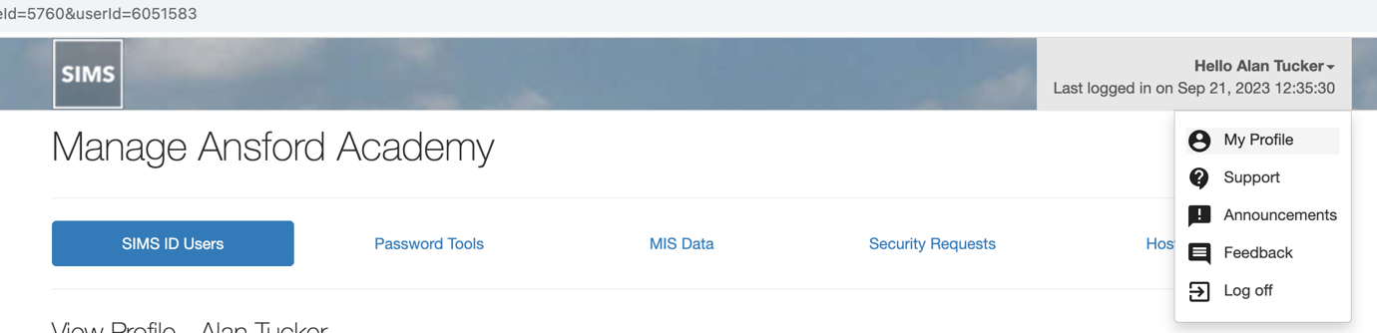
- Select Your email addresses.
Click on Login & Communication Preferences, then from the drop down click Email Addresses
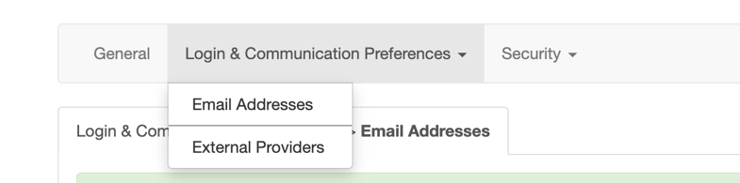
In the Add email address Box type your Ansford email address and click Save Email Address

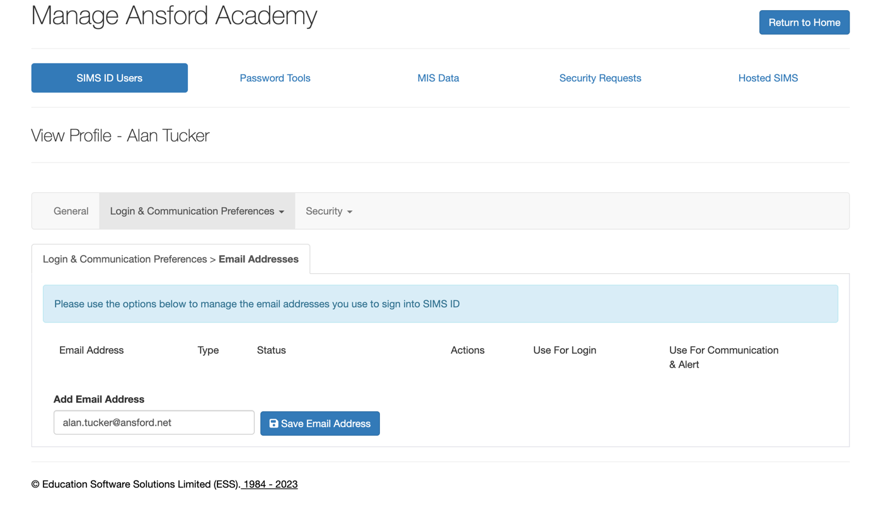

This email address will need to be verified. Click the confirm Email Button. You will then be asked to enter the full email address.
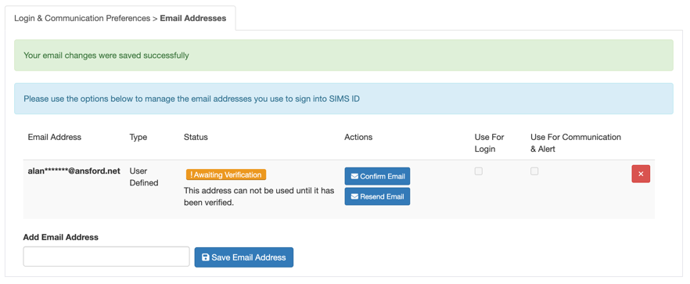
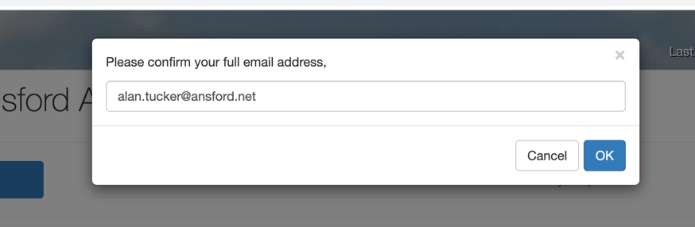
Once Verified the “User For Login” and “Use For Communication & Alert” boxes should be ticked.
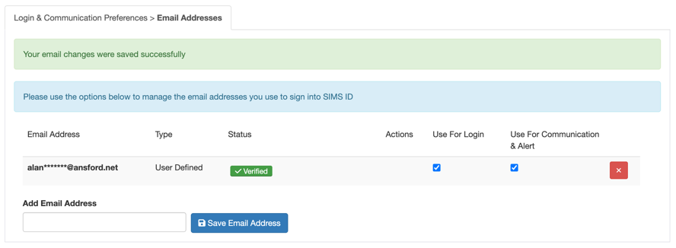
An email will have been sent to your email address with a link in it to confirm the email. If the above is not available, click the link in the email and login to sims connected with your original ID this will verify the address for login purposes. At this point you can now use your original Connected ID or your email address with your connected ID Password. Now that your email address is linked, we can continue to link this to your google account.

- Login with Your connected ID and select My Profile as we did in the procedure above, click Login & Communication Preferences, then proceed to select “Google” under “3rd Party Login”.
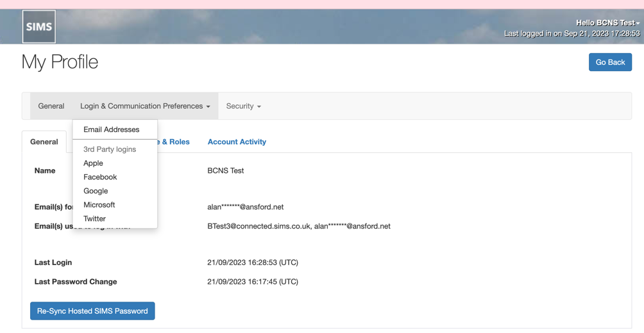
- Click the Link Google account Button and login to your Ansford Google Account.
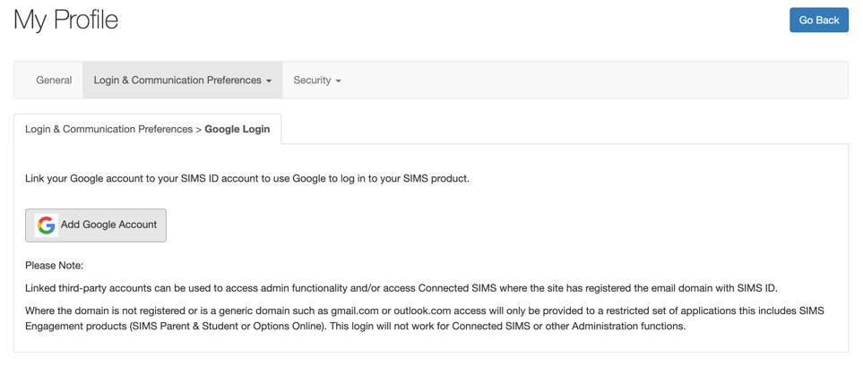
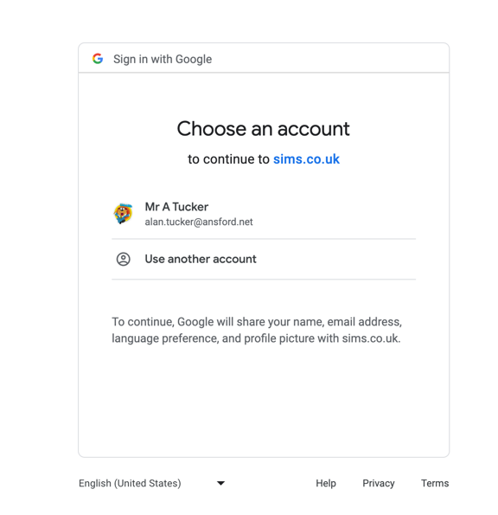
Select your account and enter login password if required.

- Wait for the “you have successfully logged in message” then the “waiting for your Profile” message, when this is finished you will be returned to “My Profile” The “Add Google account” Will now say unlink Google Account.
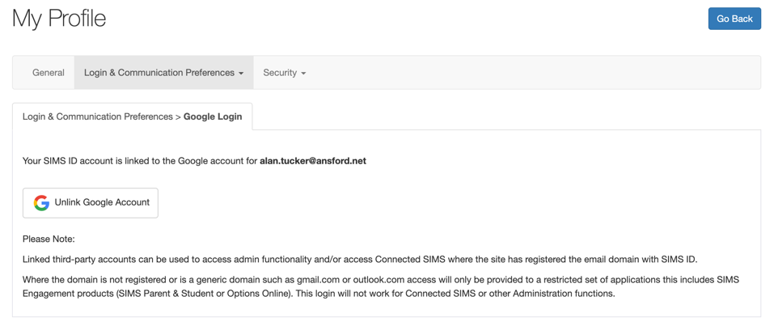

- Test Google Login
Using a browser that has already been logged into Google (Any browser logged into ansford.net or mail will do). Open a new tab and open https://id.sims.co.uk At this point do not enter login credentials under the Word “OR” click the Google icon
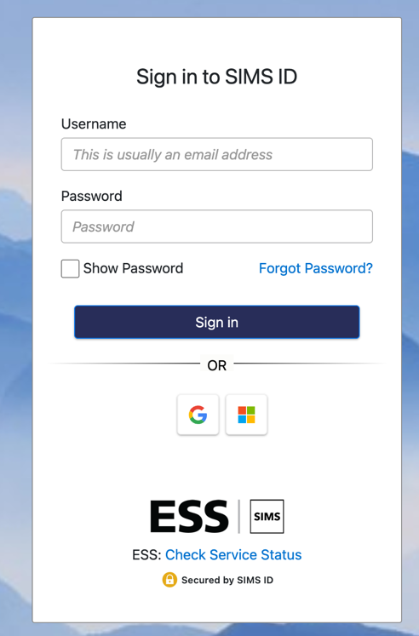
- You will then be prompted to select your google account.
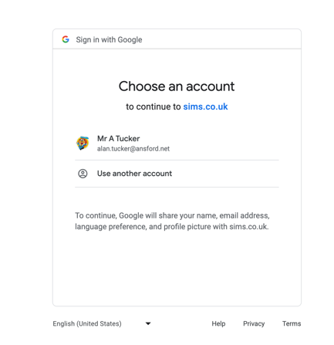
Click your account name, you will then be logged into SIMS ID. Click the purple tile to open SIMS as normal.

