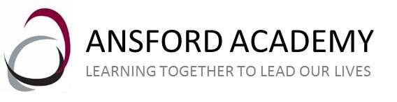

ANSFORD ACADEMY

SUPPLEMENTARY INFORMATION FORM
Admission in 2021

To be completed by the parent/carer

The governing body is the admissions authority for Ansford Academy and has responsibility for setting the admission arrangements.

Criterion 2 in the over-subscription criteria for Ansford Academy prioritises pupils who are eligible for free school meals as at the application closing date.

It may be that you feel you are eligible for consideration under this criterion. If so, please provide evidence that you are entitled to the relevant benefits stated above and that the entitlement is current. Please complete this form and return it with the necessary evidence with your school place application by the closing date of 31 October 2020. If you do not wish your child to be considered under the above criterion, this form is not necessary.

It is entirely the responsibility of the applicant to ensure that any Supplementary Information Form is returned on time.

Name of child:
Surname . . . . . . . . . . . . . . . . . . . . . First names . . . . . . . . . . . . . . . . . . . . . . . .
Date of birth . . . . . . . . . . . . . . . . . . . . .

Please place a tick in the box which describes your circumstances  criterion 2 | Children entitled to receive free school meals as at the application closing date

Please include evidence: to show your child is eligible for free school meals; This includes universal credit, income support, Employment Support Allowance (income related), Income-based job seekers allowance, Guaranteed Element of State Pension credit, Support under part VI of the Immigration and asylum act 1999, Child Tax Credits without working tax credits with an annual taxable income of less than £16190.

