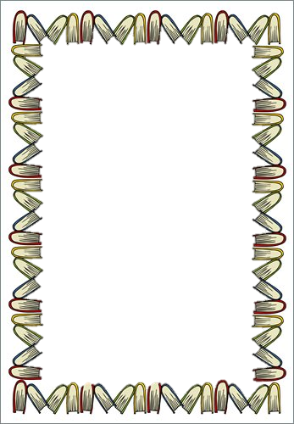

**Year 6 into Year 7**

**Summer Holiday Read-a-thon!**

Over the 6 weeks this summer, we would love you to **expand your reading horizons** and pick up a book you have never read before!

In preparation for your first year studying English at Enfield Grammar School, we would like you to complete **two book reviews**: one review on your **favourite book** and one review of a **brand new book** you read this summer.

Each book review should include:

* An engaging title and images
* A brief summary of the book – but don’t give away the ending!
* Your favourite character and why
* Your favourite moment in the book and why
* Who you would recommend this book to and why
* A rating out of 5 stars

These reviews will be presented to your English teacher in your first lesson in September.

The top reviews that show the most effort will win prizes, certificates and merits!

We suggest the following books as inspiration for your summer of reading.

* *High Rise Mystery*  by Sharna Jackson
* *The London Eye Mystery by Siobhan Dowd*
  + - * + *D-Day Dog* by Tom Palmer
        + *Ghost* by Jason Reynolds
        + Challenge Novel: *The Northern*

*Lights* by Phillip Pullman

***Have a lovely summer and happy reading!***

***From Miss Print (Literacy Co-ordinator), Ms Rudolph (Library Manager) and the English Department at EGS.***