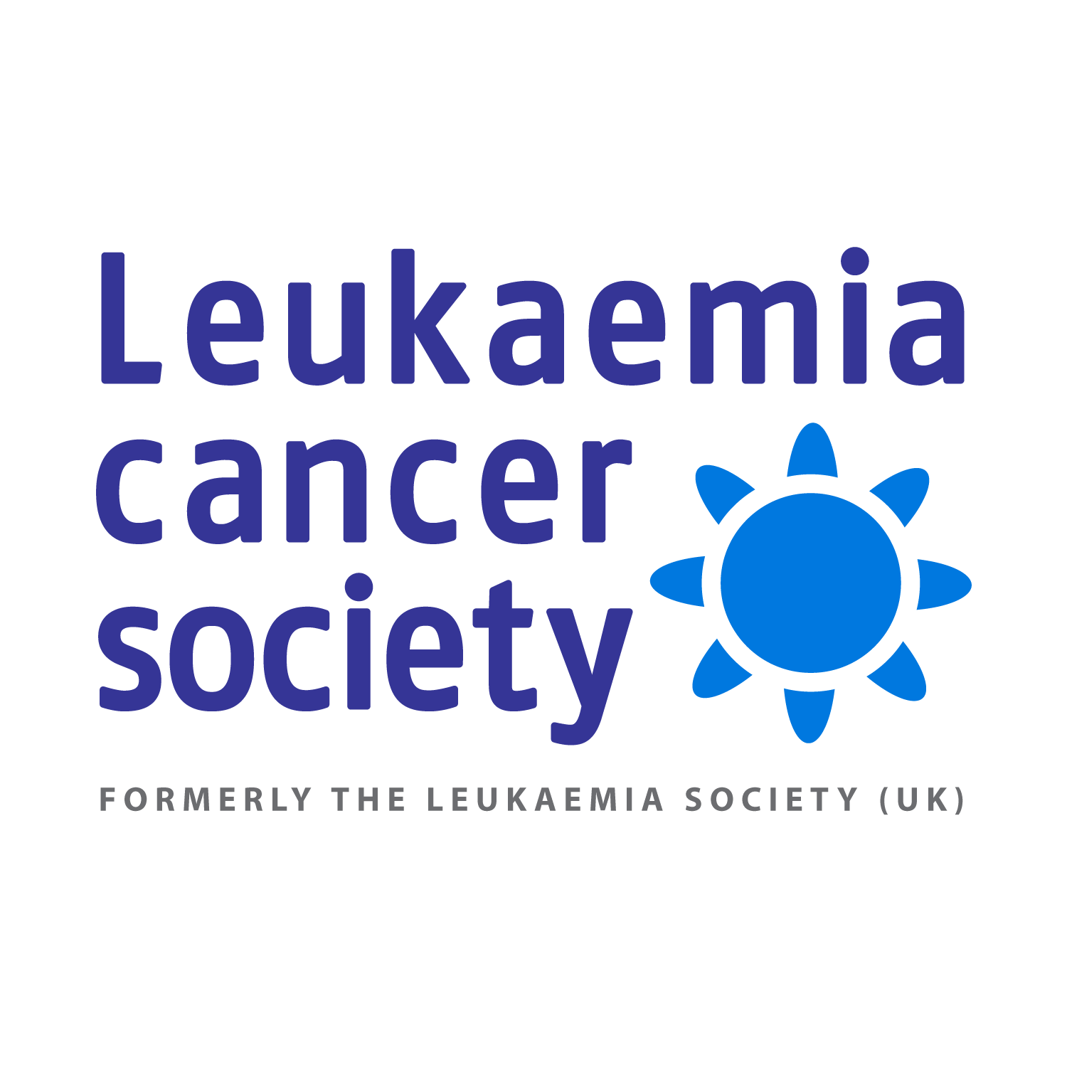
118 Myddleton Road
London N22 8NQ
Tel/Fax 020 8374 4821
Reg. Charity No. 1040984
www.leukaemiacancersociety.org
enquiries@leukaemiacancersociety.org

Children’s Story Competition Submissions Form
Teacher/Tutor/Youth Club Leader: …………………………………………………
School/College/Youth Club: …………………………………………………………
Address: ……………………………………………………………………………….
…………………………………………………………………………………………..
…………………………………………………………………………………………..
Phone number: ………………………………………………………
Email: …………………………………………………………………

PLEASE NOTE: Each story should have its own title not use the theme as its title.

No. | Pupil’s Name | Story Title | Category  A B C | Age | Gender
1.
2.
3.
4.
5.
6.
7.
8.
8.
9.
10.
11.
12.
13.
14.
15.
16.
17.
18.
19.
20.
21.
22.
23.
24.
25.
26.
27.
28.
29.
30.

Categories: Aged 7 - 9 [ A ]; Aged 10 - 12 [ B ]; Aged 13 - 15 [ C ];

Please return the completed form along with the story entries to:
The Leukaemia Cancer Society, 118 Myddleton Road, London, N22 8NQ.

For all enquiries please call 020 8374 4821 or email us at enquiries@leukaemiacancersociety.org

