 | Monday 1st | Tuesday 2nd | Wednesday 3rd | Thursday 4th | Friday 5th
Overview | AM  Listen to the Video of Miss Dibble and Miss Kiely reading Aliens Love Underpants.  While your listening can you identify the rhyming words?  Can you tell your adult your favourite part of the story and why?  https://www.youtube.com/watch?v=U9POYNBepFk  PM  Alien handprints  In today's lesson, we are going to create aliens from our handprints! We will think about the colour of our aliens, how many eyes they will have and what their arms and legs will look like. The three key areas that this lesson links to are communication and language, expressive arts and design, and maths.  https://classroom.thenational.academy/lessons/alien-handprints-61jkec | AM  Listen to the story The Very Hungry Caterpillar.  Can you tell your adult your favourite part of the story and why? What happened to the caterpillar at the end of the story?  https://www.youtube.com/watch?v=KQiVpuEEhA4  PM  To identify foods that are healthy and foods that are not healthy  In this set of lessons we learn about how to eat a healthy, balanced diet. In this lesson with Miss Hughes, we learn the importance of a healthy diet. We learn about the importance of different food groups and end the lesson by designing a plate of healthy food.  https://classroom.thenational.academy/lessons/to-identify-foods-that-are-healthy-and-foods-that-are-not-healthy-64wk0d | AM  Listen to the story We are going on a Bear Hunt. Can you join in the story with us? Maybe you could act out the different parts as we read it?  https://www.youtube.com/watch?v=quTji3Exud8  PM  Who is in my family?  In this lesson you will be exploring the different types of families. We will learn about extended families and new additions. You will be looking closely at who is in your family and be creating your very own family tree, using images; either photographs or drawn images, to show how people are related to you.  https://classroom.thenational.academy/lessons/who-is-in-my-family-64tkgr | AM  Listen to the story Stick Man. Can you join in with the repeated parts and identify the rhyming in the story?  https://www.youtube.com/watch?v=gaH5bptsUMU  PM  Play a listening and attention game. Place a number of woodland items, such as a conker, an acorn, a twig, a leaf, a pinecone on a tray. You close your eyes while your adult removes on of the objects. You have to identify which object has been removed. | AM  Listen to the story Giraffes Can’t Dance. Did you hear any new words in the story?  https://www.youtube.com/watch?v=UEesAL08Ao0  PM  Listen to your adult read you their favourite kids book? Can you try and help them read some parts of it?

Letters and sounds | Listen to:  Jolly Phonics Song -https://www.youtube.com/watch?v=_s-1sxzjPX8&t=2s  Tricky Word Dinosaur Rap https://www.youtube.com/watch?v=e2lWkrFFbwg  Watch - Geraldine the Giraffe teach the sound – ee  https://www.youtube.com/watch?v=qfM7Hz7US0U  Activity – ‘ee’ read and write | Listen to:  Jolly Phonics Song -https://www.youtube.com/watch?v=_s-1sxzjPX8&t=2s  Tricky Word Dinosaur Rap https://www.youtube.com/watch?v=e2lWkrFFbw g  Watch – Miss Dibble teach the sound – igh https://www.youtube.com/watch?v=Vo-cv7Q68TE  Activity – ‘igh’ read and reveal words. Cover the picture. Children to chop and blend the word, then look at the picture to check they are correct. | Listen to:  Jolly Phonics Song -https://www.youtube.com/watch?v=_s-1sxzjPX8&t=2s  Tricky Word Dinosaur Rap https://www.youtube.com/watch?v=e2lWkrFFbwg  Watch - Geraldine the Giraffe teach the sound – oa https://www.youtube.com/watch?v=KCJyHN0IFE8  Activity – ‘oa’ and ‘igh’ word matching. | Listen to:  Jolly Phonics Song -https://www.youtube.com/watch?v=_s-1sxzjPX8&t=2s  Tricky Word Dinosaur Rap https://www.youtube.com/watch?v=e2lWkrFFbwg  Watch – Miss Kiely teach the sound – oo https://www.youtube.com/watch?v=orCtT5qG10w  Activity – write the ‘oo’ words. | Listen to:  Jolly Phonics Song -https://www.youtube.com/watch?v=_s-1sxzjPX8&t=2s  Tricky Word Dinosaur Rap https://www.youtube.com/watch?v=e2lWkrFFbwg  Watch - Geraldine the Giraffe teach the sound – ar https://www.youtube.com/watch?v=QXBQDsgRuMo  Activity – ‘oo’ and ‘ar’ word matching.
Reading | - This week is WORLD BOOK WEEK we will be looking at a different book each day. There will be a video of us reading the book or if you have the book at home feel free to read it to your child or look up the stories on YouTube for them to listen to.  - We would like to run a competition this week for the most unusual place to read. Send us a picture of your child reading in an unusual place by Thursday evening, we will announce the winner on Friday there will be a certificate and a prize for the winner!  - Unfortunately this year we won’t be able to do our whole school ‘dress up as your favourite book character’ at school on Thursday 4th March. However you could still dress up at home and send us pictures of you dressed up – we would love to see them! if you haven’t got a costume you could make one.  - We have added some alternative Twinkl eBooks that you can access using pin code: SD0793at Twinkl Go.  - There are also lots of lovely resources at - https://www.worldbookday.com/ideas/share-a-story/ & http://www.lovemybooks.co.uk/  - Don’t forget you can access free eBooks on the Oxford Owl website (https://www.oxfordowl.co.uk/for-home/find-a-book/library-page/)  - Scholastic’s are also offering free resources for home learning - https://resource-bank.scholastic.co.uk/content/39880
PE | Join Joe wicks Monday, Wednesday and Friday at 9am for PE with Joe. You will find him on YouTube the Body Coach TV. https://www.youtube.com/user/thebodycoach1
Mark Making | ‘The benefits of mark making in the early years are clear; a child's physical skills are developed, their creative skills and imagination grows further, children are given a new output to express their feelings and also given a stepping stone into writing.’  Regular name practise is important! Even if your child can write their name they still need practise in making it neater; smaller letters; capital letter at the beginning (not in the middle!); writing their letters round the right way; not writing their names backwards.  They don’t always have to use a pen and paper to write their name or make marks! Why not try writing in flour, shaving foam, sand, oats, paint.

Creative activities | Can you design and create your own Alien wearing underpants? What could you use to make them? | Can you paint a picture like Eric Carle? Paint your own Caterpillar or butterfly in the style of Eric Carle.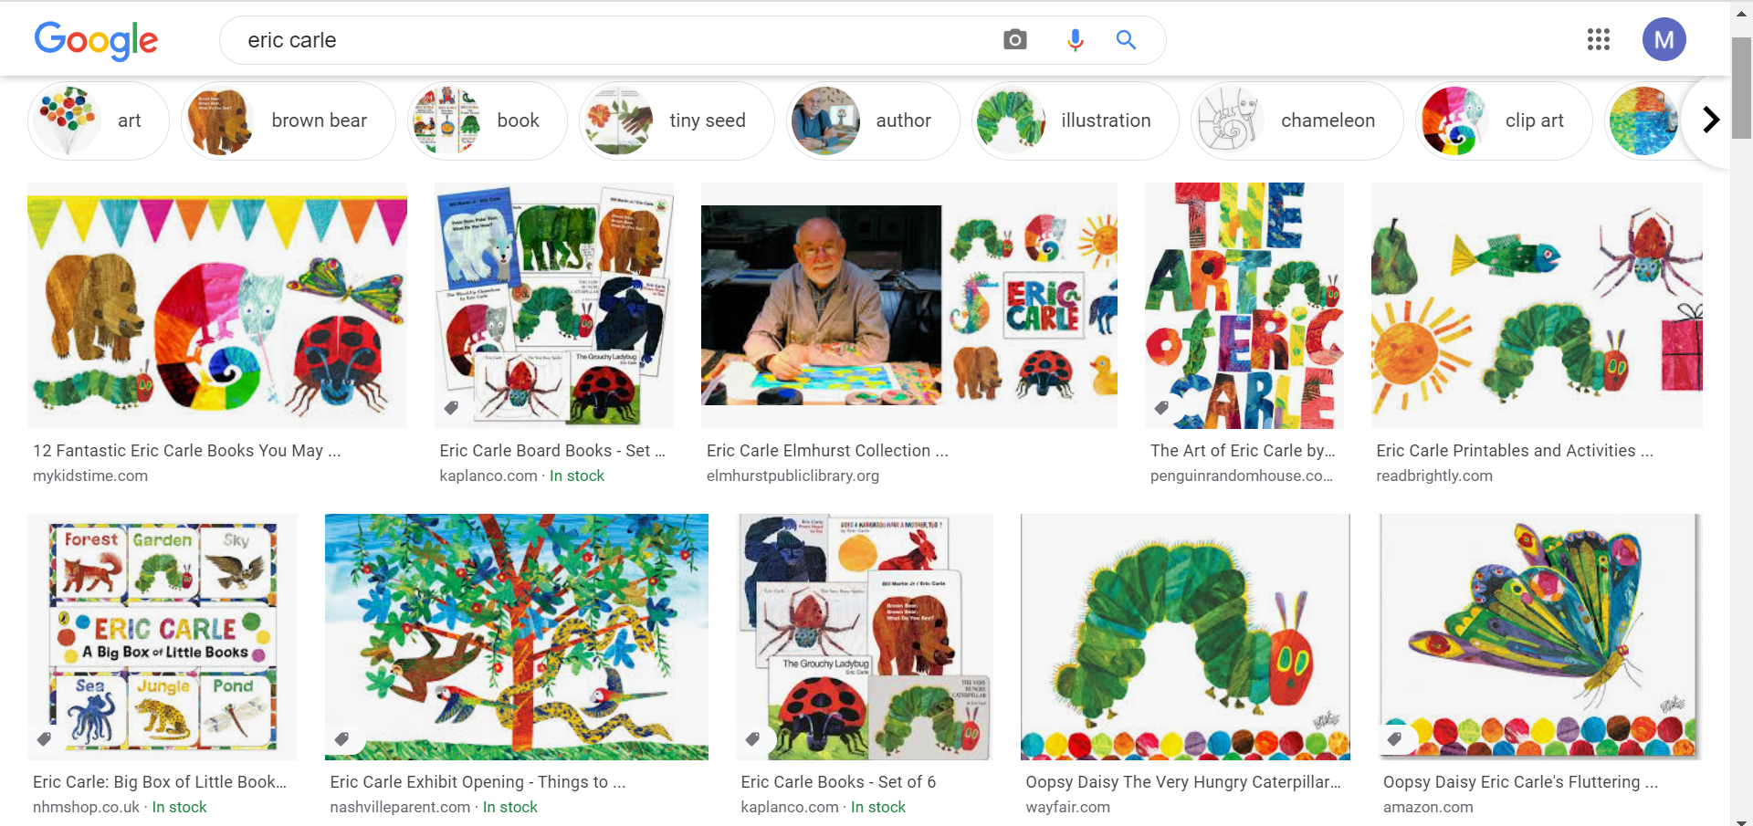 | Explore colour mixing to create different shades of brown paint. Can you paint a picture of a family of bears using the different shades of brown you have created. | Make a model stick man. You could use a cardboard tube. Send us a photo of your finished creation. 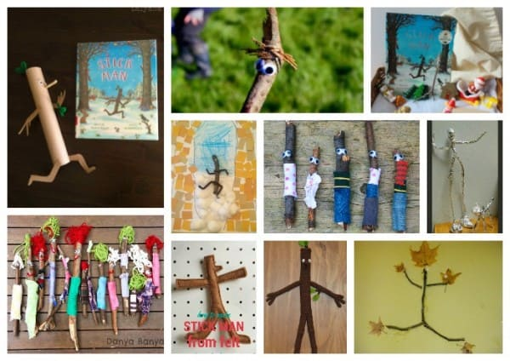 | Can you create your own giraffe? You could make a model using playdough; junk modelling or construction toys.
Maths | Can you help the Aliens answer the subtraction questions? | Can you complete the symmetrical patterns to create a symmetrical butterfly?  Why not create your own? Or ask your adult to challenge you with a difficult one? | Make some simple biscuits with the children. Encourage them to listen to and follow the recipe instructions and help to measure and weigh the ingredients. Bear-shaped cutters could be used to make bear biscuits. The biscuits could be made using cocoa powder to make them brown, or dip them in melted chocolate. | Can you create some addition and subtraction sums using sticks and leaves? | Can you use cubes to measure the giraffes?
Literacy | Using your sounds, can you write some sentences to describe the Alien you have designed? (You can use the underpants paper to write on.) Think about the colour; size; number of arms, legs and eyes; what underpants they’re wearing. Do not forget capital letters, fingers spaces and full stop! | Can you create a story map showing the different foods that the caterpillar eats in the story. Don’t forget to label the food he eats.  Can you use your story map to retell the story? | If you could search for an animal with your family, which animal would it be? Where would you go? What would you do when you found it?  Can you create your own version of We are going on a bear hunt with the animal you have chosen? Ask your adult to film you and send it to us! | Can you use the Postcard template to write a postcard to from Stick Man to his family describing his adventures?  Do not forget your sounds – chop up and blend those words, capital letters, fingers spaces and full stop! | Can you act out the story of Giraffes Can’t Dance, creating movements for the different parts of the story. Don’t forget about your facial expressions to show how Gerald felt at different parts of the story.
Problem Solving | Ask a grown-up if you can have some recycled materials from your house. Use these to build a spaceship. It could be a small model, big enough to fit a teddy bear inside, or even big enough to fit you! | Can you follow the recipe to make Fruit Pizza’s? | Use a teddy bear to demonstrate prepositions. Explore words like ‘next to’, ‘on’ and ‘behind’. Give your child different instructions of where to place the bear, for example, ‘Can you put the red bear under the chair?’  To challenge your child use two different bears and give them 2 instructions, for example ‘Can you put the small bear under the table and the big bear next to the fridge?’ | Can you create your own magic wand using a stick? | Can you order these giraffes by size?
Physical | Design your own planet. Draw a picture of it and think about what shape and colours it might be. What would you call it? Use your phonics sounds to write the name of the planet. Ask a grownup to help you write some adjectives to describe your planet. | Can you cut out the different stages of The Butterfly Life Cycle and stick them in the correct order? | Hide a teddy bear in a cave. Explore different ways of moving through the different settings in the story. The children could role play moving through each setting using a different movement for each. For example, they could tiptoe through the cave, skip through the grass and do big steps through the mud. | Join Jamie at Cosmic Kids Yoga to have a go at Stella the Stick Insect Yoga.  https://www.youtube.com/watch?v=wBdMZMEKq-s | Show us your best dance moves! Can you follow the steps to I like to Move it?  https://www.youtube.com/watch?v=ziLHZeKbMUo
UTW | Can you grow your own balloon alien? (Science Experiment Sheet). | Talk about healthy and unhealthy foods. Have a look at the food in your house. Can you sort the food into healthy and unhealthy? Talk about a balanced diet – it’s okay to have some unhealthy food, but in small amounts. | Find out 3 facts about real life bears that you can share with us? You could ask your adult to help you write them down to help you remember them. | Go on a walk in the woods and collect a variety if woodland objects.  Now your adult puts one object into a bag, you put your hand into the bag and can you guess what object is in there and describe what it feels like? Repeat with the other objects. | Giraffes are very tall animals, with very long necks. Can you find out how tall the tallest giraffe is? How tall are you? Are you as tall as a giraffe?

