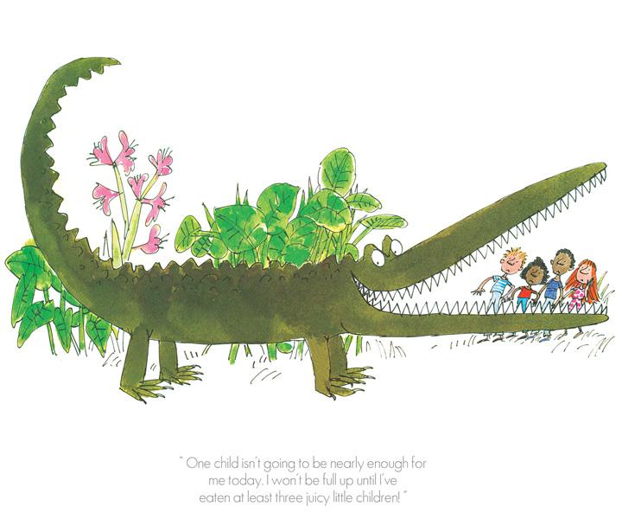
Week beginning 1.3.21 Weekly Timetable for Year 1 (1MW and 1GS) WORLD BOOK DAY MARCH 4TH
We are trying to provide a wide range of activities, please do not feel like you have to do all of them.
Some fun extra activities to try at home:
Sharing a story sheet.
World Book Day storybook game
Dress up as your favourite book character on World Book Day (Thursday)
There are some extra activities on - https://www.worldbookday.com/2020/09/world-book-day-2021-announcements/
- Puffin Books will be airing 20 minute story time sessions every weekday at 3.30pm on their YouTube, Instagram and Facebook channels, with separate sessions for ages 0-5, 6-11 and 7+, including readings and draw-alongs from brilliant authors and illustrators to help children connect with the stories.
- Julia Donaldson will be performing stories, songs and poems every Thursday at 4pm on The Gruffalo Official Facebook page, joined by her husband and a host of illustrators she works with, including Axel Scheffler, Rebecca Cobb, Lydia Monks, David Roberts and Nick Sharratt
- Stay At Home Storytime with Oliver Jeffers on Instagram @oliverjeffers – Oliver will be reading one of his stories every Monday, Wednesday and Friday at 7pm
- Children’s Laureate Cressida Cowell is reading How to Train Your Dragon in daily chapters on her YouTube channel along with writing tips and drawing.
- Enjoy the wonderful Sue Hendra doing a special reading of Barry the Fish with Fingers (featuring Betty the dog) on YouTube
- Have a look at BBC Bitesize with three new lessons every weekday including videos, activities and more

We would love to see some photos of your child’s work, so please email them to us or send via Teams
vanessa.skinner@grahamjamesacademy.co.uk faye.gilmore@grahamjamesacademy.co.uk michelle.walker@grahamjamesacademy.co.uk
Take care and stay safe.
From the Year 1 Team

 | Letters and Sounds  20 mins | Reading time  10/15 mins | Maths Time  25 mins |  | Spellings  10 mins | English/Topic  30 mins | Other subjects or activities  25 mins
M | Phase 5  Recap the sound ay like in day, tray, pay and crayon. Children could watch Geraldine or alphablocks. Children to complete the phase 5 ay spelling activity sheet. Challenge – can your child use the words to write their own sentence on the back?  Phase 3  Recap the long oo sound like in boot, roof, hoof and food. Children could watch Geraldine or alphablocks.  Children to complete the oo spelling activity sheet (page 5). | Reading  This week we are focusing on retrieving information from a story.  Children to complete the Rex Retrieval sheets pages 8 and 9. | Maths  Activity – count in 2’s.  Watch the white rose video and then complete the 100 hundred grid (colouring in each 2’s number).  https://vimeo.com/507065512 |  | Spellings  This weeks spelling are:  Monday  Tuesday  Wednesday  Thursday  Friday  Saturday  Sunday  Children to read each word in turn then to spell each word – make sure you let them see the correct spellings so that today they can copy them! | Literacy  For the next few weeks, we will be learning the story ‘The Enormous Crocodile’ by Roald Dahl.  Children to go through the Roald Dahl power point then draw and write a fact.  You could dictate a sentence for your child to write e.g. He would write in a small hut in his garden.  Please remember to use a capital letter, finger spaces and a full stop. | Yoga  Cosmic Kids Yoga on YouTube -  We're Going on a Bear Hunt | A Cosmic Kids Yoga Adventure!  https://www.youtube.com/watch?v=KAT5NiWHFIU
T | Phase 5  Recap the sound ou like in sound, found, round and scout. Children could watch Geraldine or alphablocks. Children to complete the phase 5 ou spelling activity sheet. Challenge – can your child use the words to write their own sentence on the back?  Phase 3  Recap the short oo sound like in look, wood, book and foot. Children could watch Geraldine or alphablocks.  Children to complete the oo spelling activity sheet (page 6) | Reading Comprehension  Children to play - Name That Story Game.  In this fairy tales game, children begin by picking a card and reading the clue (they may need a bit of help). Children to identify the fairy tale or traditional story using the descriptive clue.  Children could also be challenged to describe their favourite story for others to identify. They could even create their own card to add to the game. | Maths  Count in 2’s  Watch the white rose video and then complete the white rose activity sheet.  https://vimeo.com/505658511 |  | Spellings  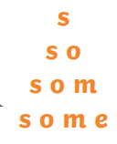  Write each of your words like a pyramid: | English  Watch Miss Skinner and Mrs Gilmore reading the first part of the story, The Enormous Crocodile.  Choose one or two of the animals from the story The Enormous Crocodile. Write a sentence using two adjectives to describe the animal.  Use the adjectives sheet (describing animals) to support. | Science  Use Oak National Academy  Key Stage 1, Science – The animal kingdom – What is a living thing?  https://classroom.thenational.academy/lessons/what-is-a-living-thing-70t3ae
W | Phase 5  Recap the sound ea like in beach, sea, read and meat. Children could watch Geraldine or alphablocks.  Children to complete the phase 5 ea spelling activity sheet. Challenge – can your child use the words to write their own sentence on the back?  Phase 3  Recap the sound ar like in park, car, bark and shark. Children could watch Geraldine or alphablocks.  Children to complete the ar spelling activity sheet (page 7) | Reading  Children to complete the World Book Day Story Setting sheet.  Children will need their favourite book and some colouring pencils. | Maths  Count in 5’s activity.  Watch the white rose maths video.  https://vimeo.com/507067325  Then use a 100 grid to colour in all the multiples of 5.  ** There are also lots of songs on YouTube for counting in 5’s and 2’s if your child likes singing.  https://www.youtube.com/watch?v=EemjeA2Djjw |  | Spellings  Upper and Lower  Write each of your spelling words two times.  First, write each word in upper case letters. Then, write each word in lower case letters. | English  **Watch Miss Walker reading the next part of the story.  Create a poster, using the Beware of the Crocodile sheet, warning others about the crocodile. Write a couple of sentences describing why they should look out for the crocodile.  Then draw a picture of the crocodile. | Art/Topic  Decorate a potato as a book character here are some examples:  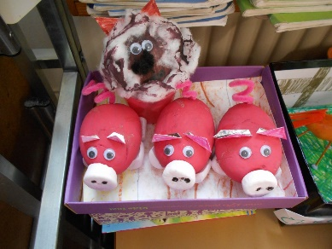  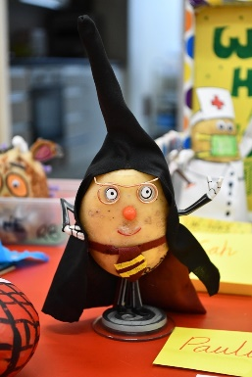  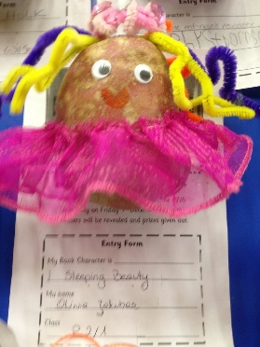
TH | Phase 5  Recap the sound ie like in tie, lie, cried and fried. Children could watch Geraldine or alphablocks.  Children to complete the phase 5 ie spelling activity sheet. Challenge – can your child use the words to write their own sentence on the back?  Phase 3  Recap the sound or like in for, fork, cord and horn. Children could watch Geraldine or alphablocks.  Children to complete the or spelling activity sheet (page 8) | Reading  Today is World Book day 2021  Children to complete the World book day scavenger hunt sheet. | Maths  Count in 5’s.  Watch the white rose video.  https://vimeo.com/507075995  Then complete the white rose activity sheet. |  | Spellings  Three times  Write each of your spelling words three times using a different coloured crayon, pen or pencil. | English/Geography  Look at Google Maps and find the route from England to Africa.  Choose two countries that you would see along the way. You can choose which route you will take. Draw them on the sheet between England and Africa. EG, France – you could draw the Eiffel Tower.  Italy – Leaning Tower of Pisa/Colosseum | Wellbeing time  YouTube - Rainbow Waterfall (Peace Out: Guided Meditation for Kids) | Cosmic Kids  https://www.youtube.com/watch?v=hh58j2Yw6dg  PSHE  Use Oak National Academy  Key Stage 1, RHE (PSHE)  forever friends – That’s not fair - lesson 2  https://classroom.thenational.academy/units/forever-friends-45e8
F | Practise any sound from the week – either spelling a word with each sound or play a game e.g. sentence substitution, rocket rescue, make a match and sentences – all on phonics play.  Phase 3 – Children to play roll and read. Challenge – Can you use your words to write your own sentences? | Reading  Take a photo of your child reading their favourite book in an unusual place at home e.g. reading in the shower with your shower cap on. | Maths Game Day  Practise counting in 2’s and 5’s – you could do this out loud or you could use objects and group them to count in 2’s or 5’s.  Play hit the button in 2’s or 5’s.  https://www.topmarks.co.uk/maths-games/hit-the-button  https://www.ictgames.com/mobilePage/duckShoot/index.html |  | Spellings  Test your child on the spellings for the week!  Make it fun though as some of them are quite tricky. | Grammar and Punctuation lesson  Children may need a little bit of help/reminding with some of the activities.  Please complete Grammar sheet page 3. | Music  Use Oak National Academy Key Stage 1 – Music –Timbre– lesson 1- Exploring different ways to use your voice  https://classroom.thenational.academy/units/timbre-3b9d

