 | too | cord | fork | hood | pool
 | fort | zoo | born | jar | look
 | pool | farm | market | zoom | hard
 | wood | food | hard | born | park
 | sort | moon | root | farmyard | torn
 | rooftop | cart | bark | wool | cool

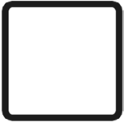

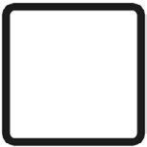

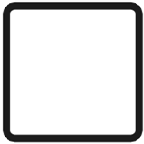
Roll and Write Mat

