04.03.21 LO: to spell and use common homophones.
I have used the homophones from this week. | I have written in the form of a book review.  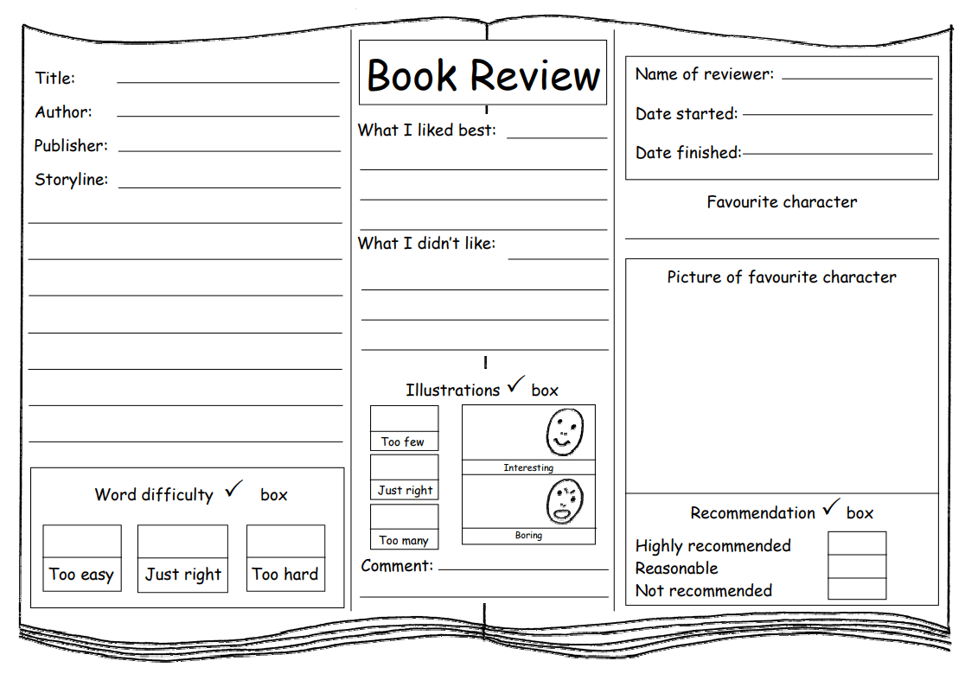
I have included the correct punctuation. | I have formed my letters correctly.  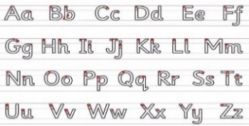
Challenge- I have spelt most words correctly.
Greater depth – I have included conjunctions in my book review (although, despite, however).
Words of the week – vicious recommend unusual

