Edmund

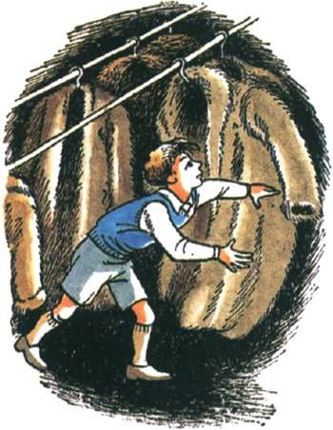

Do you think Edmund treats his siblings in a nice way? Explain

_____________________________________________  
  
_____________________________________________  
  
_____________________________________________  
  
_____________________________________________

Who does Edmund treat the worst? How do you know? (Give some examples.)   
  
____________________________________________________________________________  
  
____________________________________________________________________________

Would you like Edmund to be your friend? Why/why not?

____________________________________________________________________________  
  
____________________________________________________________________________

How do you think Edmund felt after discovering that there really was a magical world through the wardrobe and that Lucy was telling the truth?

____________________________________________________________________________  
  
____________________________________________________________________________  
  
____________________________________________________________________________

What piece of advice would you give to Edmund on how he should treat others?

____________________________________________________________________________  
  
____________________________________________________________________________