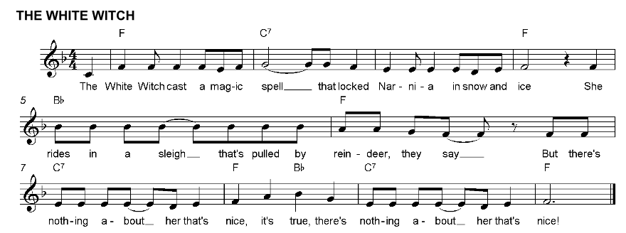

She likes to think she is a Queen
But her heart is colder than the ice
She waves a white wand,
Of which she’s terribly fond
But there’s nothing about her that’s nice! It’s true,
There’s nothing about her that’s nice!

She thinks her power will rule supreme
But her magic can melt like winter ice
For Aslan the King
Has changed the season to Spring
And the witch disappears in a trice! It’s true,
the witch disappears in a trice!

