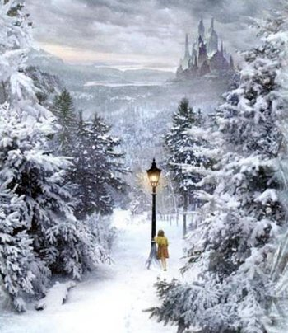Describing Narnia

Challenge:

Similes   
e.g. The sky was as dark as coal.

Adjectives  
e.g. chilly

Greater Depth:

Metaphor:

Adverbs   
e.g. carefully

Verbs   
e.g. walking

Nouns   
e.g. tree